Moduldokumentation

Modul Verteilte Systeme (vesys)

Simon Wächter

2017

Inhalt

1 Einleitung 7

1.1 Einleitung 7

1.2 Lernziele 7

1.3 Prüfungen 7

2 Woche 1 8

2.1 Definition of Distributed Systems 8

2.1.1 Definitions 8

2.1.2 Classification 8

2.1.3 Pros and Cons 9

2.1.4 Interaction Models 9

2.1.5 Client/Server Model 10

2.1.6 Communication Models 10

2.1.7 Communication Styles 11

2.2 Challenges of Distributed Systems 12

2.2.1 Heterogeneity 12

2.2.2 Latency 12

2.2.3 Security 12

2.2.4 Scalability 13

2.2.5 Failures 13

2.2.6 Concurrency 14

2.2.7 Consistency 14

2.3 Networking 14

2.3.1 Protocol & Network Levels 14

2.3.2 IP Socket Connections 15

2.3.3 IP Addressing 15

2.3.4 TCP/UDP Common Port Numbers 16

2.3.5 InetAddress 16

2.3.6 Network Interfaces 17

2.4 Sockets 17

2.4.1 Sockets 17

2.4.2 TCP Sockets 18

2.4.3 Java Socket 18

2.4.4 Sample Client (Echo) 20

2.4.5 Sample Client (Mailer) 20

2.4.6 ServerSocket 21

2.4.7 Echo Server 22

2.4.8 Concurrent Echo Server 22

2.4.9 Concurrent Echo Server (Threaded) 22

2.4.10 Concurrent Echo Server (Limitierter Threadpool) 23

2.4.11 Concurrent Echo Server (Dynamischer Threadpool) 24

3 Woche 2 26

3.1 Input and Output Streams 26

3.1.1 OutputStream 26

3.1.2 InputStream 26

3.2 Filter Streams 27

3.2.1 FilterOutputStream 27

3.2.2 DataOutputStream 28

3.2.3 DataOutputStream with writeInt 28

3.2.4 DataOutputStream with writeUTF 28

3.2.5 PrintStream 29

3.2.6 FilterInputStream 29

3.2.7 DataInputStream 29

3.2.8 DataInputStream with readFully 30

3.2.9 Filter Streams 30

3.3 Object Streams & Serialization 30

3.3.1 ObjectStream 30

3.3.2 Serialization with ObjectStream 31

3.3.3 Serial Version Number 32

3.3.4 Serialization Customization 33

3.3.5 Serialization Hints 33

3.4 Sending and Receiving Data 34

3.4.1 Framing 34

3.4.2 Example of Framing 34

3.5 Summary 34

3.5.1 Whole Picture of Input Streams 34

3.5.2 Whole Picture of Output Streams 35

3.5.3 Reading and Writing Text (Unicode Strings) 36

3.5.4 Whole Picture of Reader 36

3.5.5 Whole Picture of Writer 36

3.6 Controlling Socket Behaviors 37

3.6.1 Blocking and Timeouts 37

3.6.2 Send and Receive Buffer Size 38

3.6.3 Package Delay 38

3.7 Closing Connections 38

3.7.1 Closing Connections 38

3.7.2 Example of a Close Test 39

3.7.3 Example of a Compression Server 40

3.8 UDP Sockets 40

3.8.1 UDP (User Datagram Protocol) 40

3.8.2 Java Classes for Datagram 41

3.8.3 DatagramSocket 41

3.8.4 DatagramPacket 42

3.8.5 Example of a UDP Server and Client 43

3.8.6 UDP Implementation 43

3.8.7 Reliable UDP 44

4 Woche 3 45

4.1 HTTP Protocol 45

4.1.1 IETF RFC 45

4.1.2 HTTP Protocol 45

4.1.3 HTTP Request 45

4.1.4 HTTP Response 46

4.1.5 HTTP Protocol 46

4.1.6 HTTP Sample 46

4.1.7 HTTP 1.0 Request Methods 48

4.1.8 HTTP Response Codes 48

4.1.9 HTTP Request Headers 48

4.1.10 HTTP Response Headers 49

4.1.11 MIME Types 49

4.1.12 HTTP Request/Response Sample 50

4.1.13 HTTP 1.1 Enhancements 50

4.2 HTTP Web Server 51

4.2.1 A simple Web Server 51

4.2.2 Java internal Web Server 53

4.3 HTML Forms & URL Encoding 54

4.3.1 HTML GET Form 54

4.3.2 URL Encoding 55

4.3.3 HTML POST Form 55

4.4 HTTP Requests from Java 56

4.4.1 URL 56

4.4.2 Sending GET Requests from within Java 56

4.4.3 URLConnection 56

4.4.4 URLConnection Tips & Tricks 57

4.4.5 Sample 1: URLConnection GET 57

4.4.6 Sample 2: URLConnection POST 58

4.4.7 Sample 3: Currency Converter 58

4.4.8 Other Libraries 60

5 Woche 4 61

5.1 Servlets 61

5.1.1 Servlet Specification 61

5.1.2 Dynamic Content 61

5.1.3 Servlets 61

5.1.4 Servlet Packages 61

5.1.5 Servlet Life-Cycle Methods 62

5.1.6 HttpServlet 62

5.1.7 HttpServletRequest 63

5.1.8 HttpServletResponse 63

5.1.9 Servlet Example 63

5.1.10 Webapplication Structure 64

5.1.11 Annotation WebServlet 65

5.1.12 Webapplication Structure 65

5.2 Tomcat Servlet Server 66

5.2.1 Tomcat 66

5.2.2 Tomcat Directory Structure 66

5.2.3 Tomcat Scripts 66

5.2.4 Tomcat Startup Screen 67

5.2.5 Tomcat Managers 67

5.2.6 Debugging 67

5.2.7 Tomcat Architecture 68

5.2.8 Configuration of a Host 68

5.2.9 Configuration of a Context 69

5.2.10 Deployment while development 70

5.2.11 Eclipse and Servlets (JEE Eclipse Version) 70

6 Woche 5 72

6.1 Motivation XML-RPX 72

6.1.1 Services over HTTP (Currency Converter) 72

6.1.2 XML-Remote Procedure Calls 73

6.2 SOAP und JAX-WS 73

6.2.1 SOAP 73

6.2.2 JAX-WS 74

6.2.3 JAX-WS HTTP Request 80

6.2.4 JAX-WS HTTP Response 80

6.2.5 SOAP Message Structure 81

6.2.6 Tools for SOAP 81

6.3 WSDL 82

6.3.1 WSDL 82

6.3.2 WSDL Examples 82

6.3.3 WSDL Structure 82

6.3.4 WSDL Definitions 83

6.3.5 Message Exchange Patterns (MEP) 84

6.3.6 WSDL Definitions 85

6.3.7 Web Service Styles 85

6.3.8 RPC/Encoded 86

6.3.9 RPC/Literal 87

6.3.10 Document/Literal/Bare 88

6.3.11 Document/Literal/Wrapped 89

6.3.12 Web Service Styles 90

6.3.13 Further References 90

7 Woche 6 91

7.1 REST Concepts 91

7.1.1 Representational State Transfer (REST) 91

7.1.2 REST Principles 91

7.1.3 REST Short Primer 93

7.1.4 SOAP versus REST 93

7.1.5 REST Common Patterns 93

7.1.6 Example Doodle 94

7.1.7 REST versus SOAP 95

7.1.8 Client Side 95

7.1.9 Web Client Plugins 95

7.1.10 Client Side via curl 96

7.2 REST Server Implementations 96

7.2.1 Server Side 96

7.2.2 JAX-RS Services 97

7.2.3 JAX-RS HTTP Methods 97

7.2.4 JAX-RS Injection 97

7.2.5 JAX-RS Content Negotoation 99

7.2.6 JAX-RS Content Handlers 100

7.2.7 JAX-RS Responses 100

7.2.8 JAX-RS Conditional GET 101

7.2.9 JAX-RS Cache Control 102

7.2.10 JAX-RS Optimistic Locking 103

7.2.11 JAX-RS Deployment 103

7.2.12 Deploy Stand Alone via Jersey 104

7.3 REST Clients 105

7.3.1 JAX-RS Client API 105

7.3.2 Resources 107

8 Woche 7 108

# Einleitung

## Einleitung

Dieses Dokument stellt die Moduldokumentation für das Modul vesys dar. Allfällige Unterlagen sind im Modulordner zu finden.

## Lernziele

Das Modul beinhaltet folgende Lernziele:

* Erstellen einer Verbindung zwischen zwei Rechnern mittels Sockets
* Wissen über http Protokoll und Webserver
* Implementieren einfacher Servlets
* Prinzipien und Programmierung von RMI
* Prinzipien von Webservices und Programmierung mittels JAXWS
* Verwendung von Webservices mittels WSDL
* Prinzipien und Programmierung von REST und deren Unterschiede zu SOA und ROA
* Prinzipien der asynchronen Programmierung mittels JMS und Akka
* Entscheidung, welche der Technologien für eine Situation geeignet ist

## Prüfungen

Die Modulnote setzt sich aus einer Semesterprüfung zu 50% und einer Modulschlussprüfung zu 50% zusammen. Zusätzlich müssen 4 von 8 Übungen erfüllt werden.

# Woche 1

## Definition of Distributed Systems

### Definitions

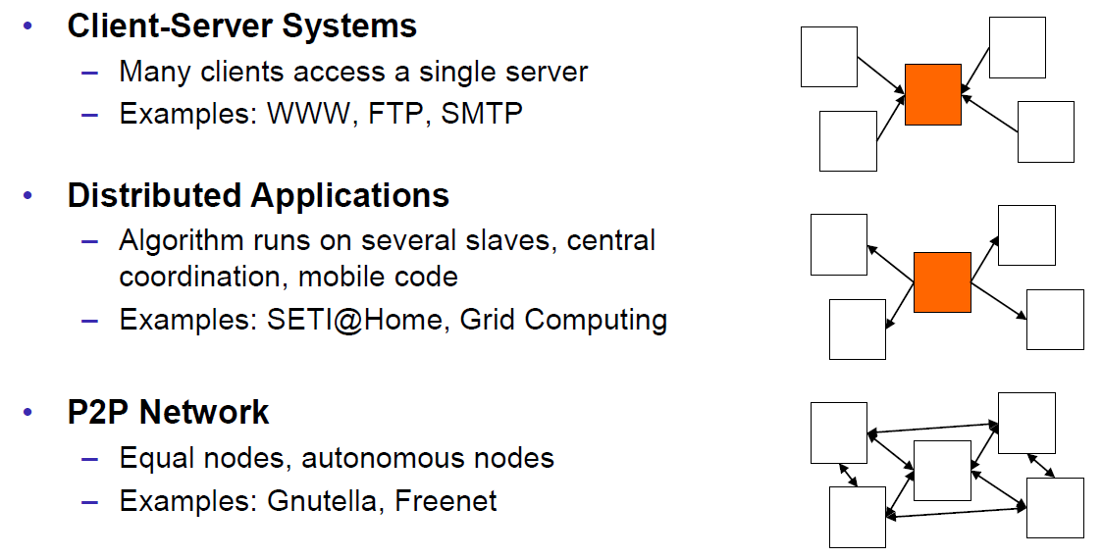

### Classification

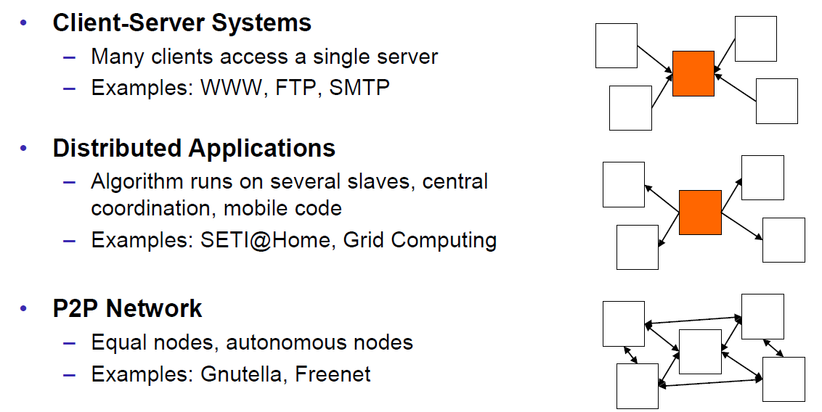

### Pros and Cons

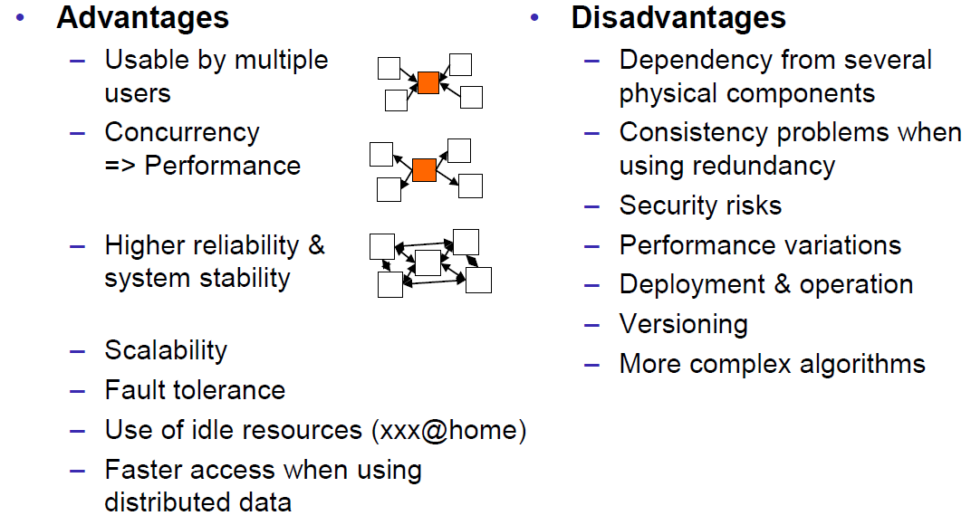

### Interaction Models

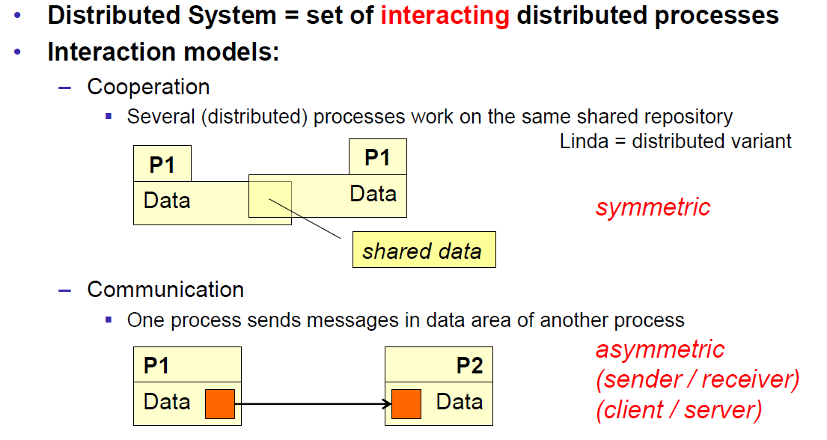

### Client/Server Model

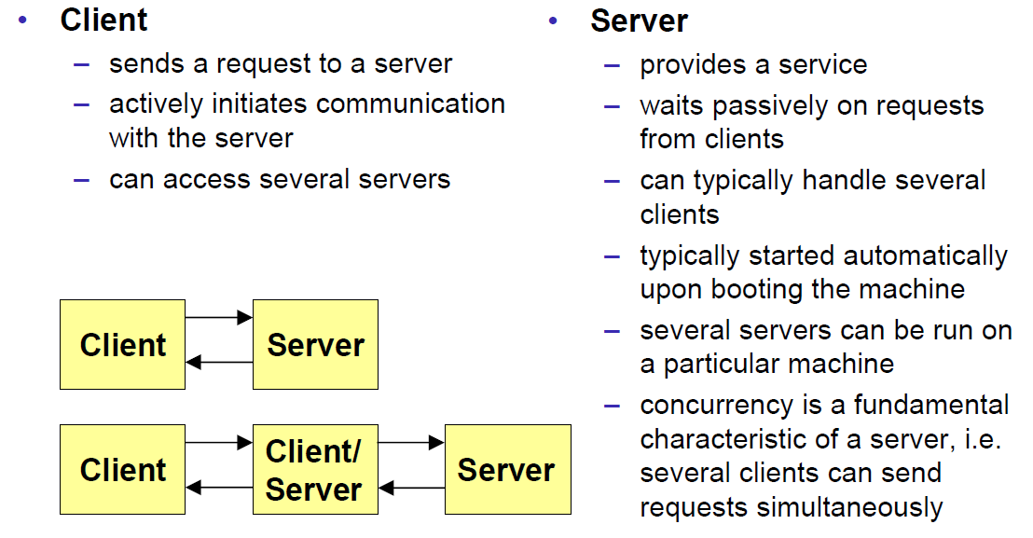

### Communication Models

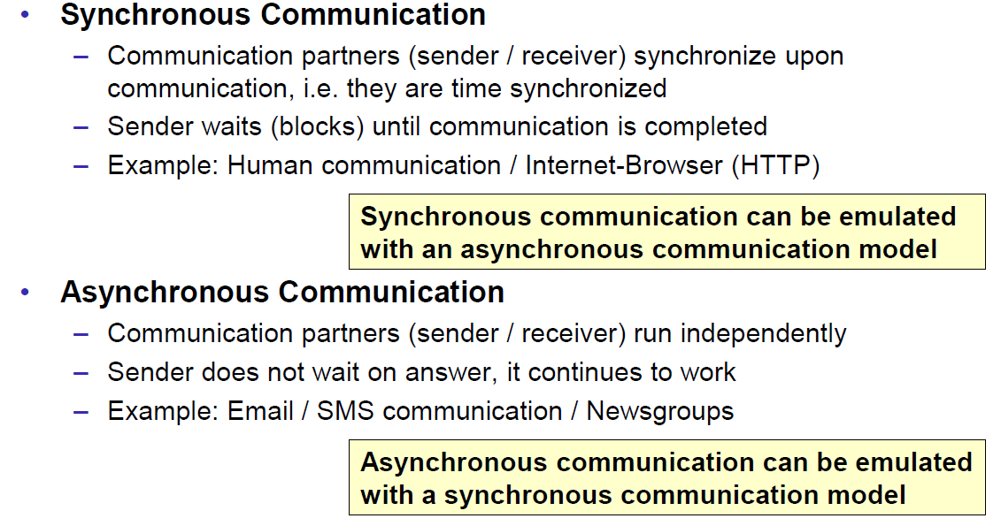

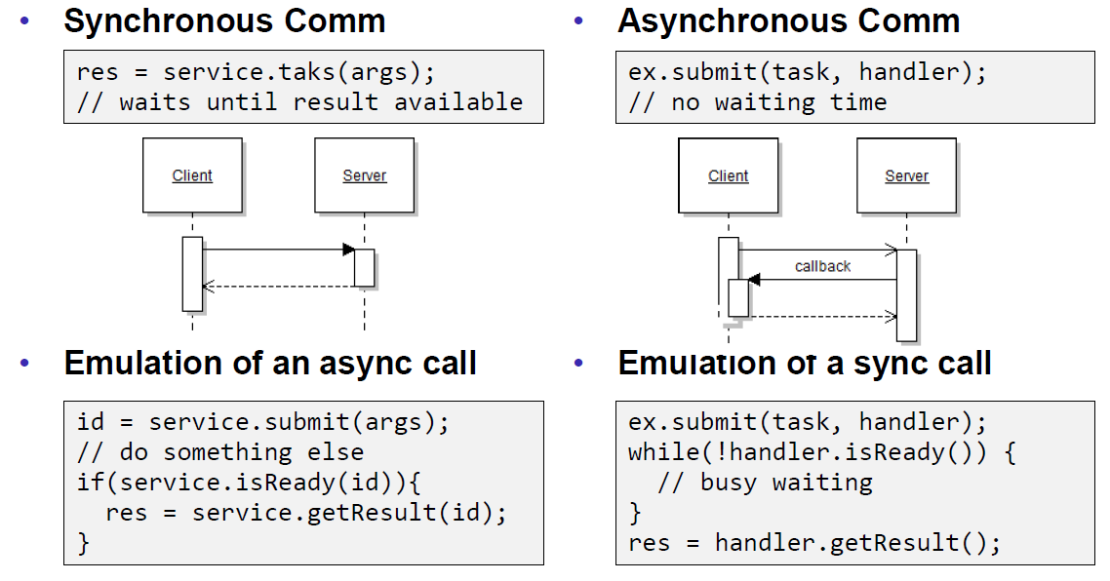

### Communication Styles

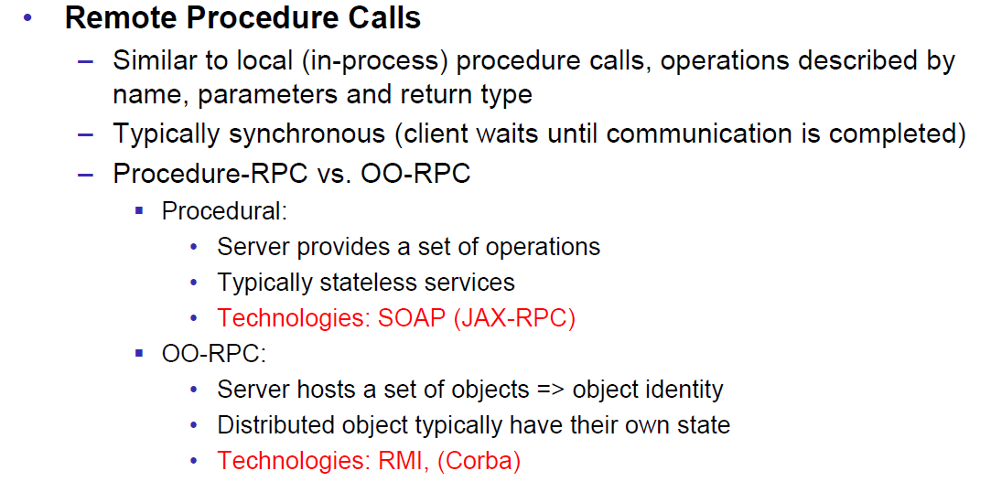

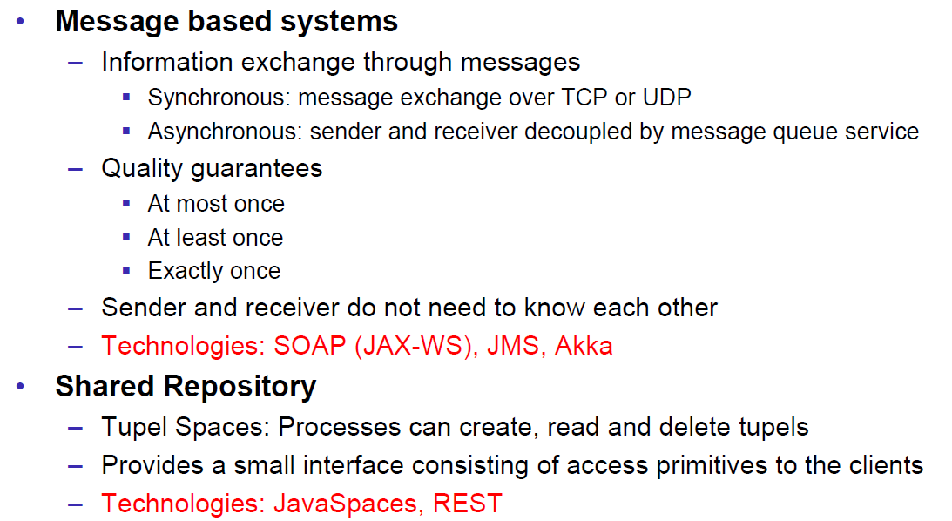

## Challenges of Distributed Systems

### Heterogeneity

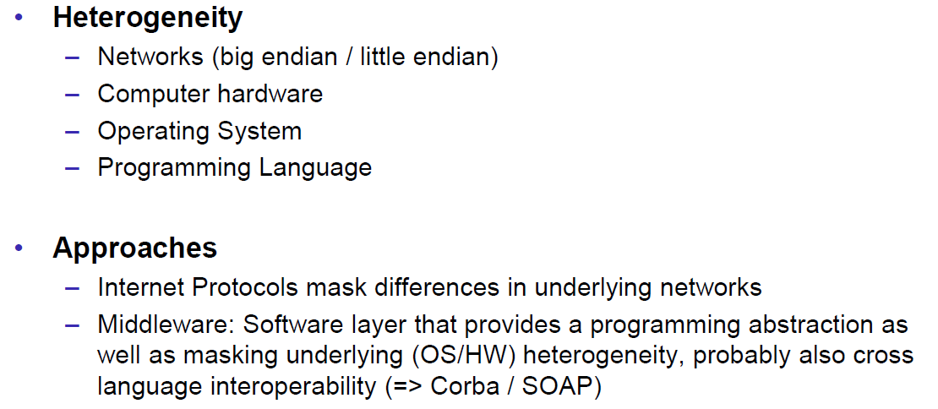

### Latency

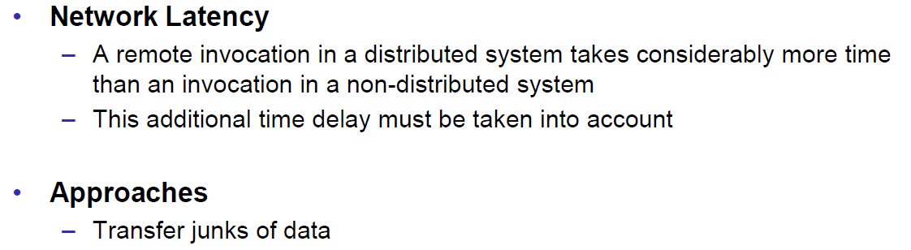

### Security

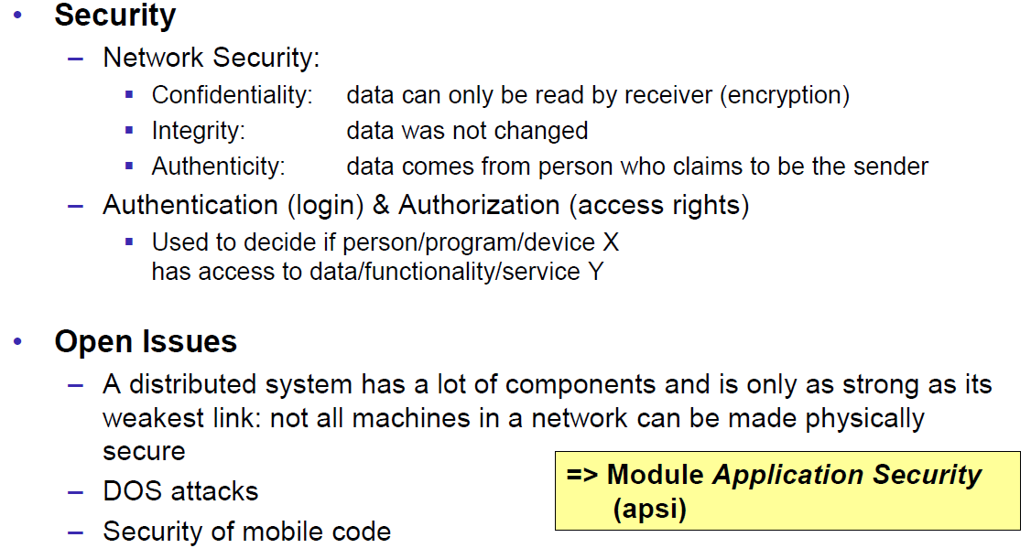

### Scalability

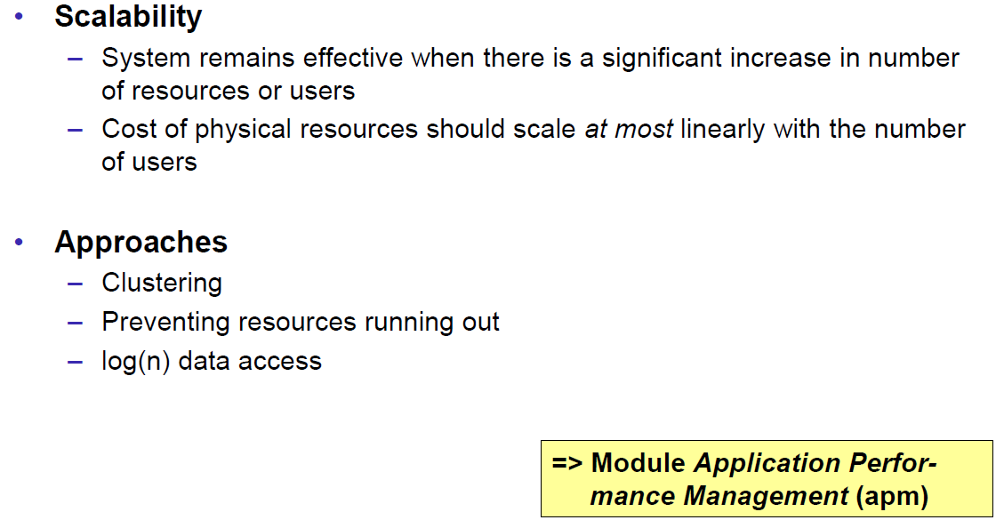

### Failures

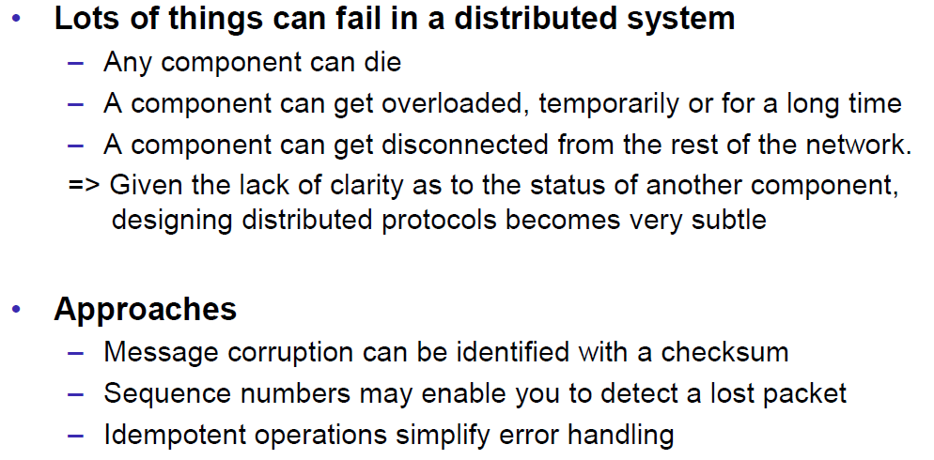

### Concurrency

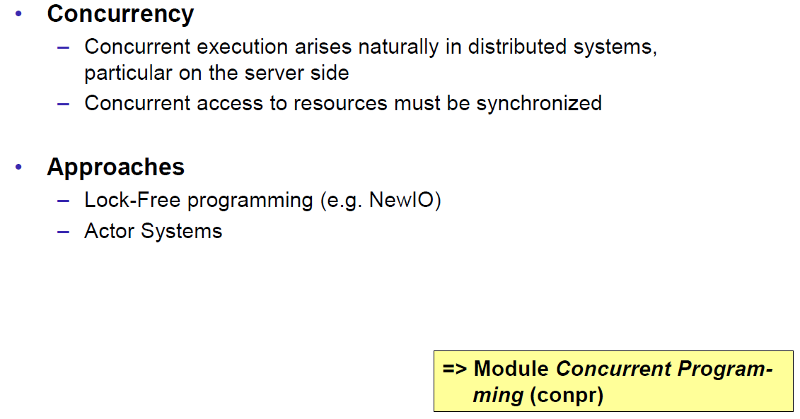

### Consistency

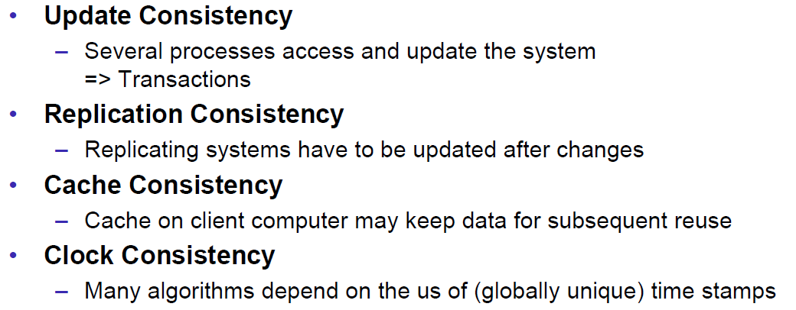

## Networking

### Protocol & Network Levels

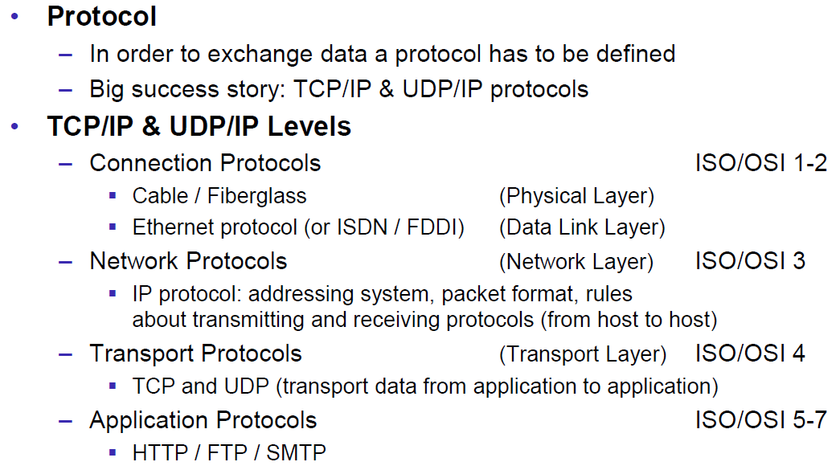

### IP Socket Connections

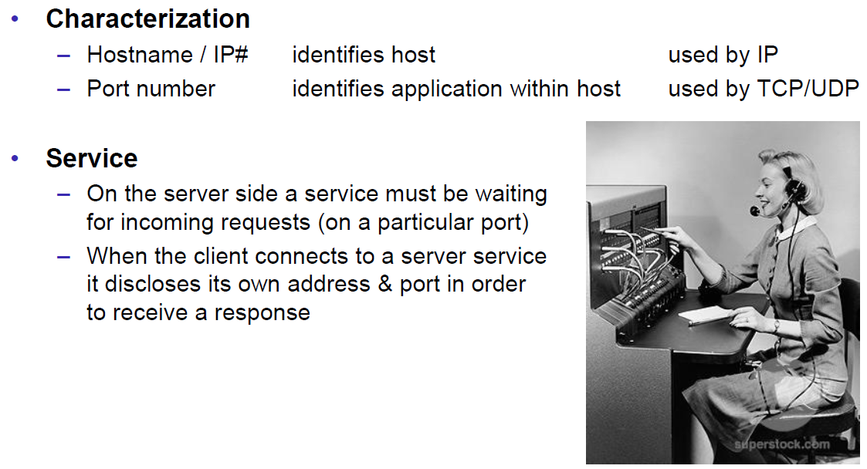

### IP Addressing

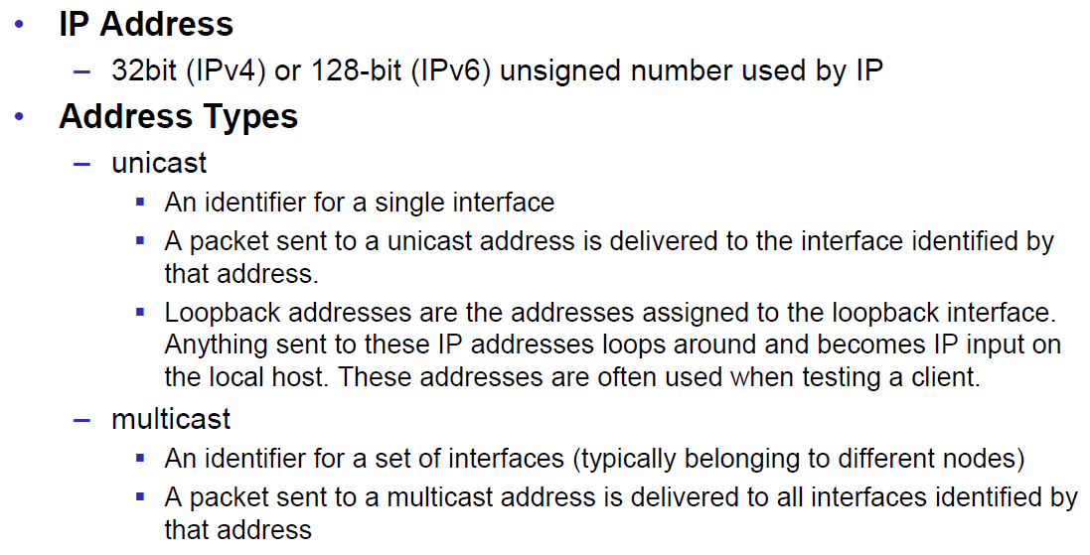

### TCP/UDP Common Port Numbers

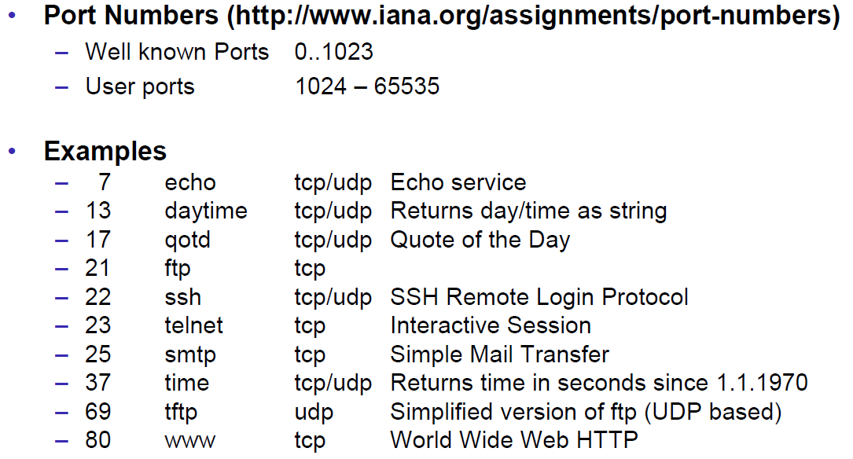

### InetAddress

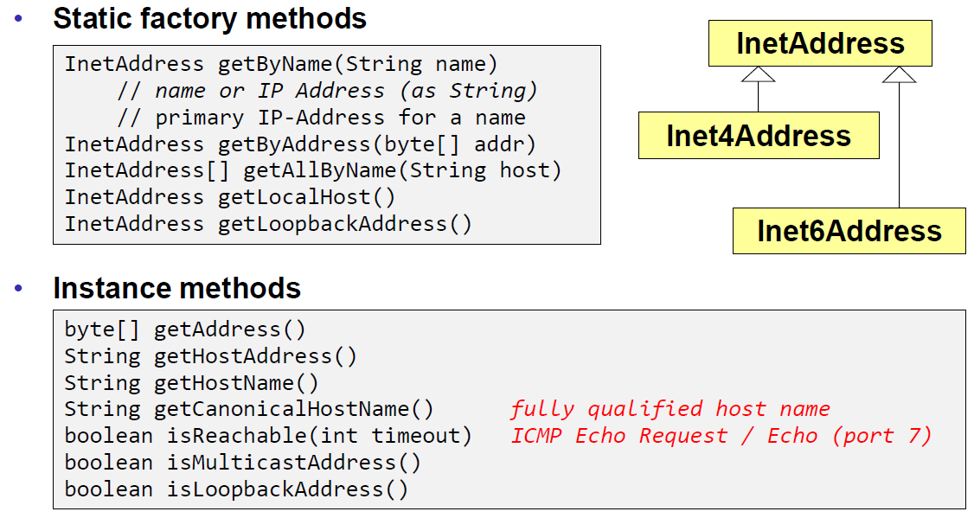

### Network Interfaces

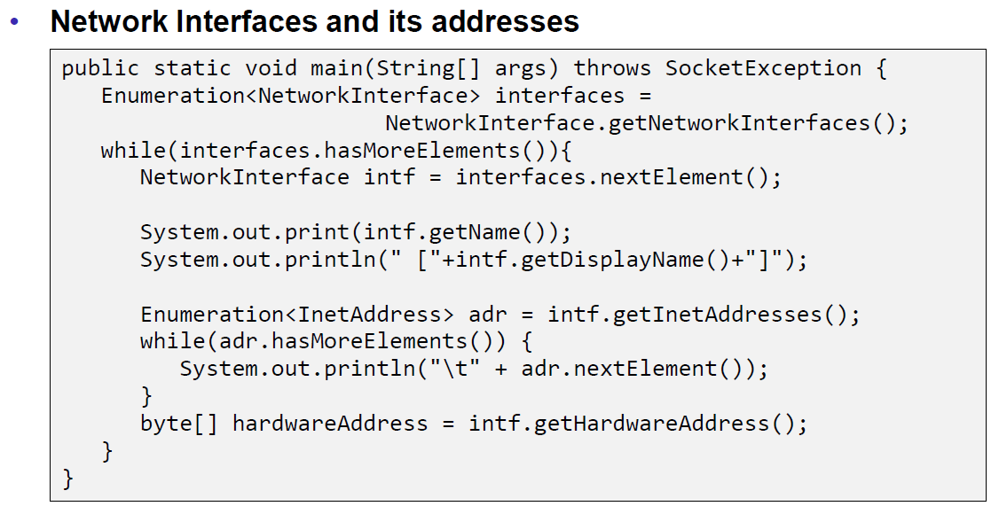

## Sockets

### Sockets

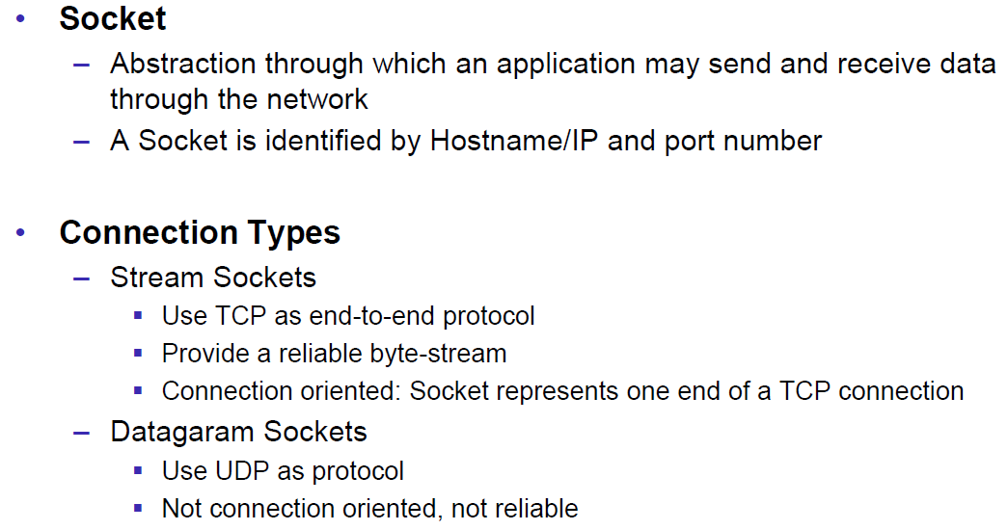

### TCP Sockets

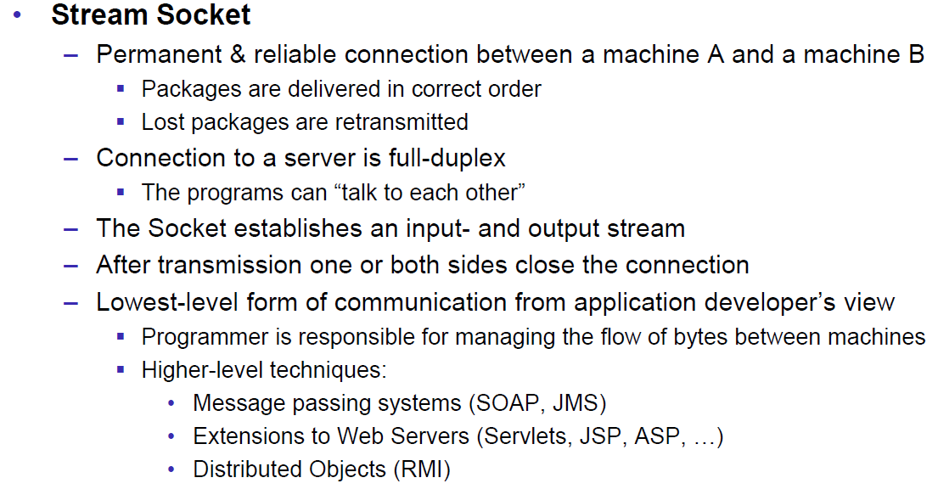

### Java Socket

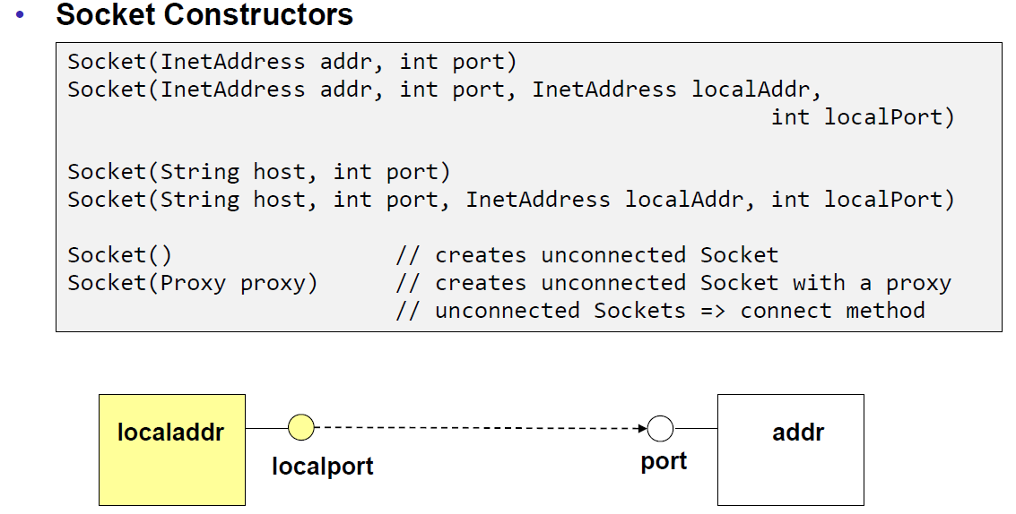

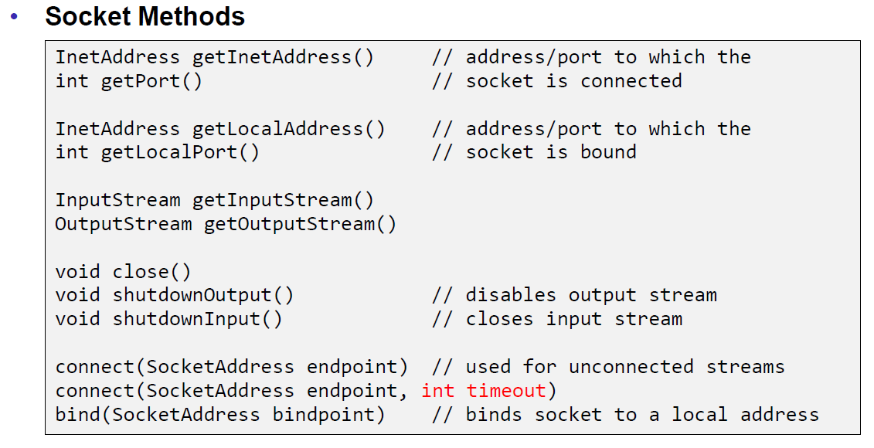

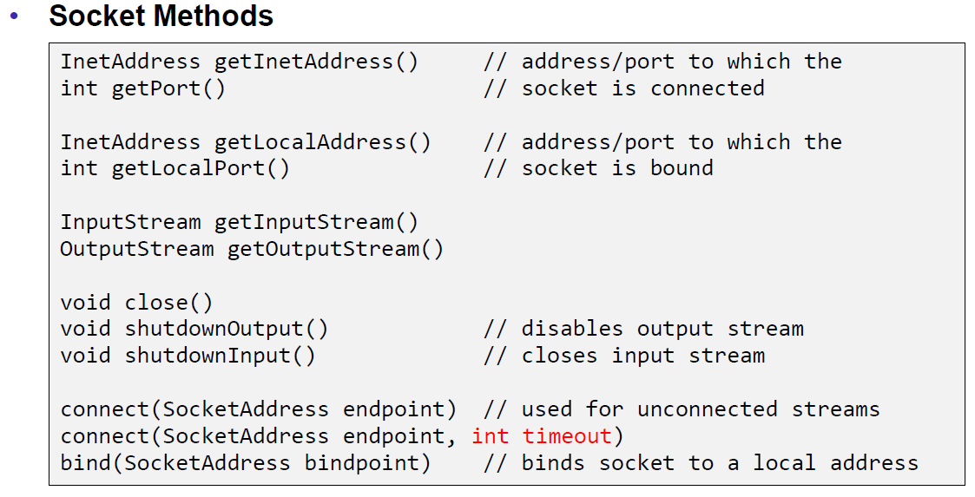

### Sample Client (Echo)

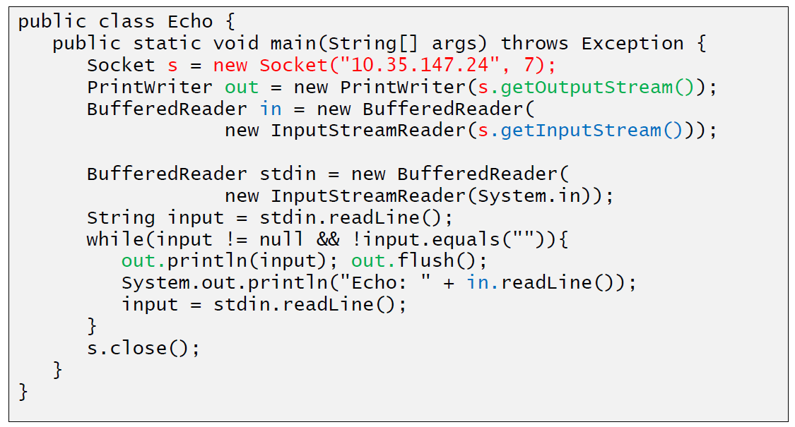

### Sample Client (Mailer)

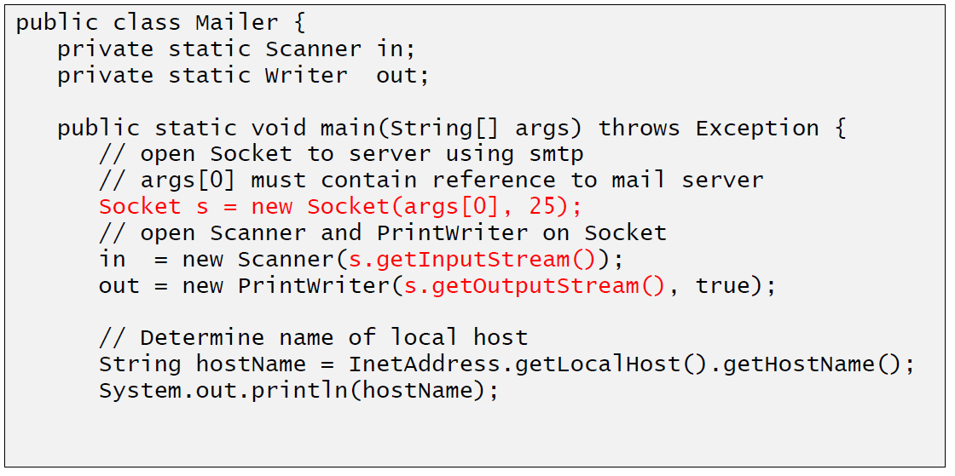

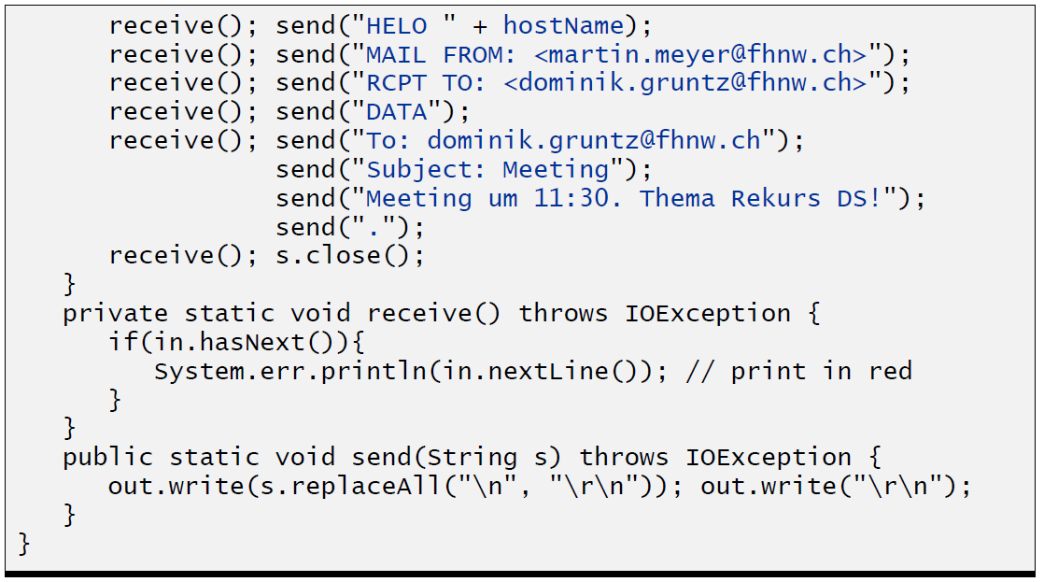

### ServerSocket

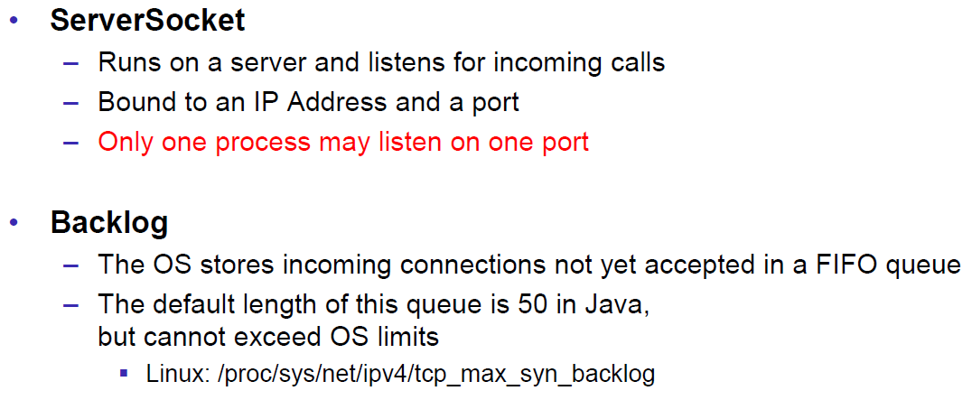

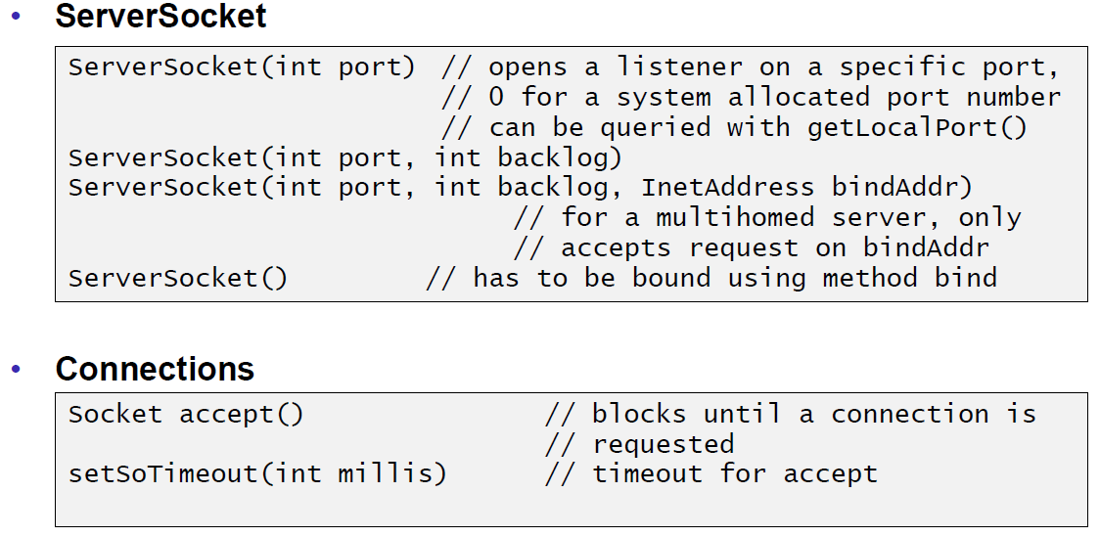

### Echo Server

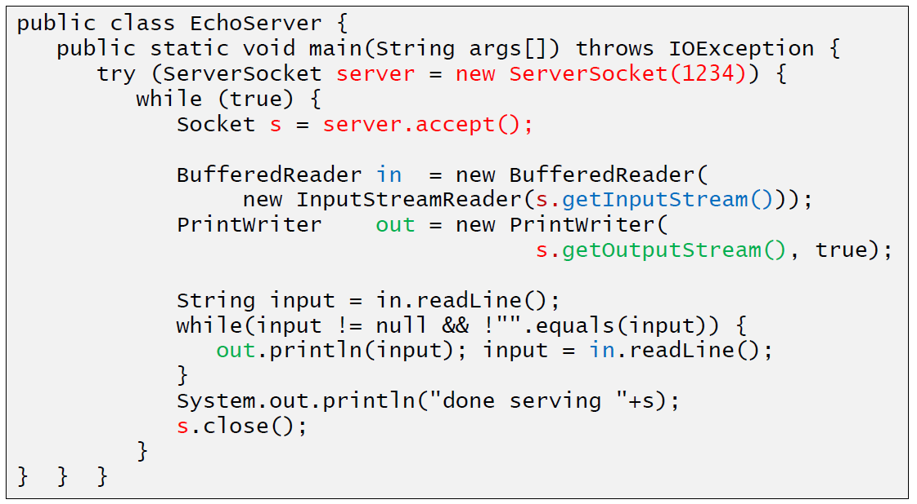

### Concurrent Echo Server

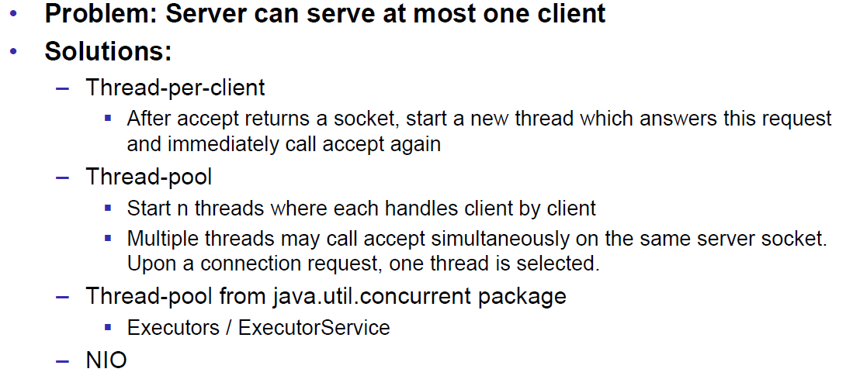

### Concurrent Echo Server (Threaded)

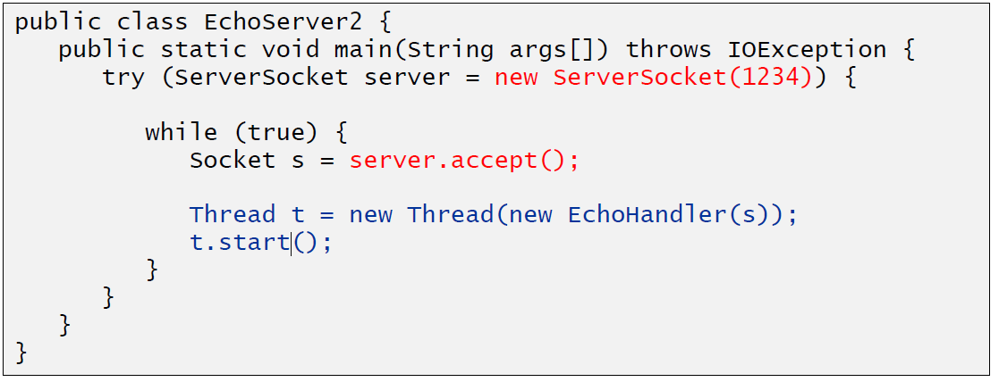

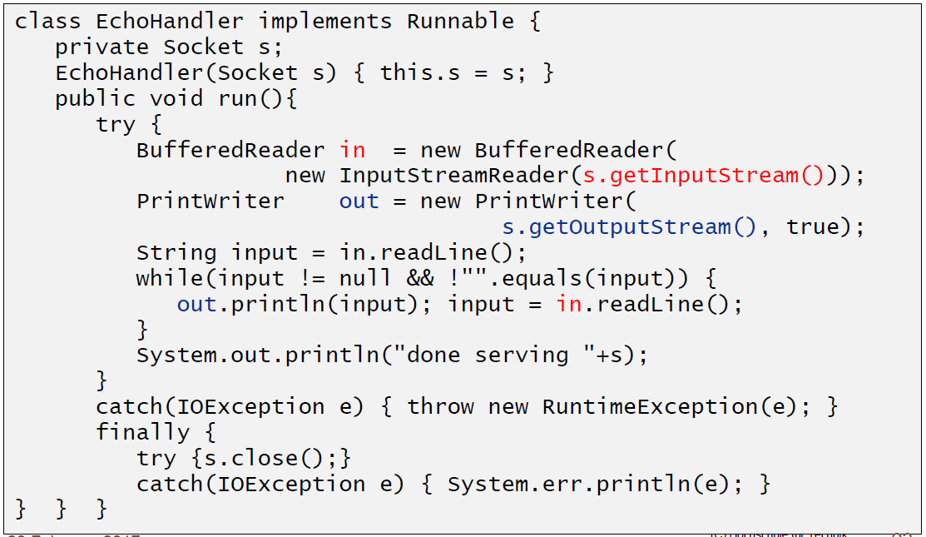

### Concurrent Echo Server (Limitierter Threadpool)

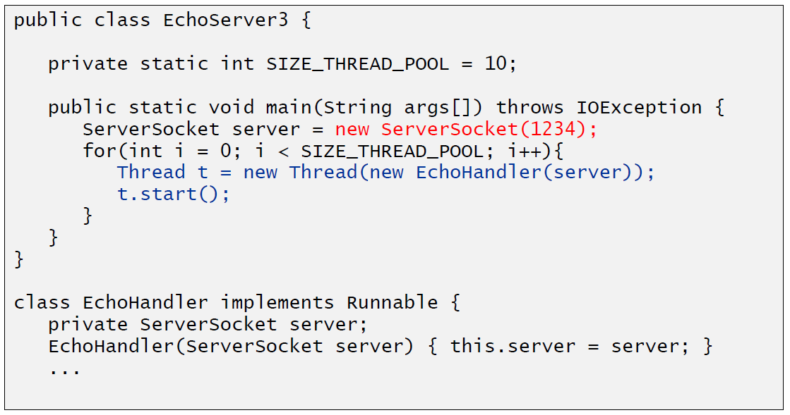

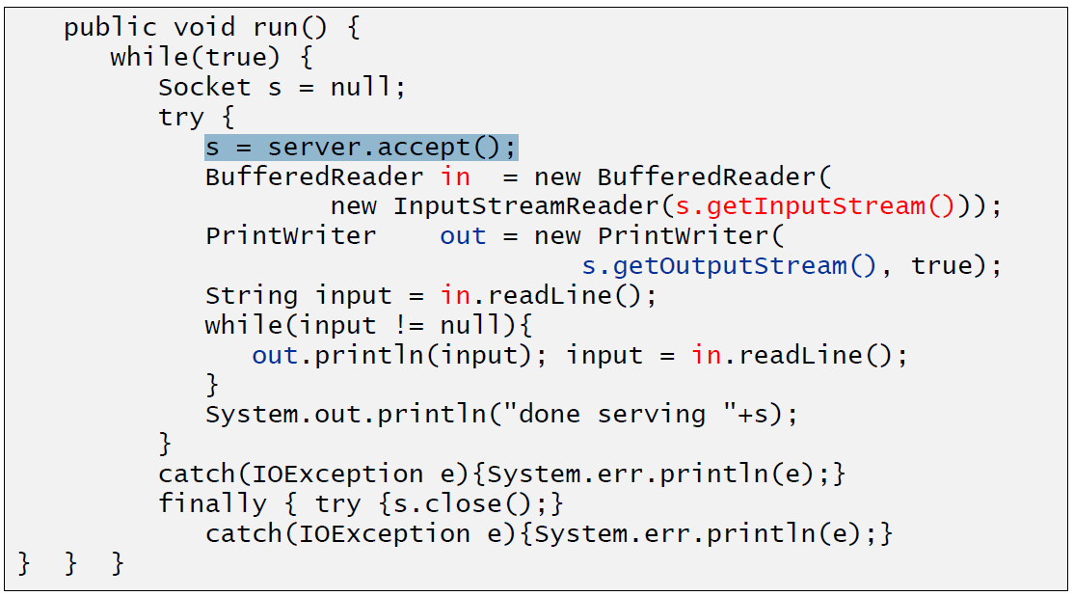

### Concurrent Echo Server (Dynamischer Threadpool)

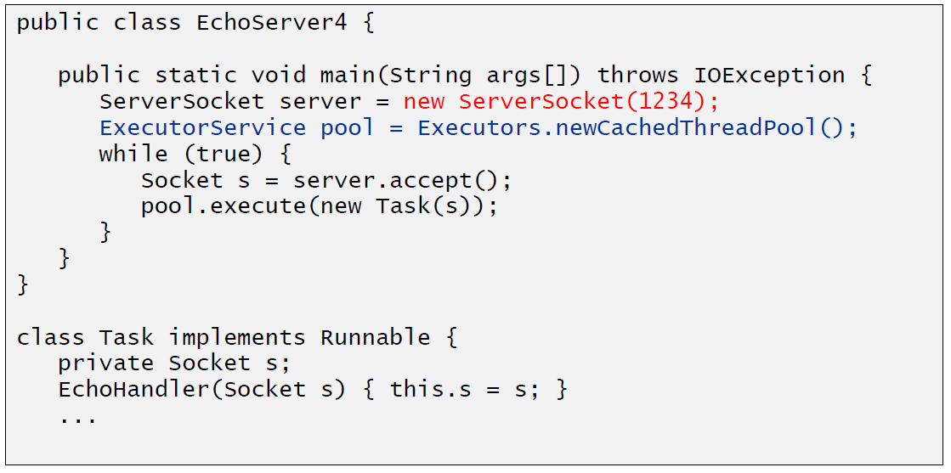

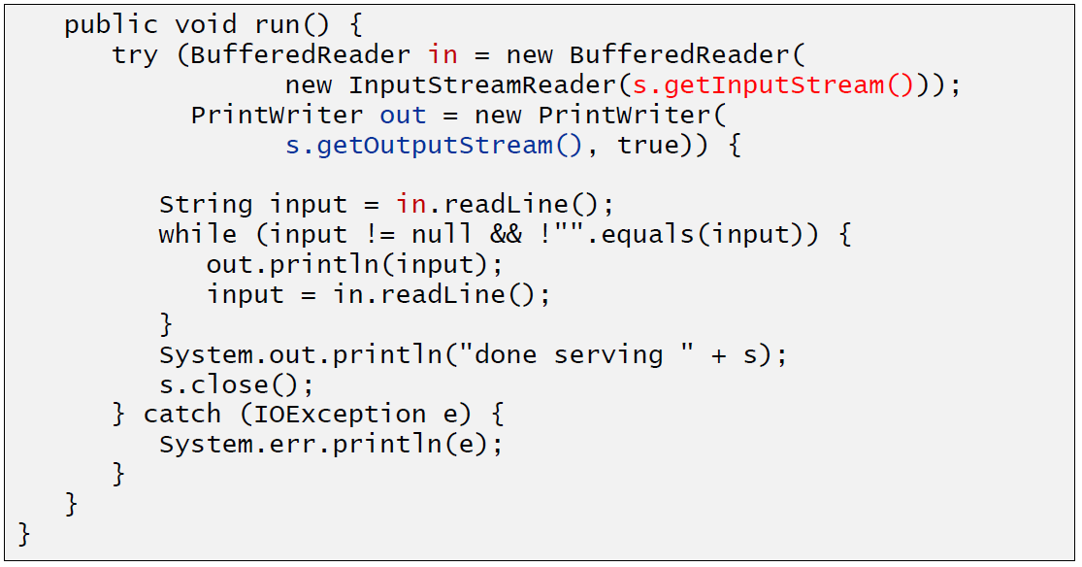

# Woche 2

## Input and Output Streams

### OutputStream

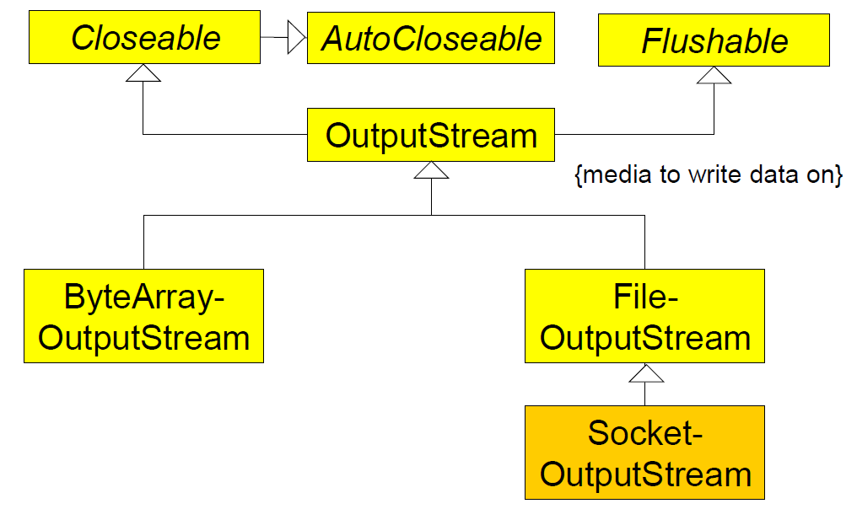

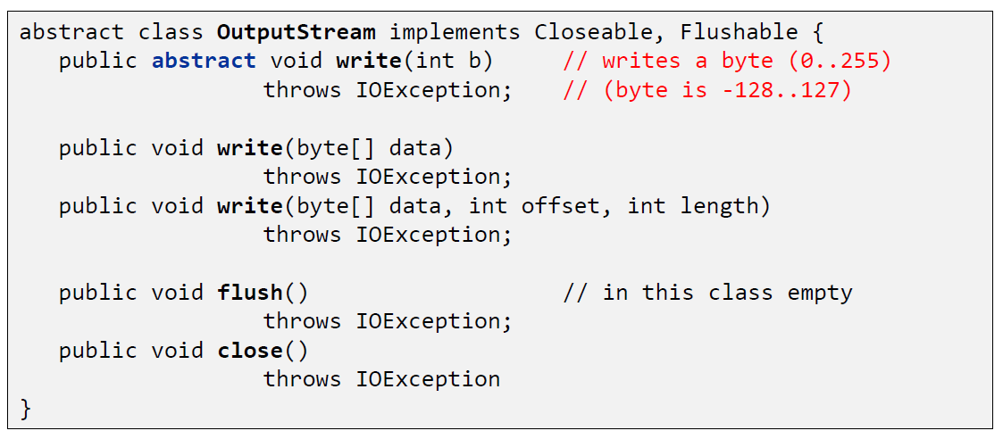

### InputStream

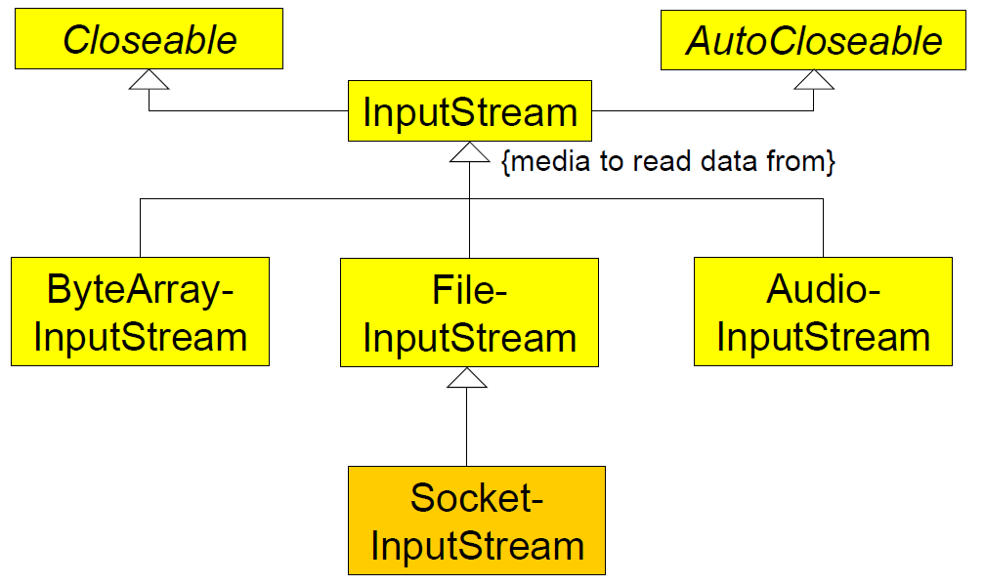

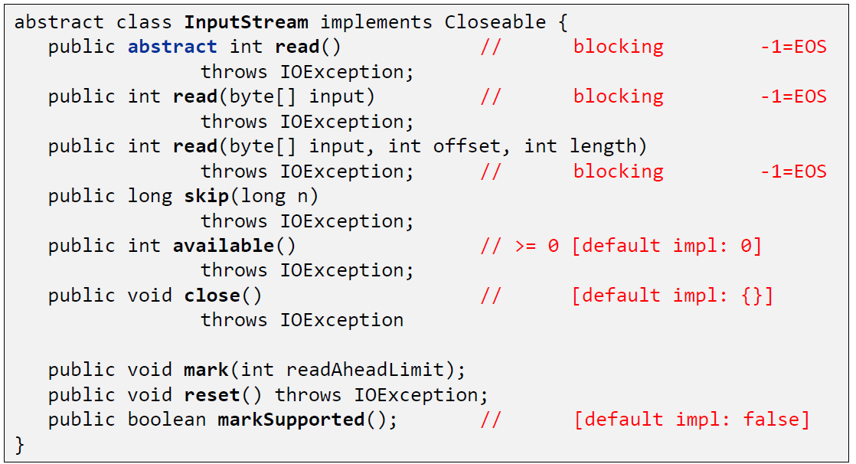

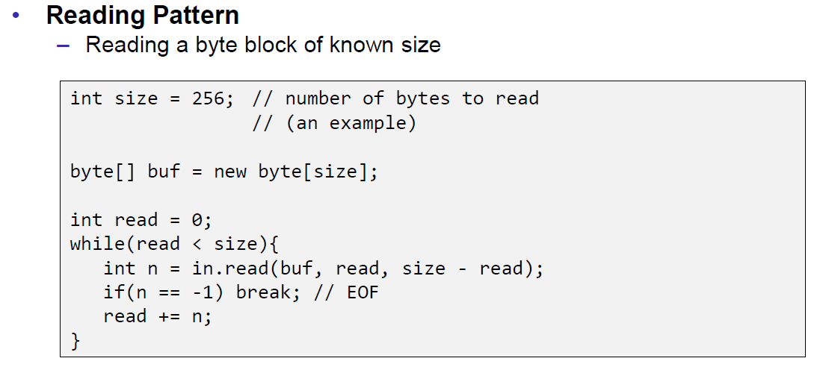

## Filter Streams

### FilterOutputStream

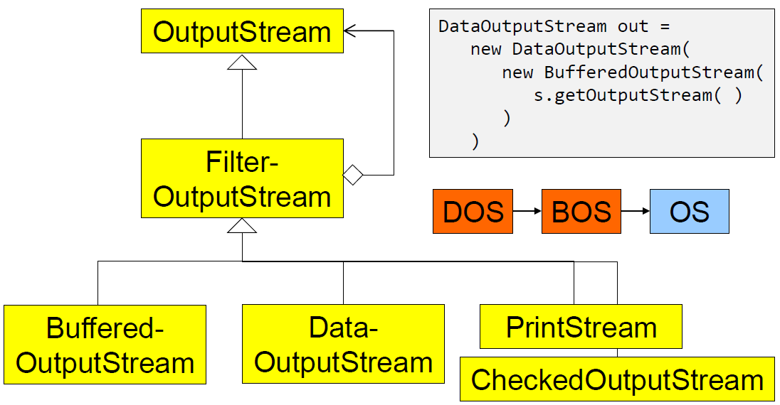

### DataOutputStream

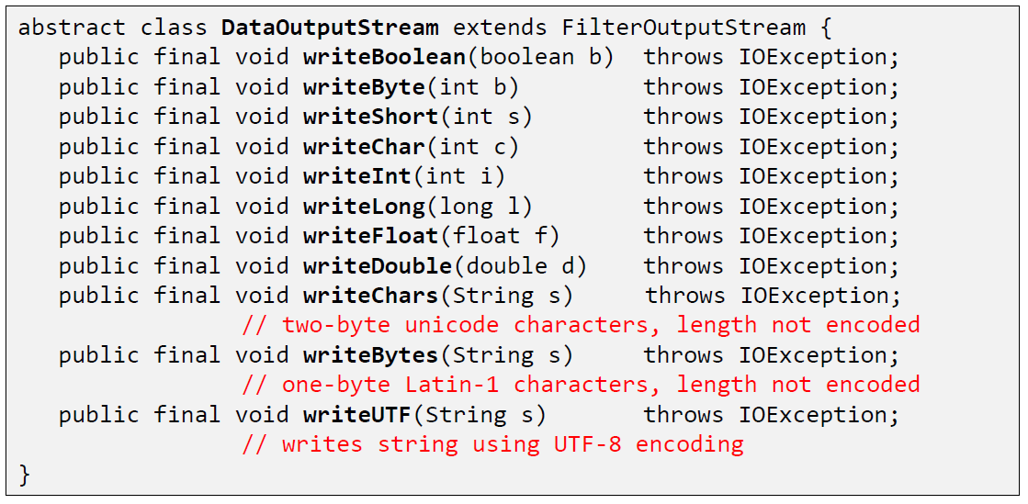

### DataOutputStream with writeInt

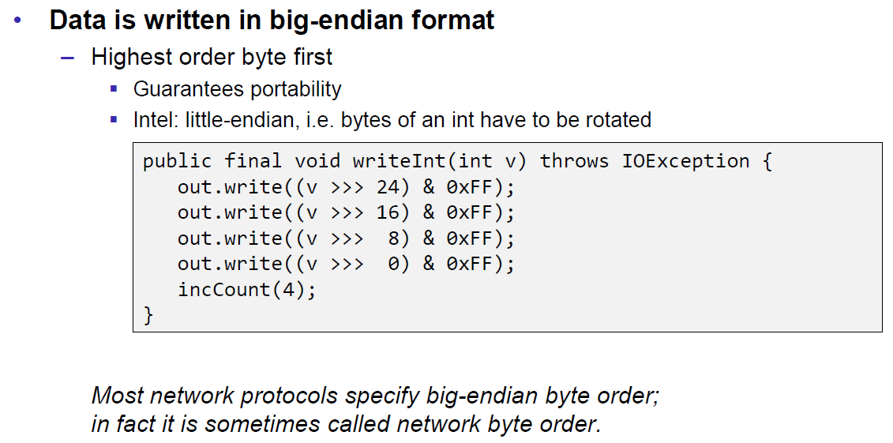

### DataOutputStream with writeUTF

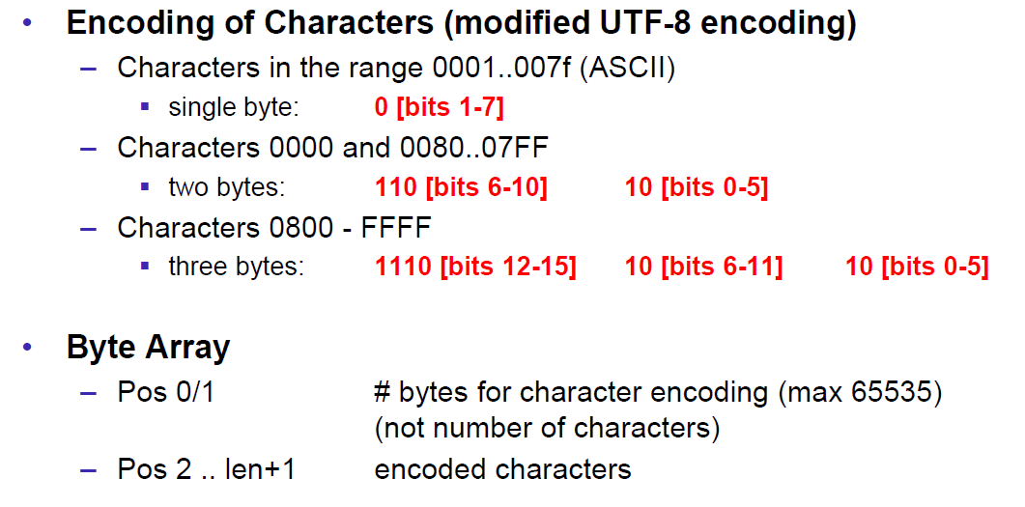

### PrintStream

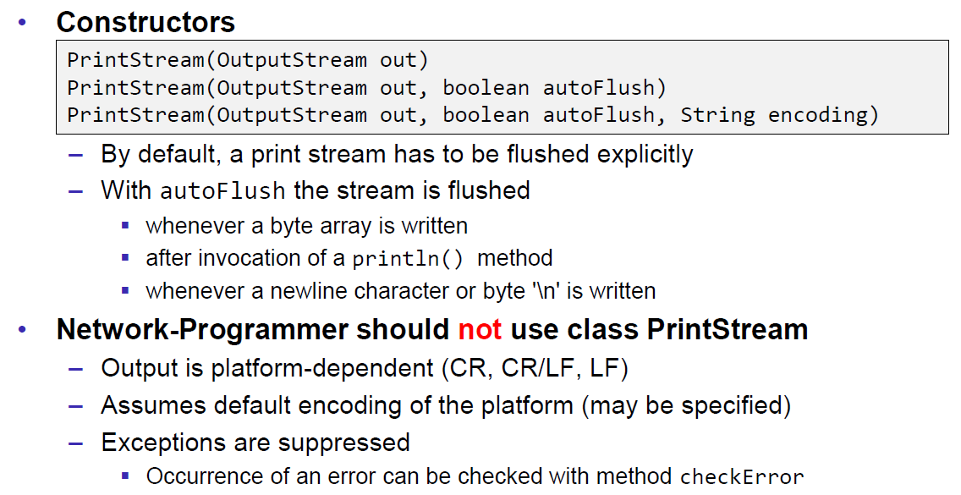

### FilterInputStream

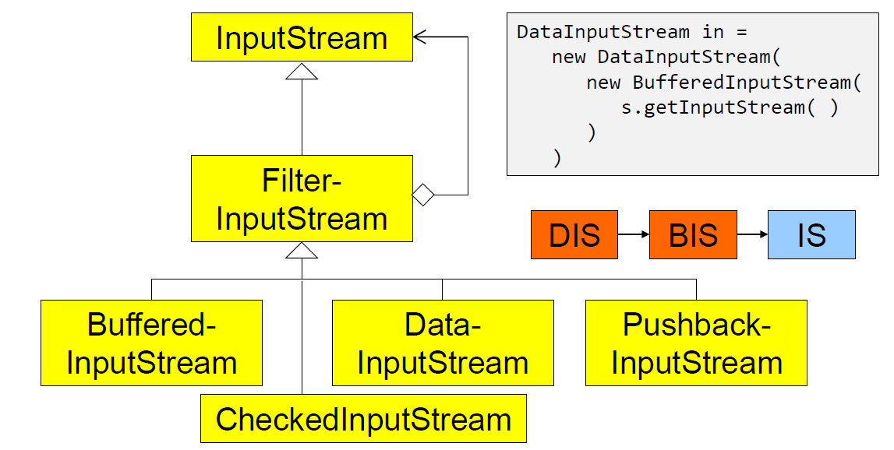

### DataInputStream

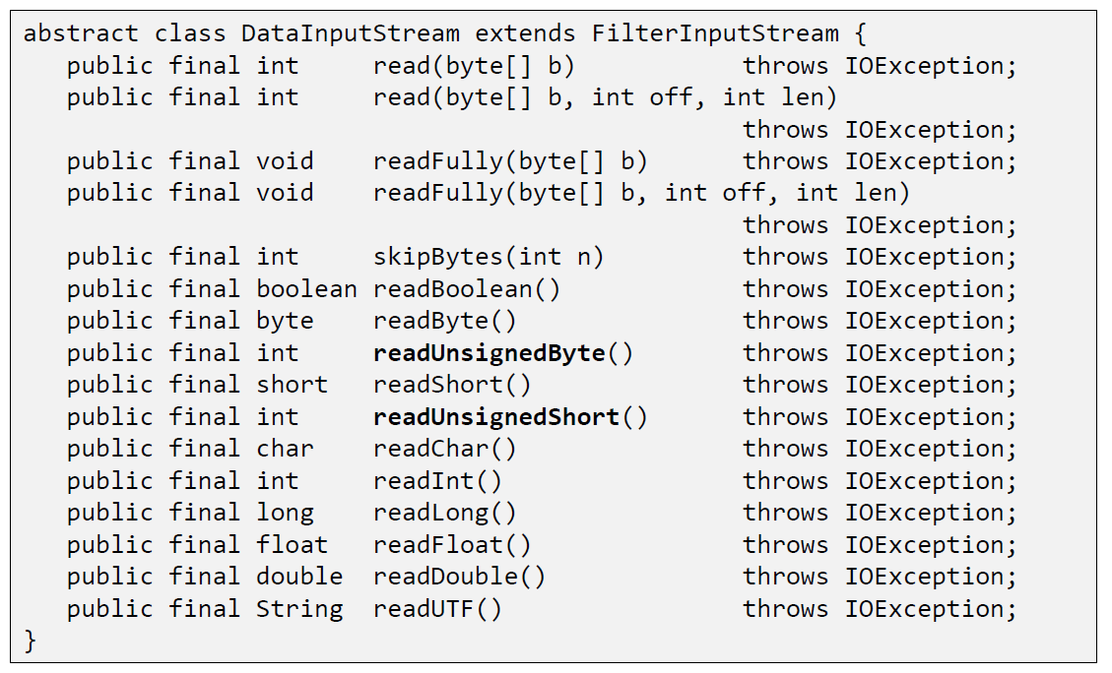

### DataInputStream with readFully

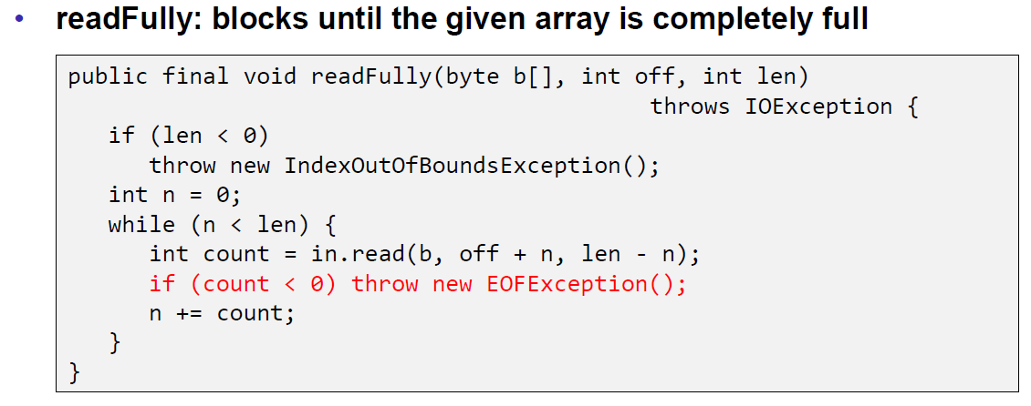

### Filter Streams

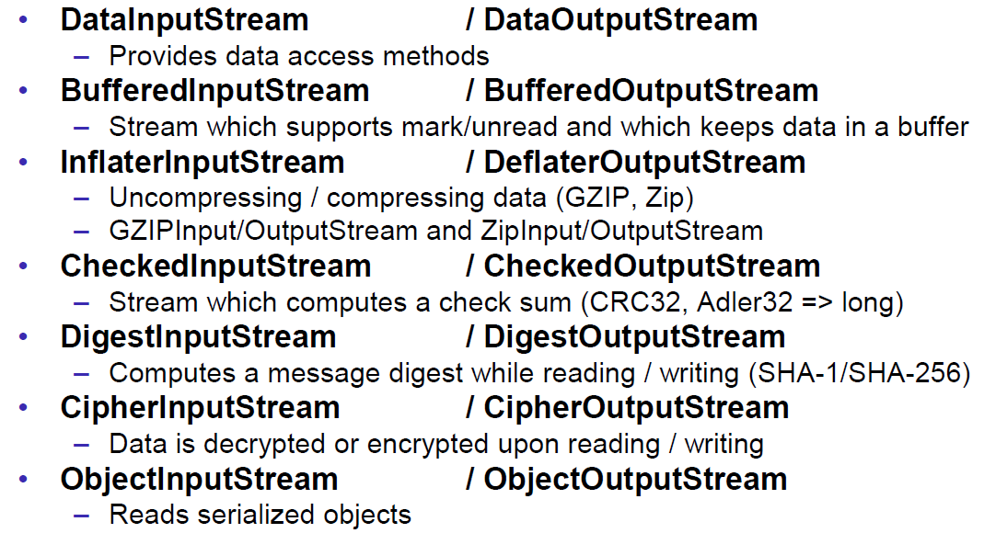

## Object Streams & Serialization

### ObjectStream

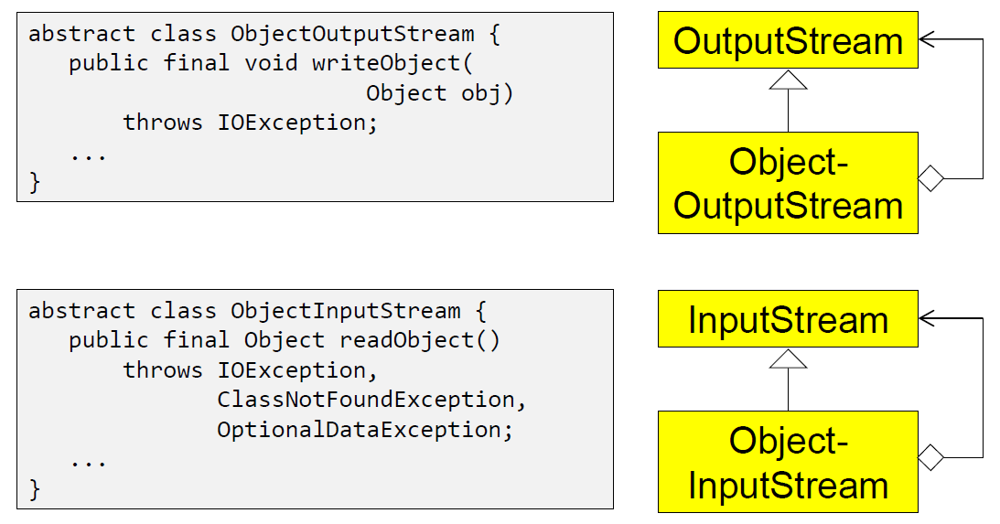

### Serialization with ObjectStream

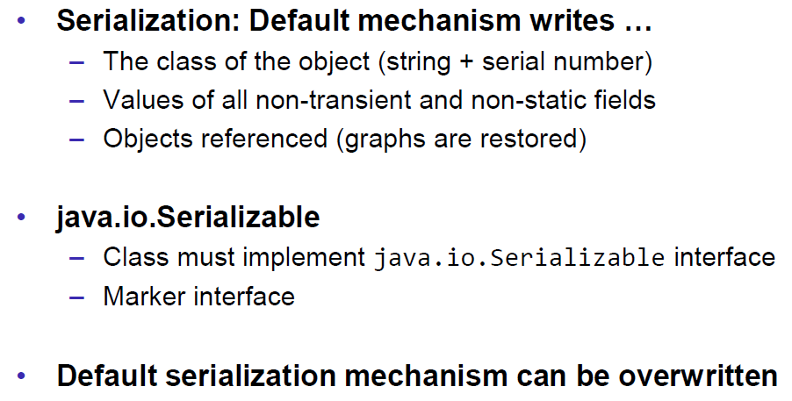

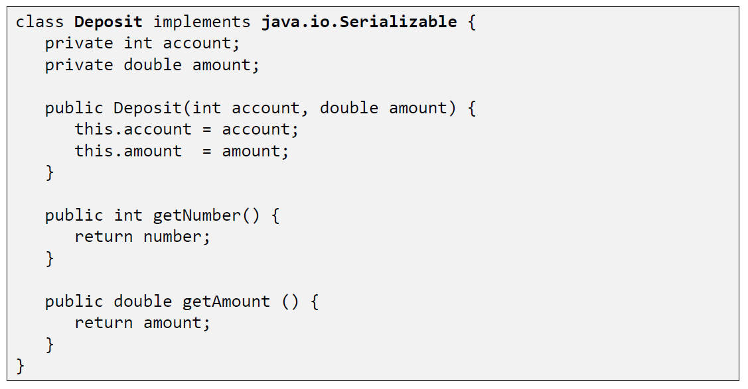

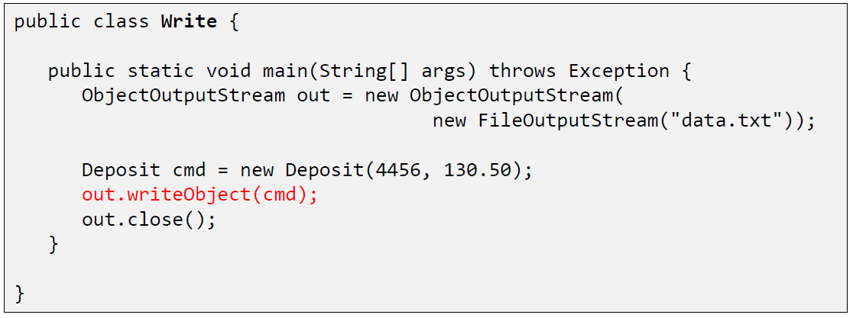

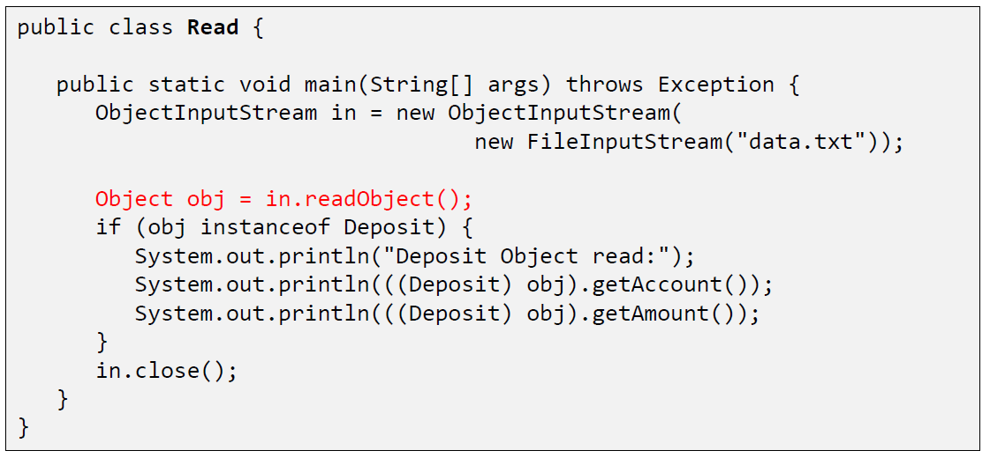

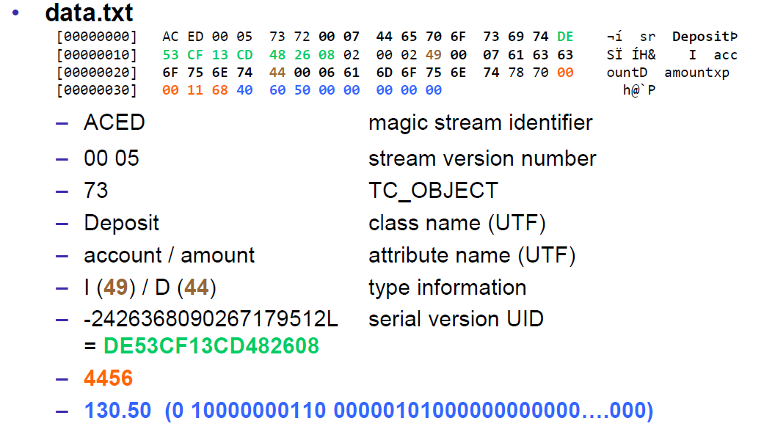

### Serial Version Number

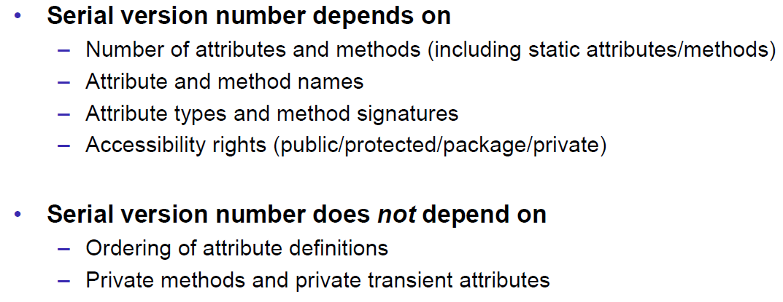

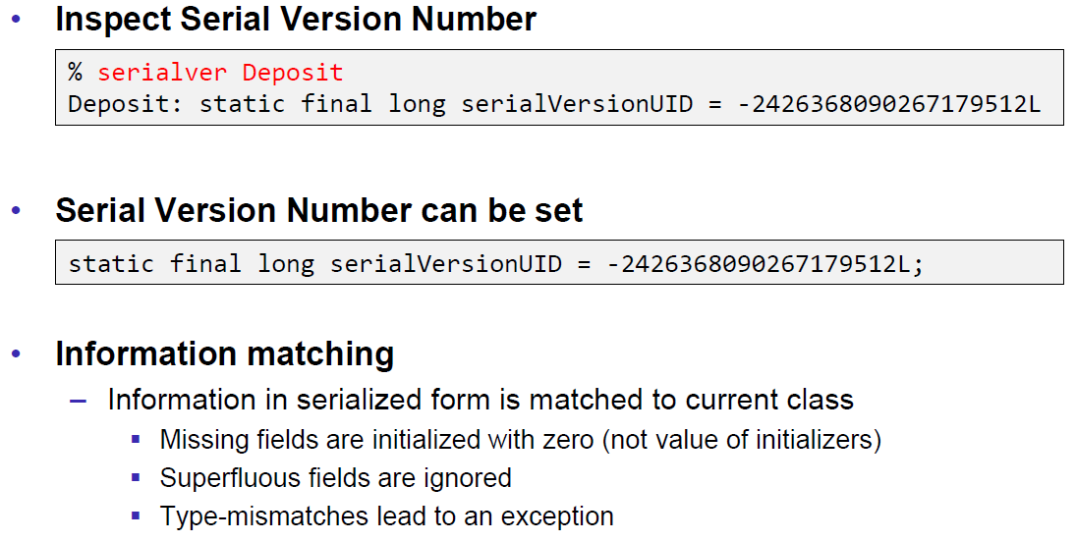

### Serialization Customization

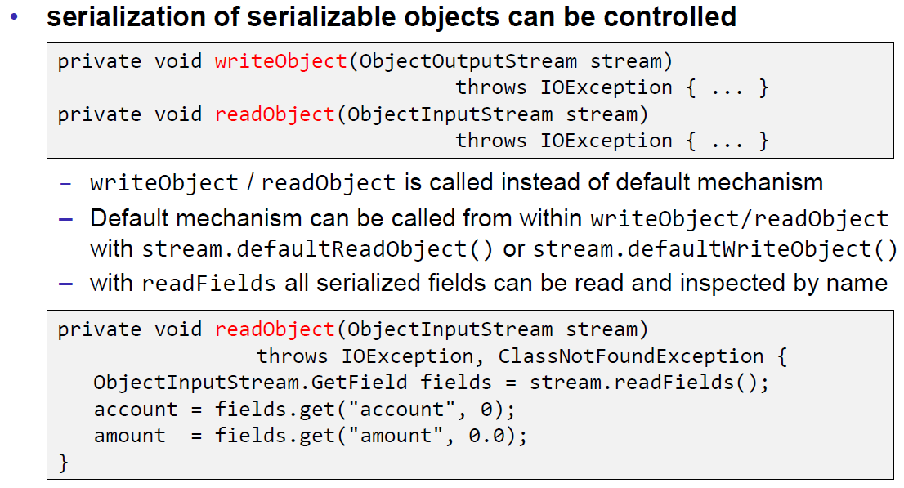

### Serialization Hints

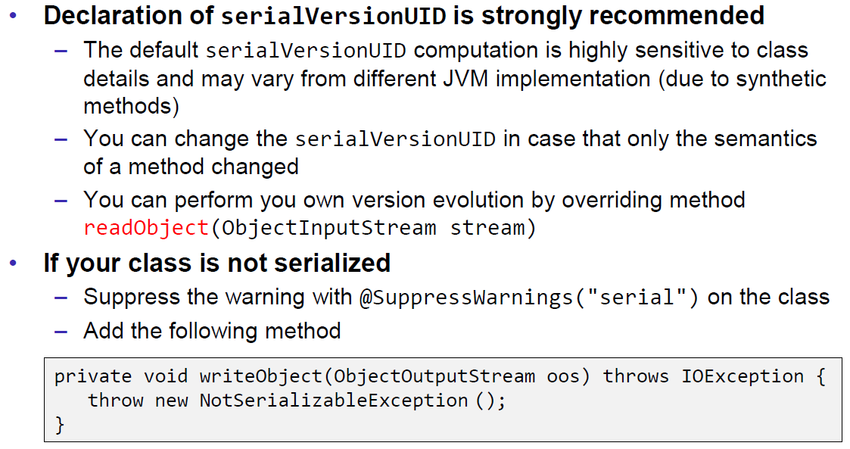

## Sending and Receiving Data

### Framing

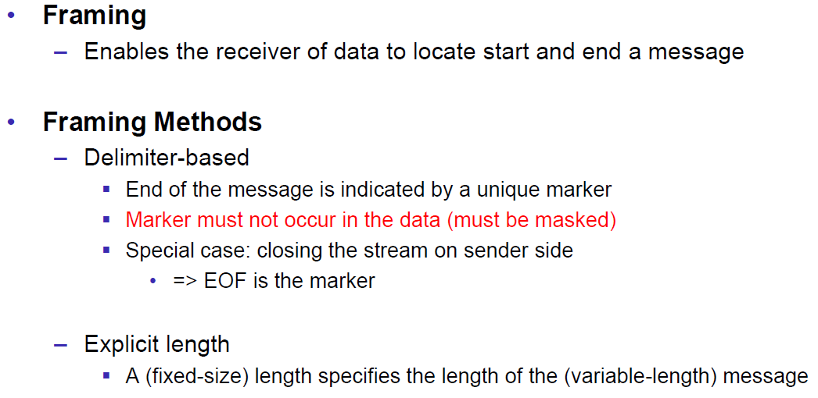

### Example of Framing

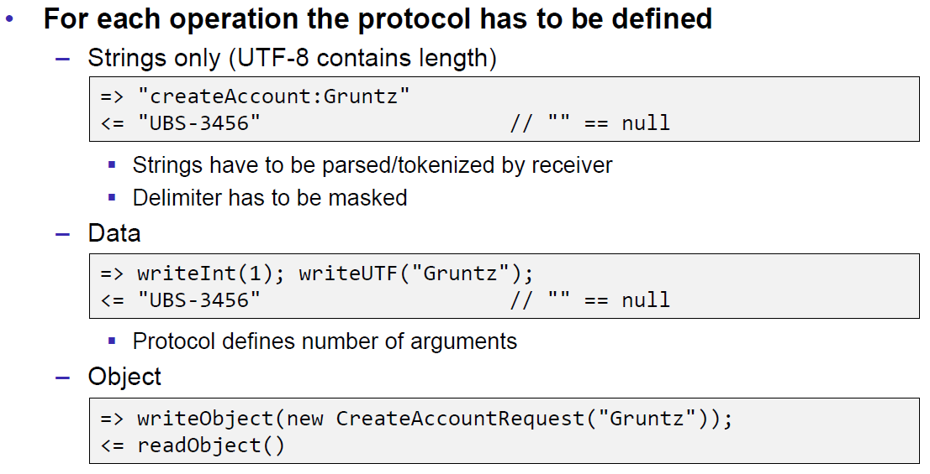

## Summary

### Whole Picture of Input Streams

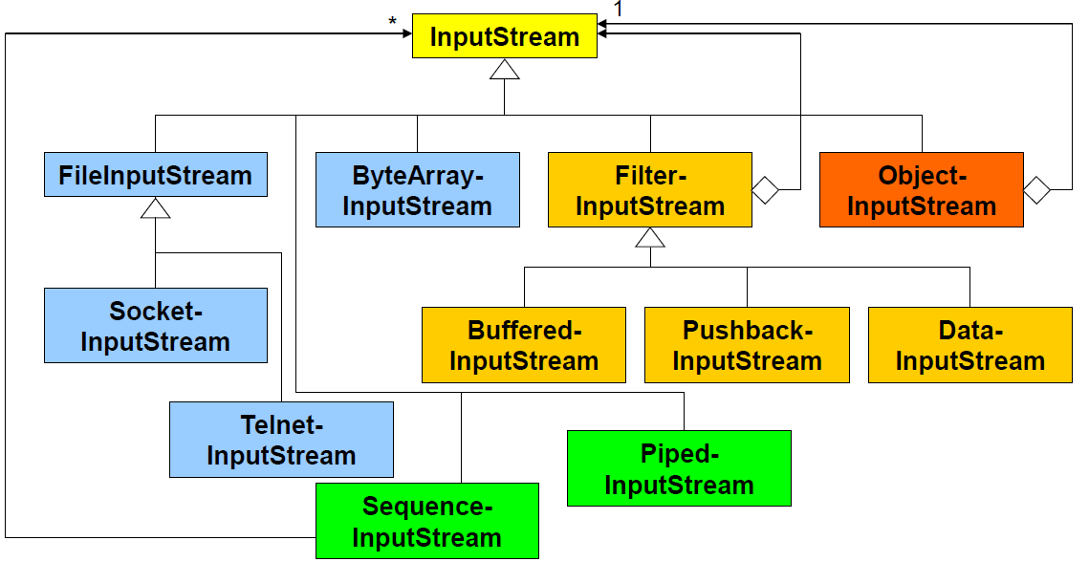

### Whole Picture of Output Streams

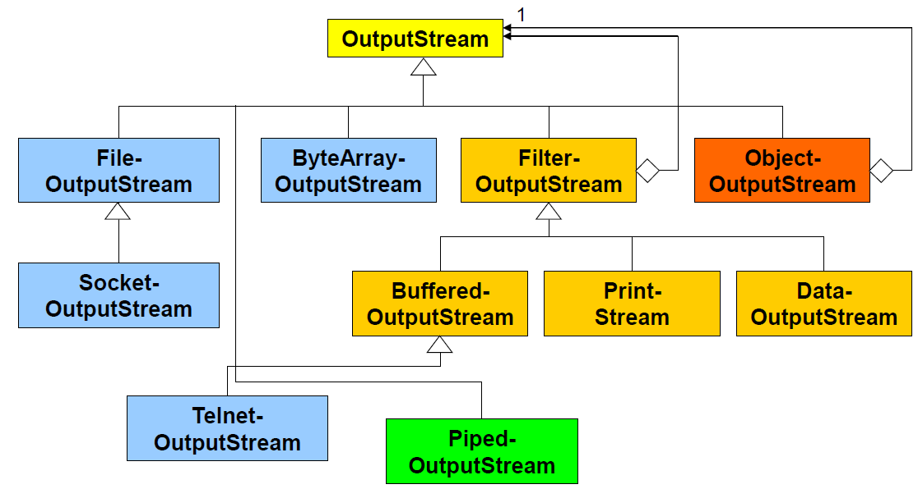

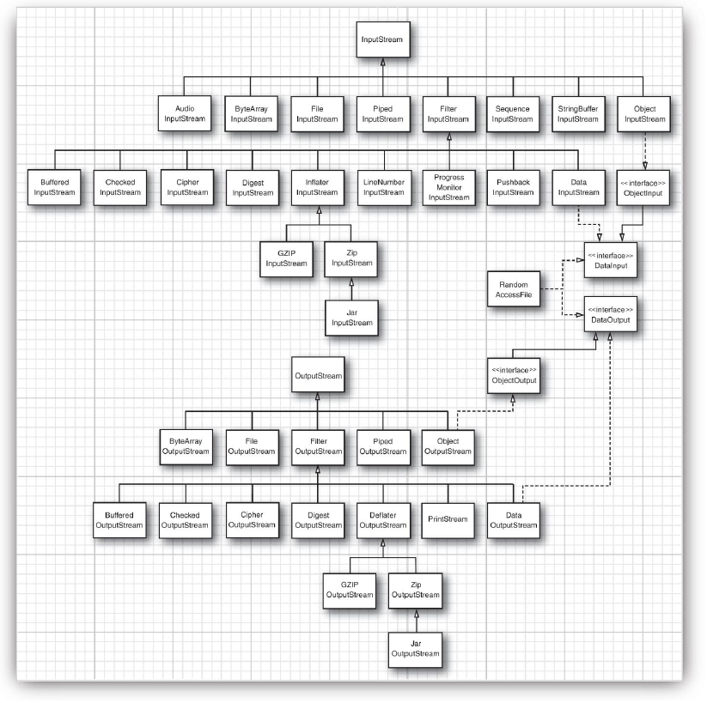

### Reading and Writing Text (Unicode Strings)

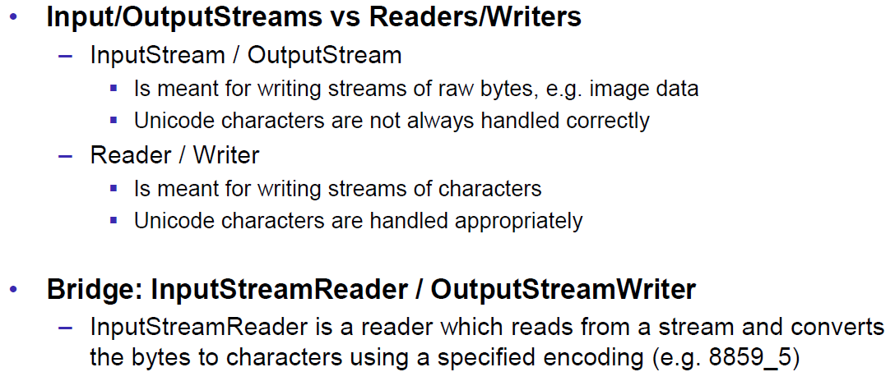

### Whole Picture of Reader

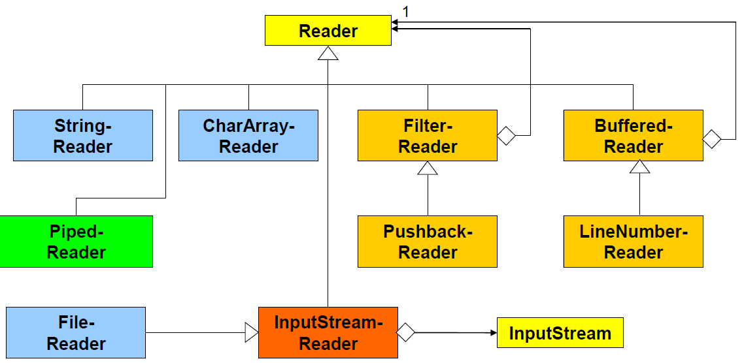

### Whole Picture of Writer

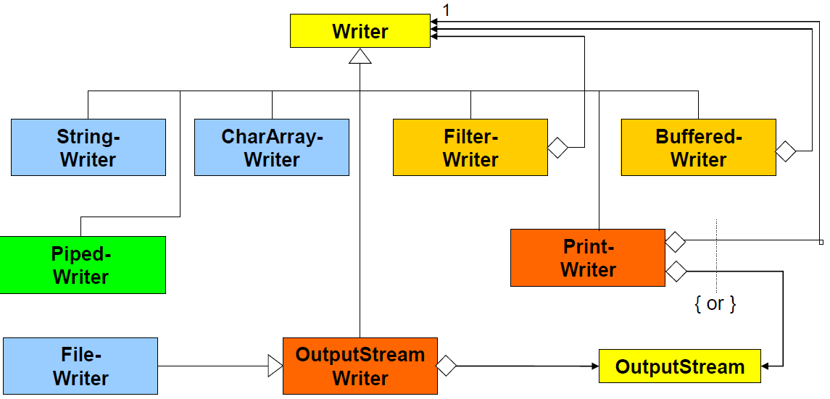

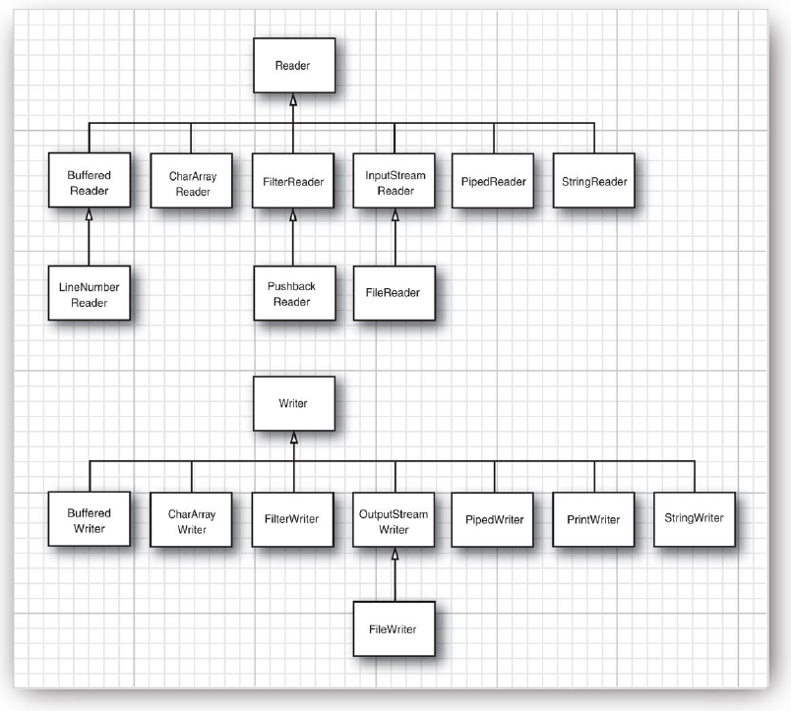

## Controlling Socket Behaviors

### Blocking and Timeouts

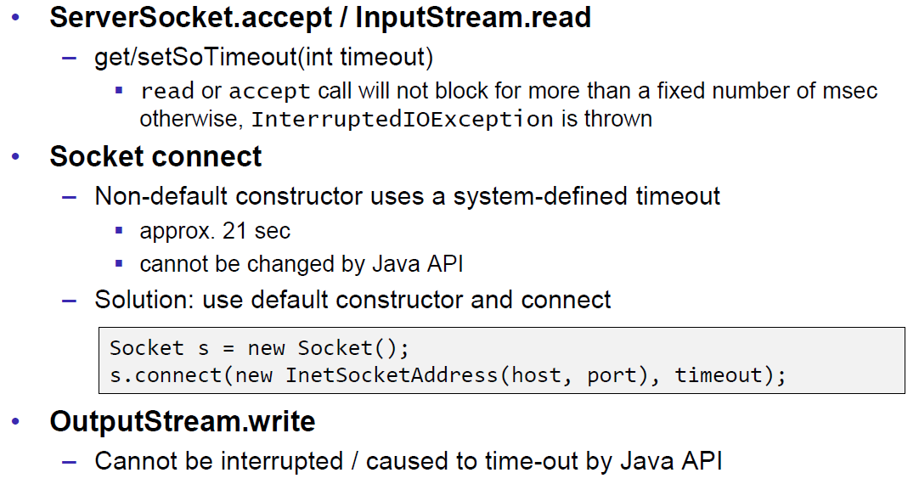

### Send and Receive Buffer Size

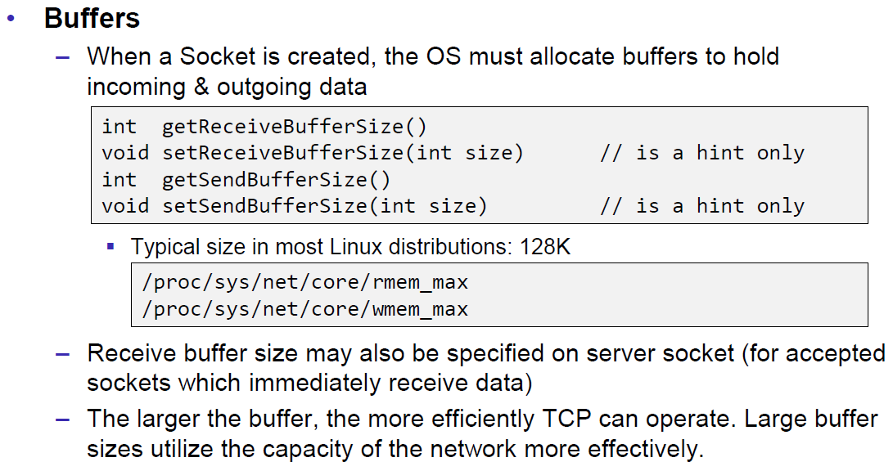

### Package Delay

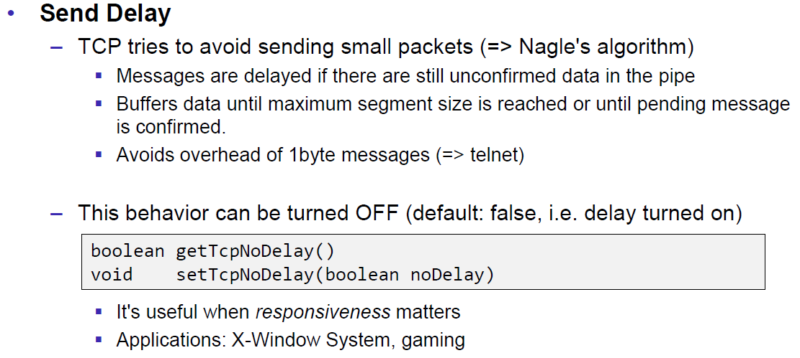

## Closing Connections

### Closing Connections

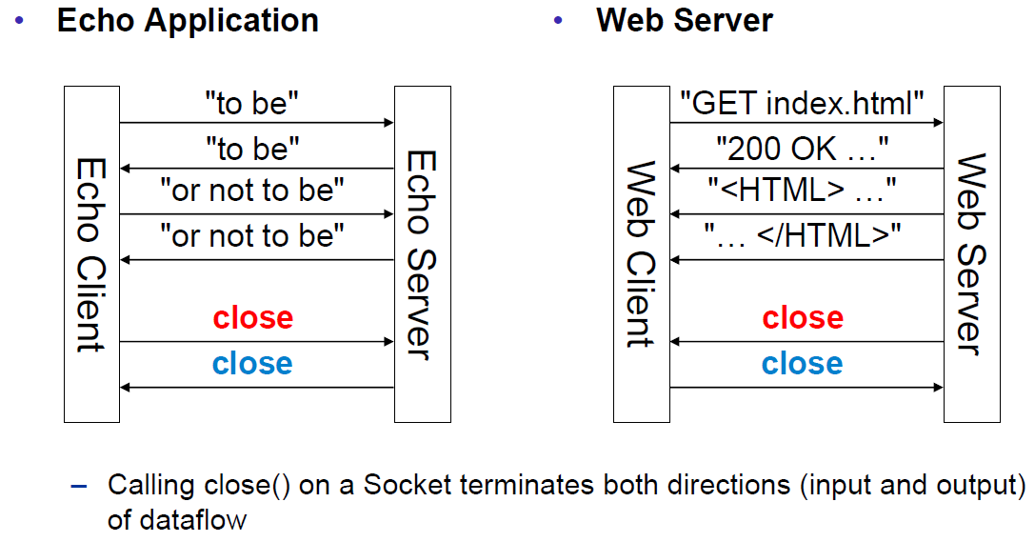

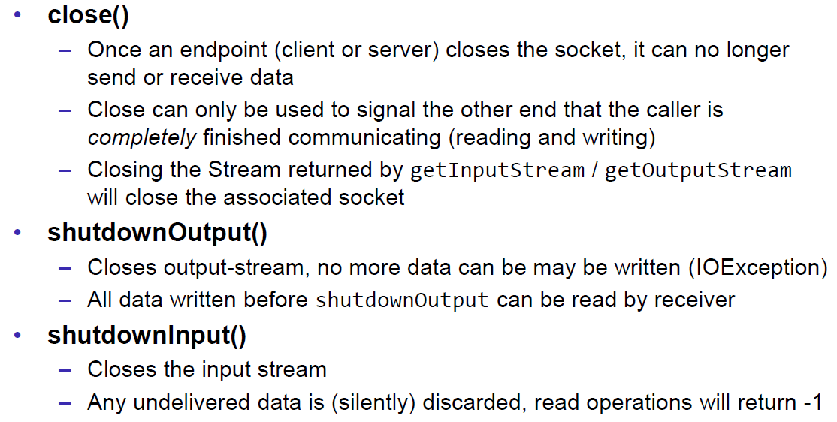

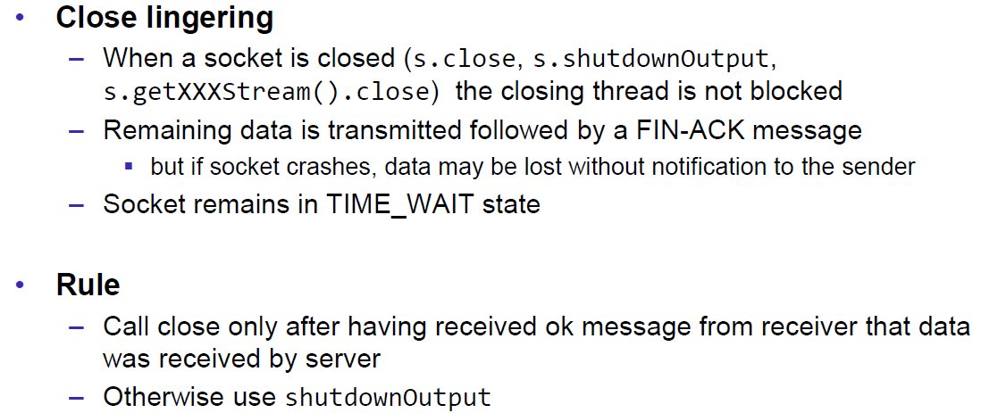

### Example of a Close Test

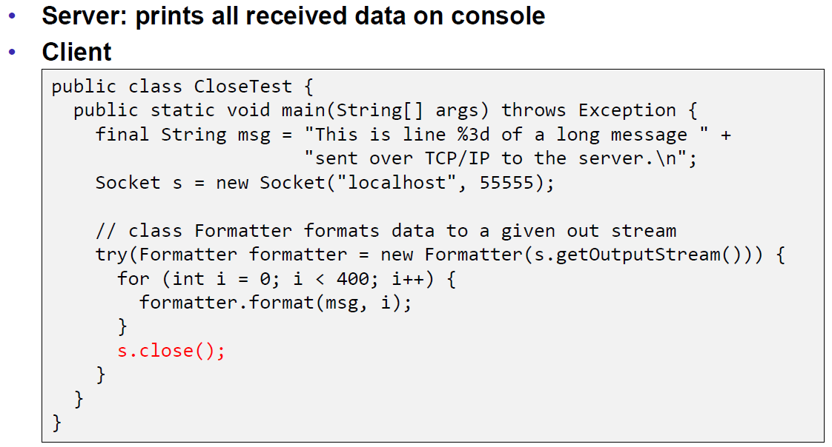

Problem: Some content of the formatter is not received by the server.

Solution: Flush the formatter before you close the socket, otherwise the buffer of the formatter won’t be sent.

### Example of a Compression Server

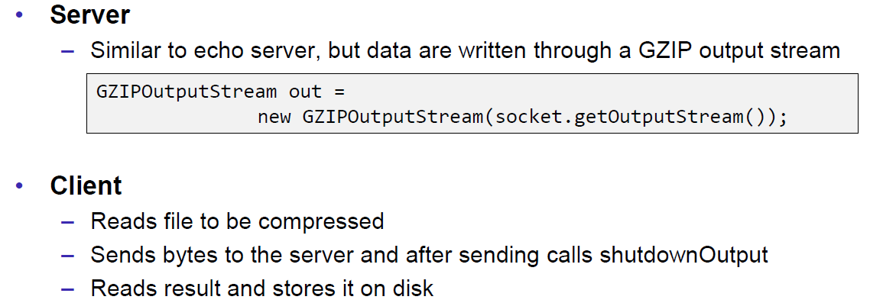

Problem: At some point, the server hangs up and doesn’t reply anymore.

Solution: Don’t send all content before you start reading. Otherwise you will fill up the outgoing (sending) cache of the server (because no one is reading it) and the write process of the server becomes blocking (this prevents a data loss because the outgoing buffer is full). A solution to this problem is to write and read block by block or to start the send process in a separate thread (Both happens in the client), so the client is able to immediately read the result and prevents a full sender buffer of the server.

## UDP Sockets

### UDP (User Datagram Protocol)

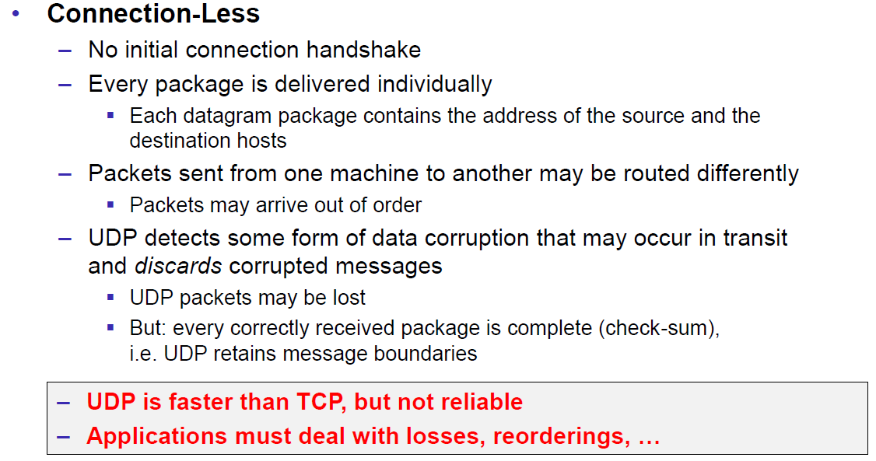

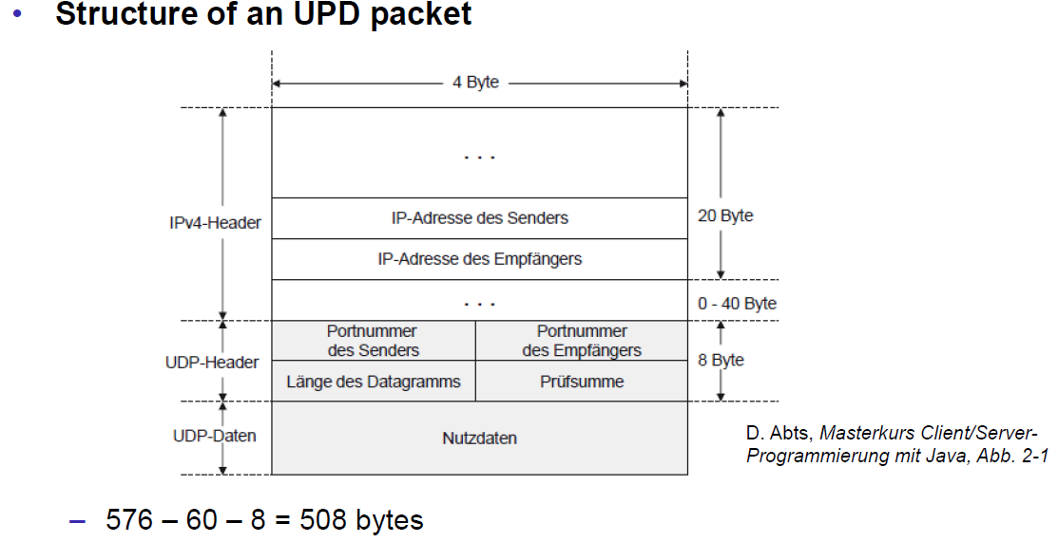

### Java Classes for Datagram

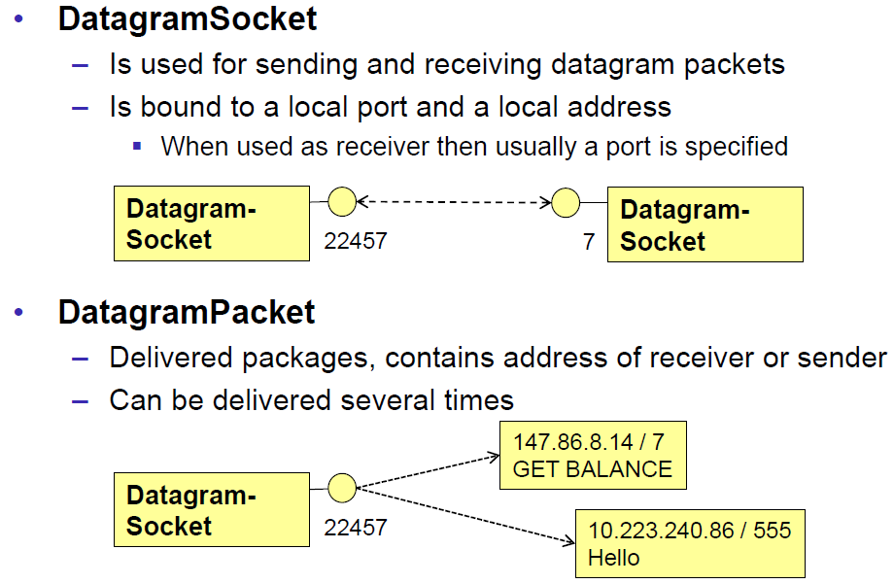

### DatagramSocket

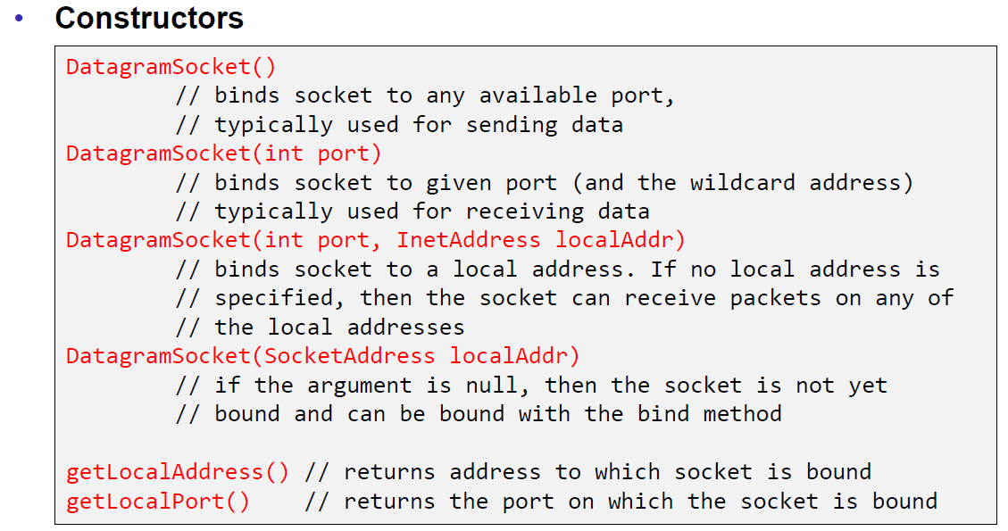

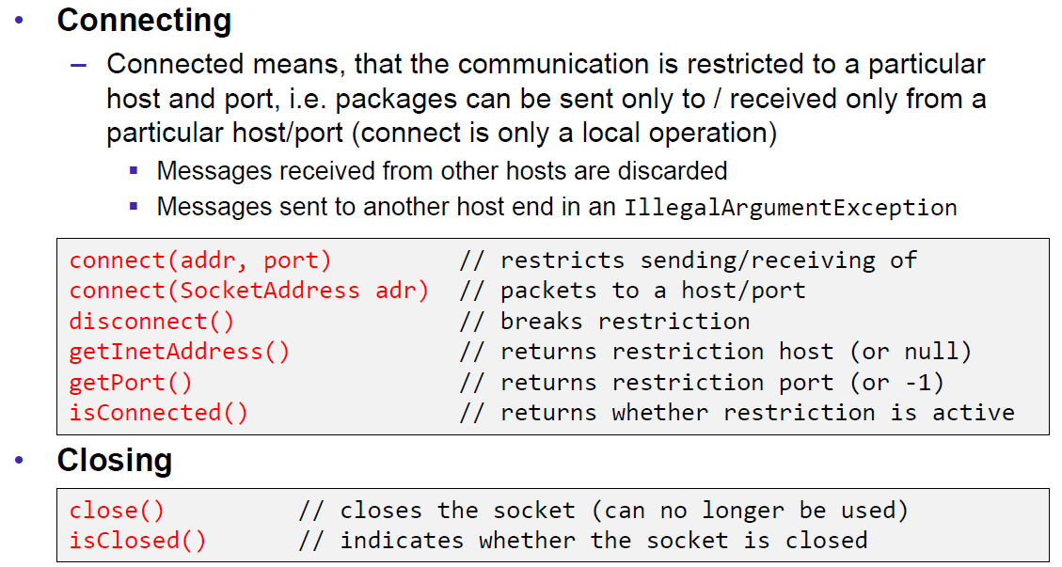

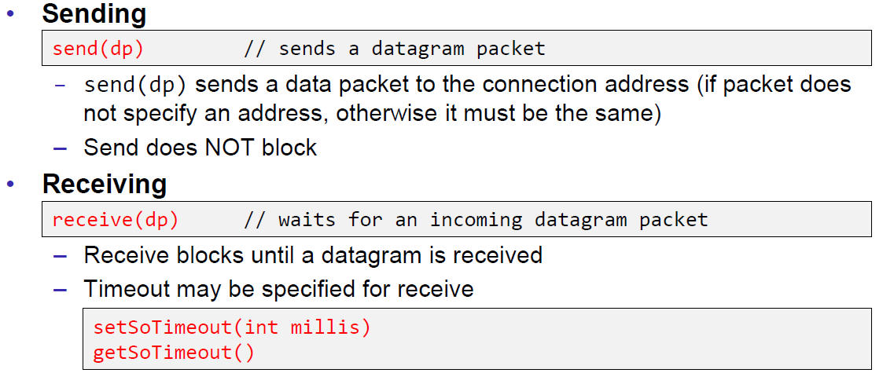

### DatagramPacket

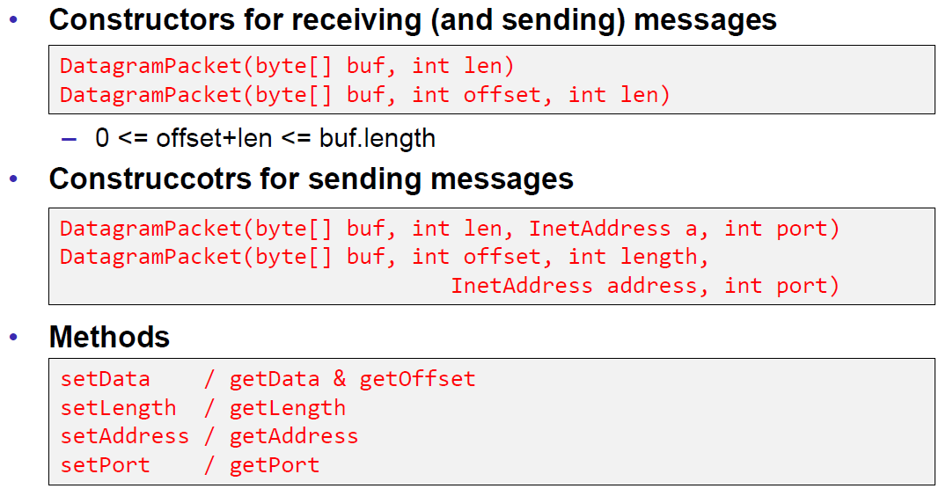

### Example of a UDP Server and Client

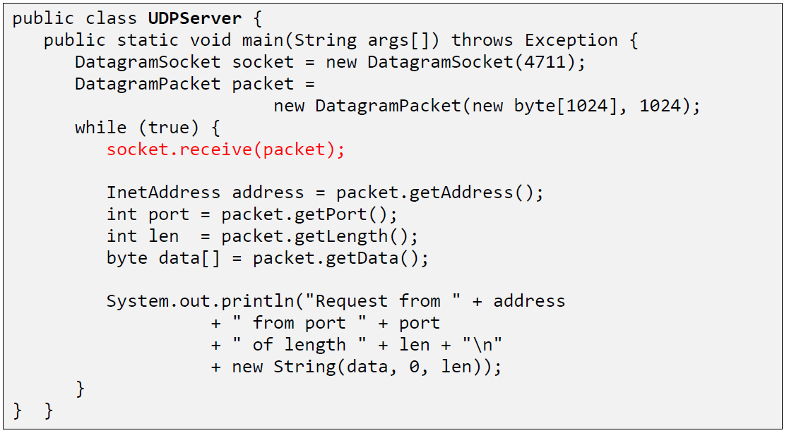

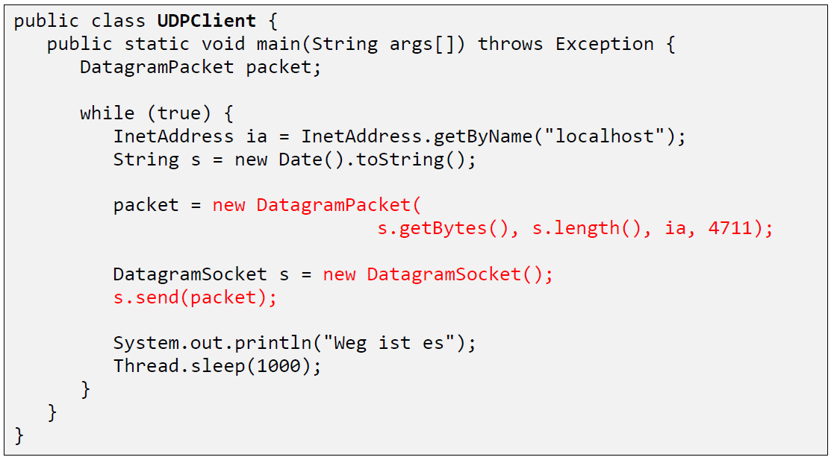

### UDP Implementation

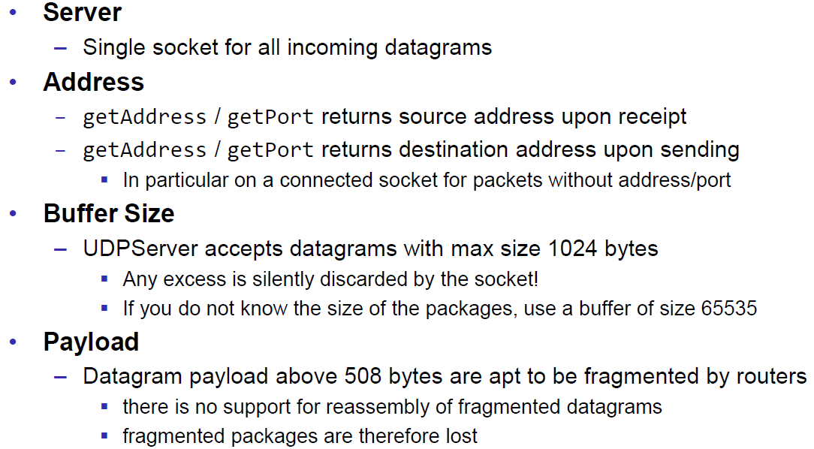

### Reliable UDP

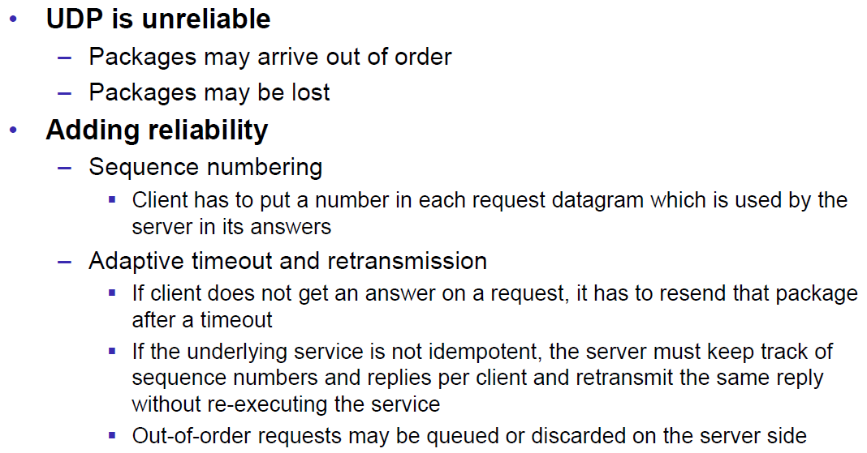

# Woche 3

## HTTP Protocol

### IETF RFC

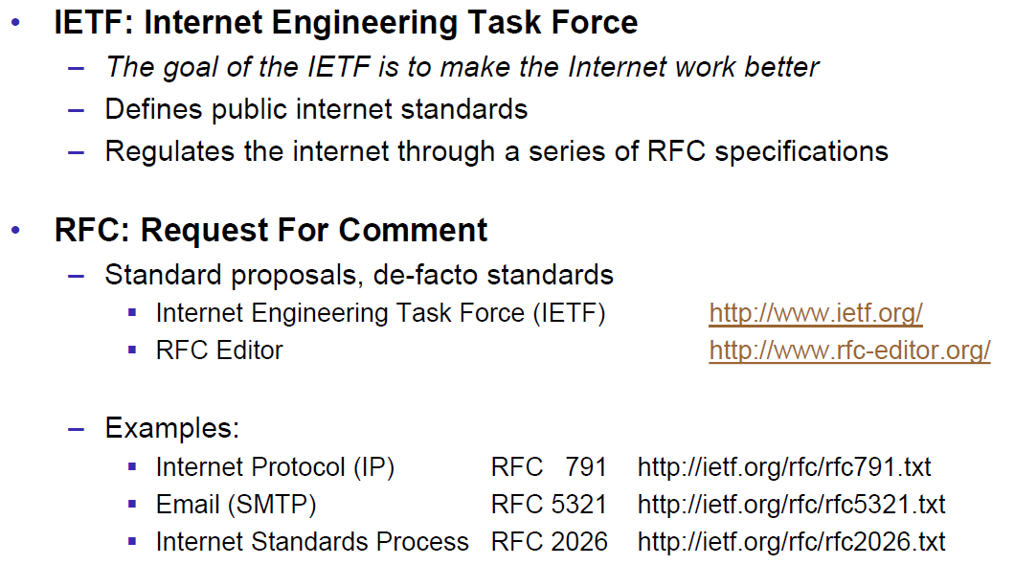

### HTTP Protocol

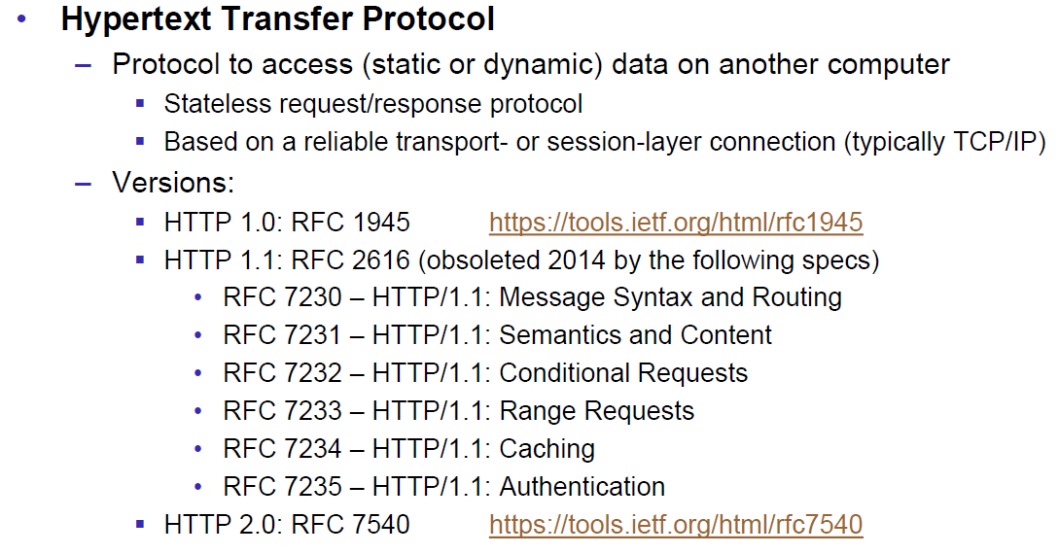

### HTTP Request

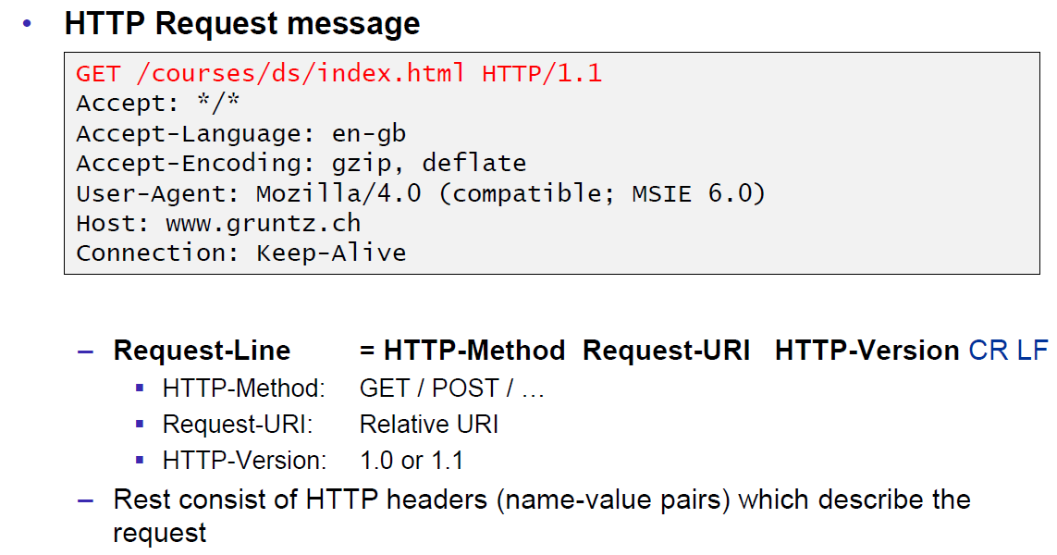

### HTTP Response

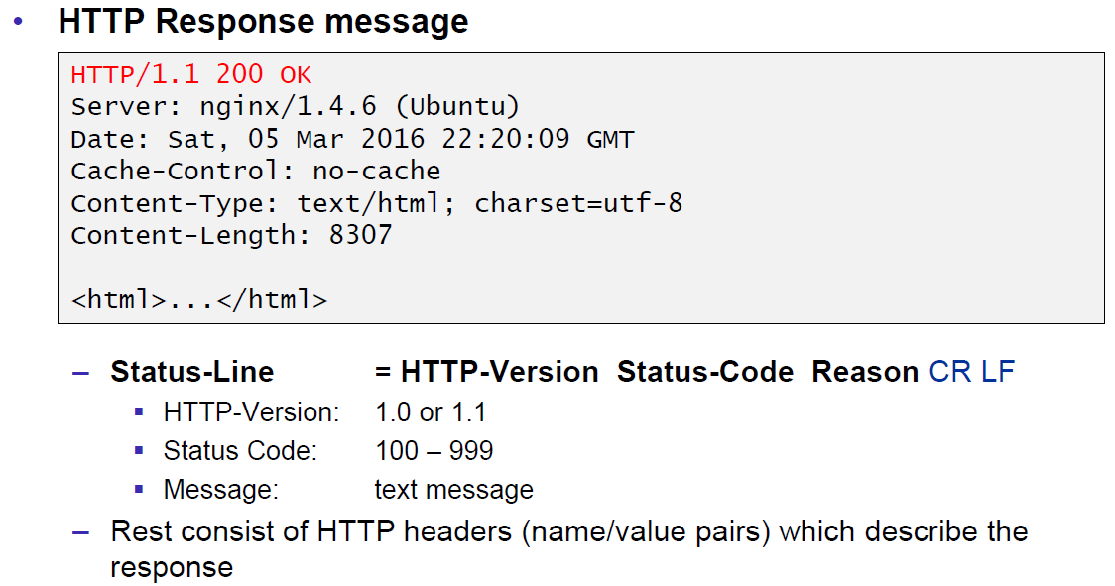

### HTTP Protocol

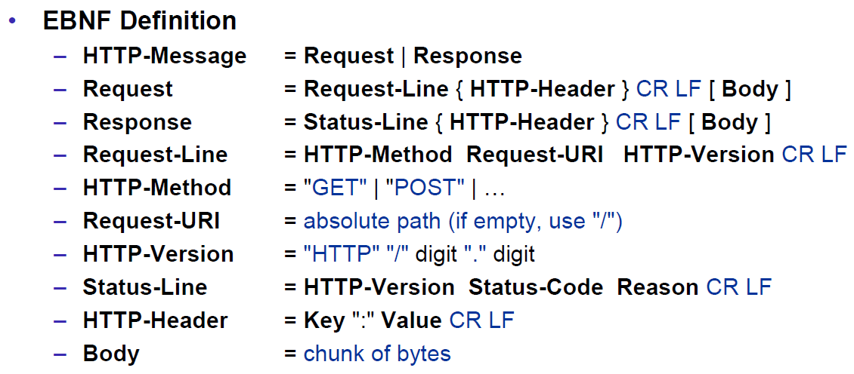

### HTTP Sample

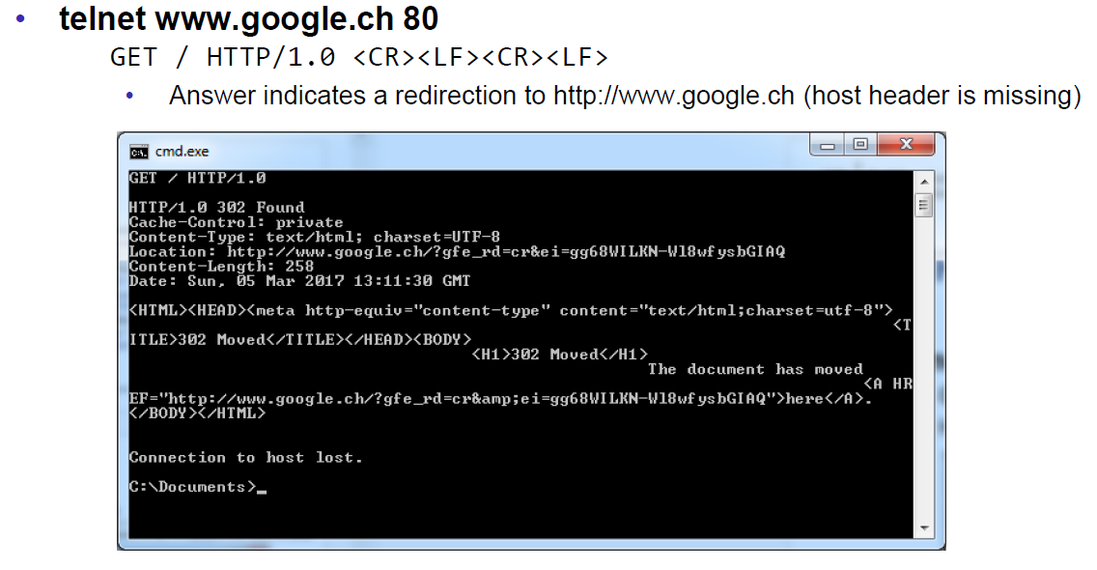

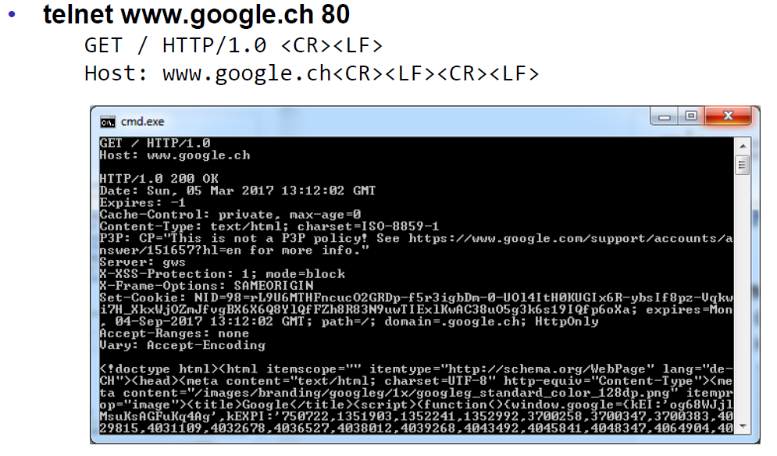

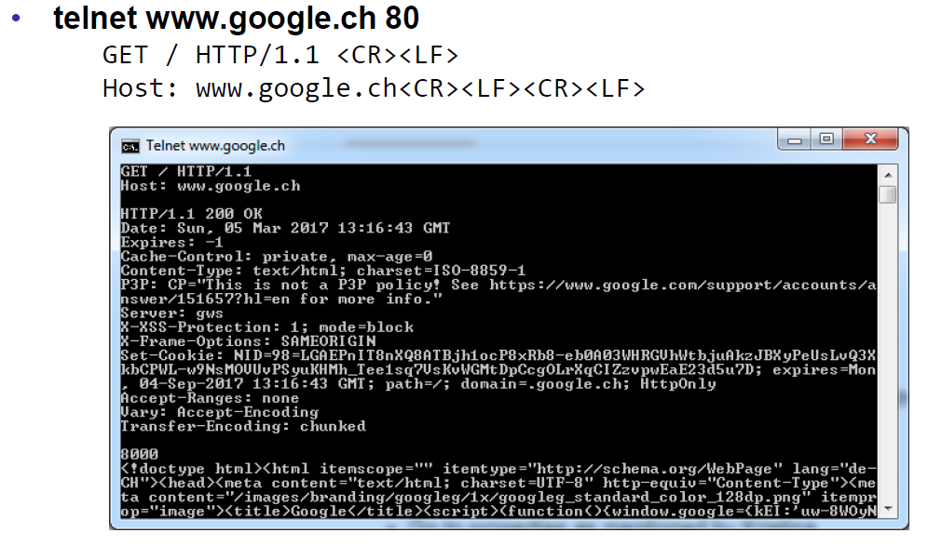

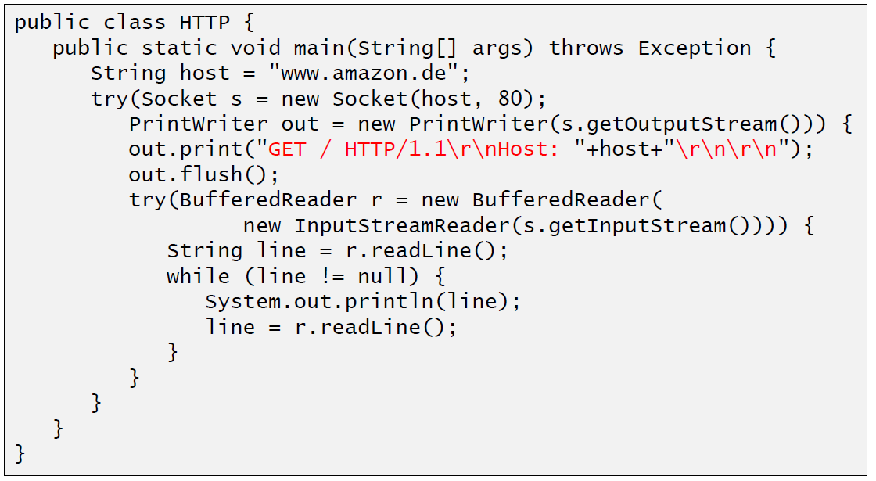

### HTTP 1.0 Request Methods

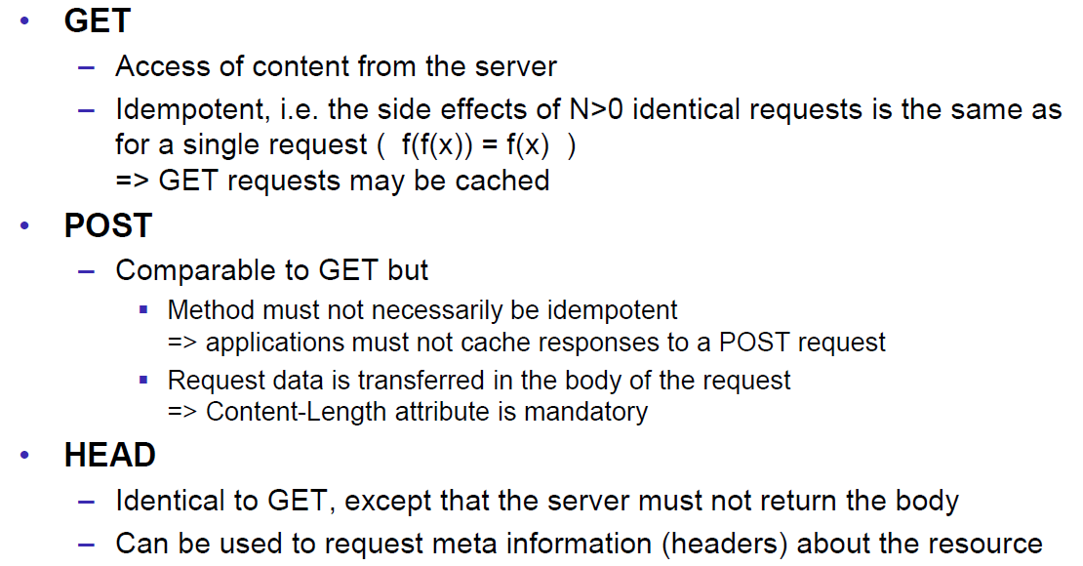

### HTTP Response Codes

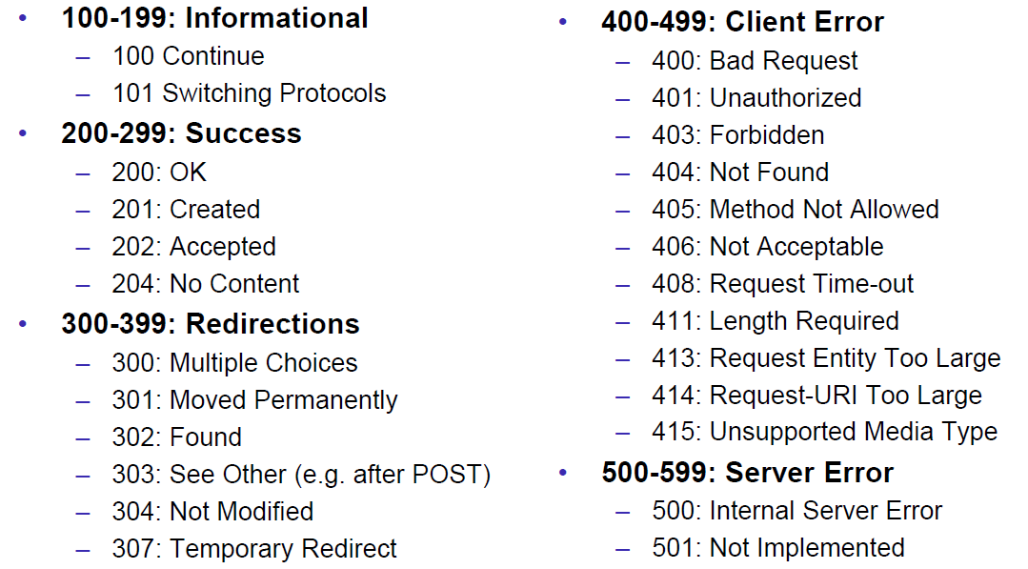

### HTTP Request Headers

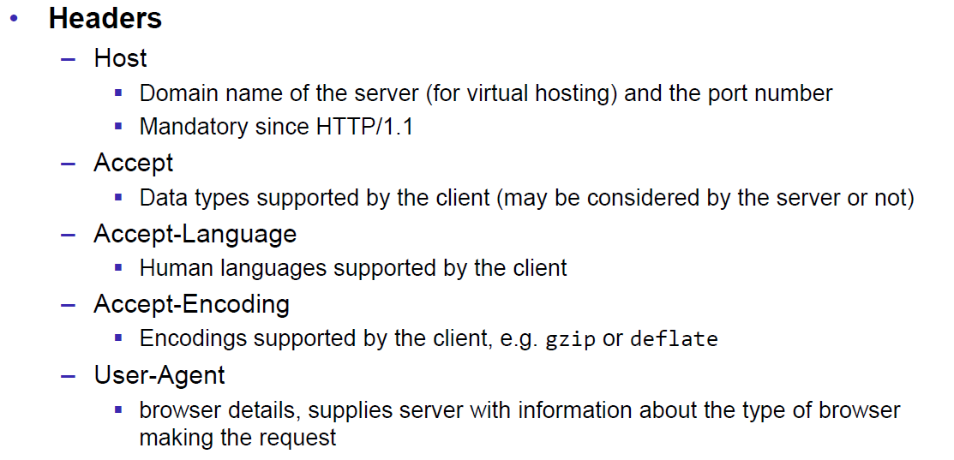

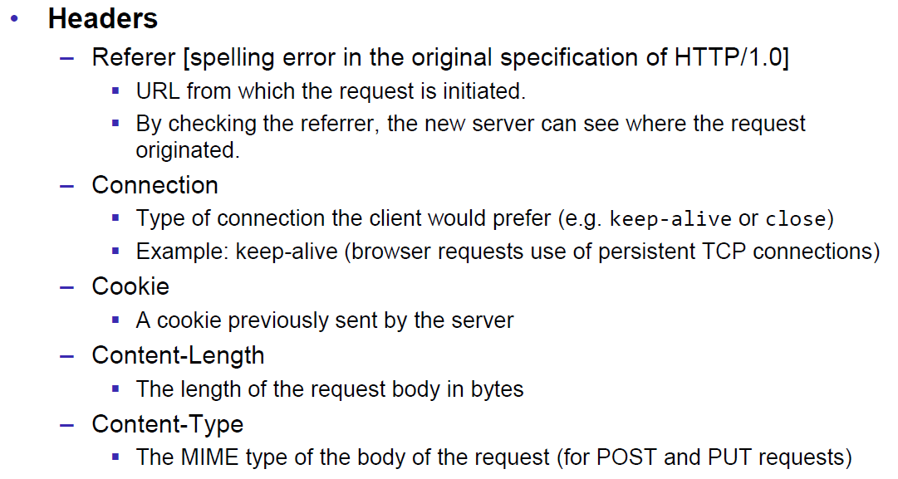

### HTTP Response Headers

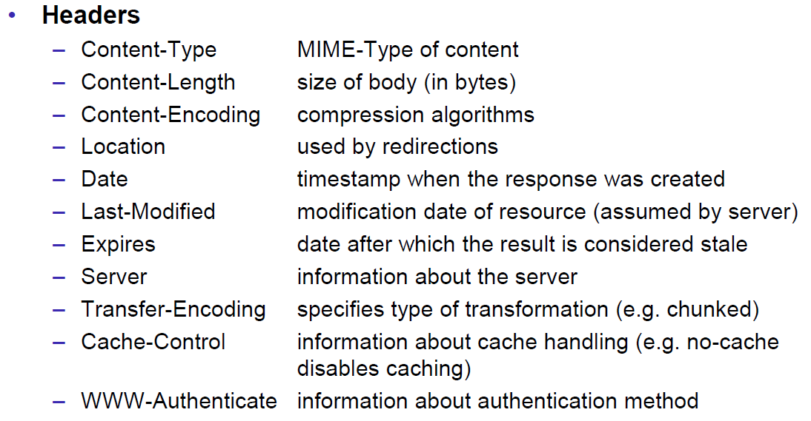

### MIME Types

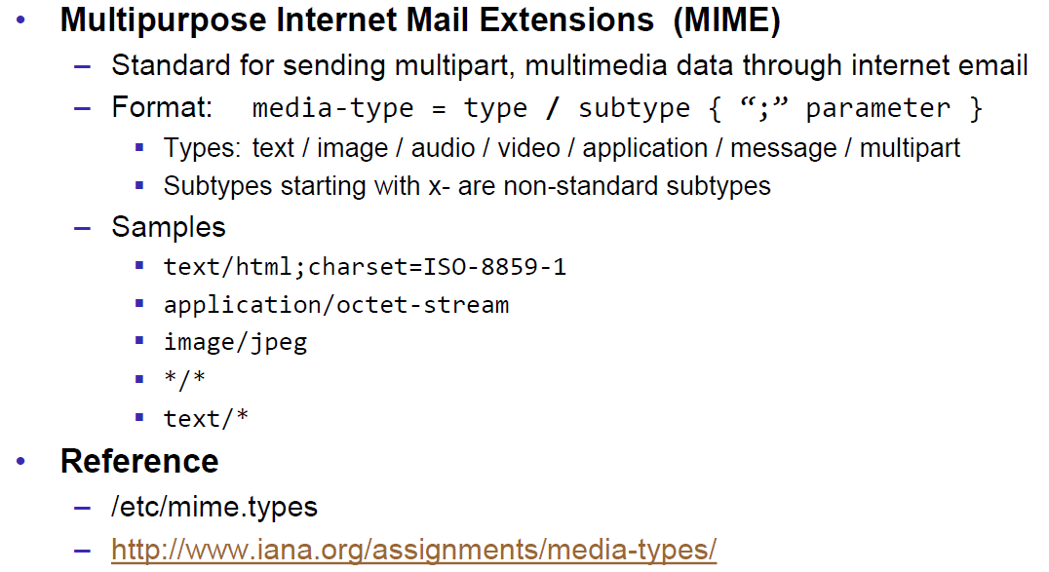

### HTTP Request/Response Sample

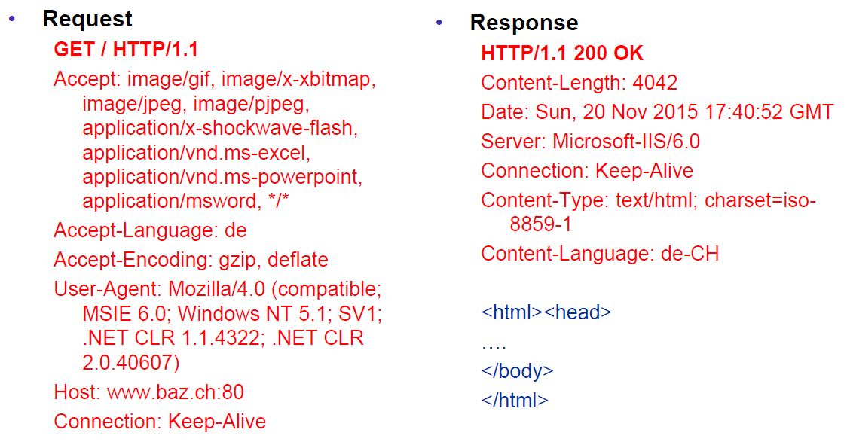

### HTTP 1.1 Enhancements

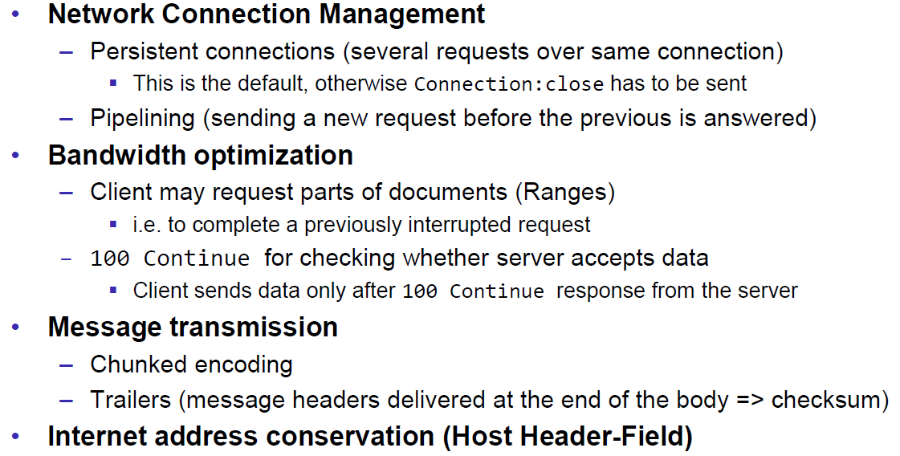

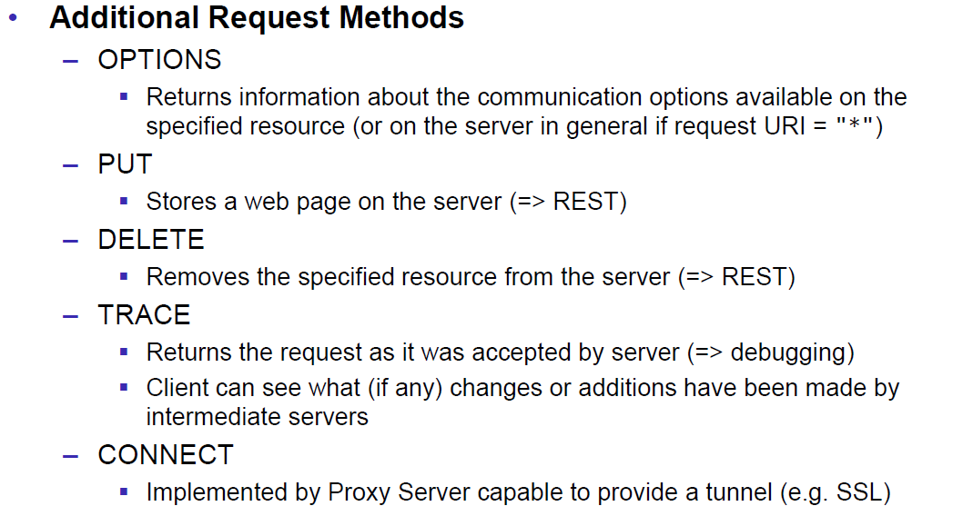

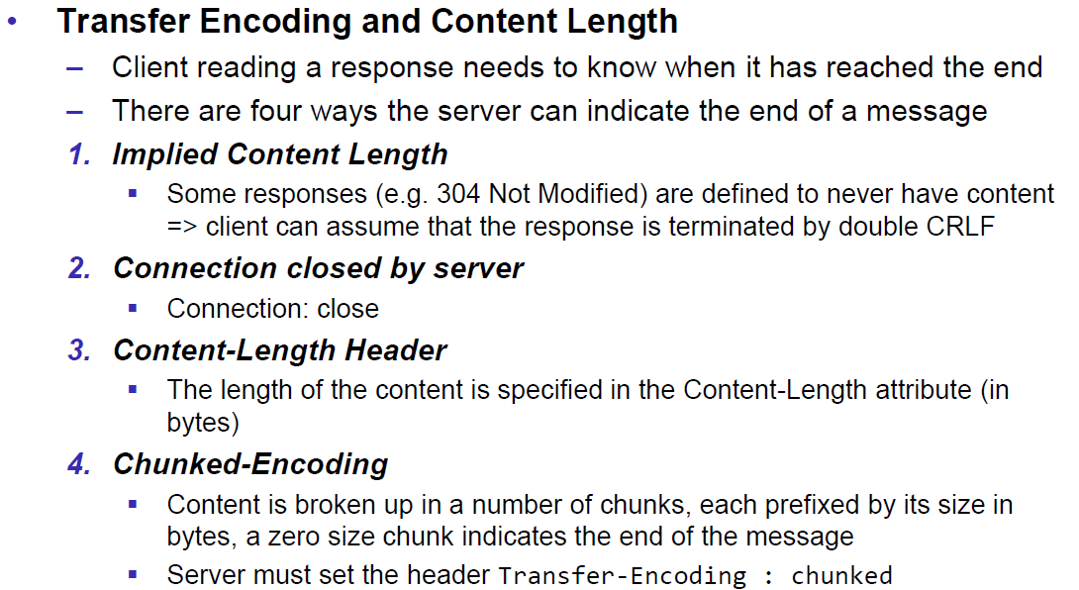

## HTTP Web Server

### A simple Web Server

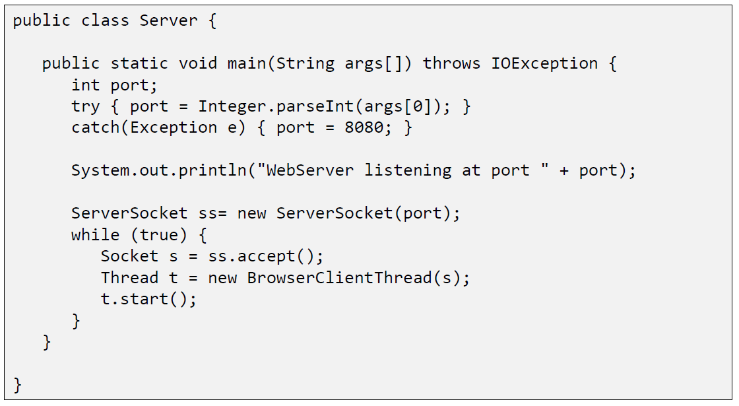

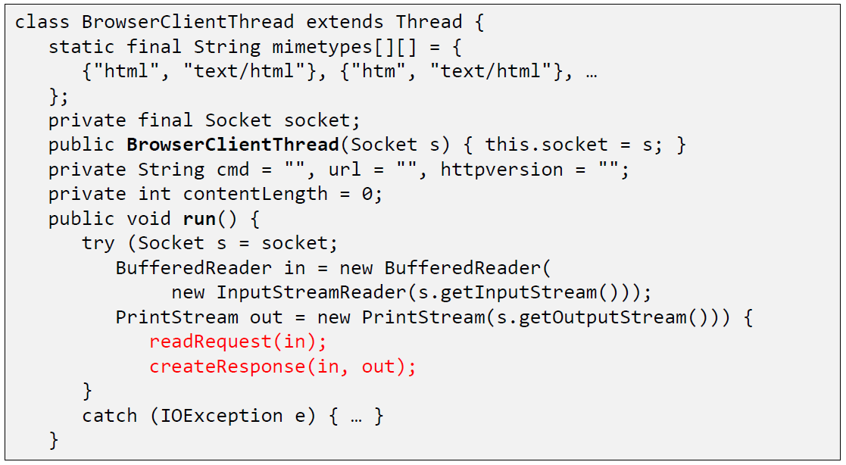

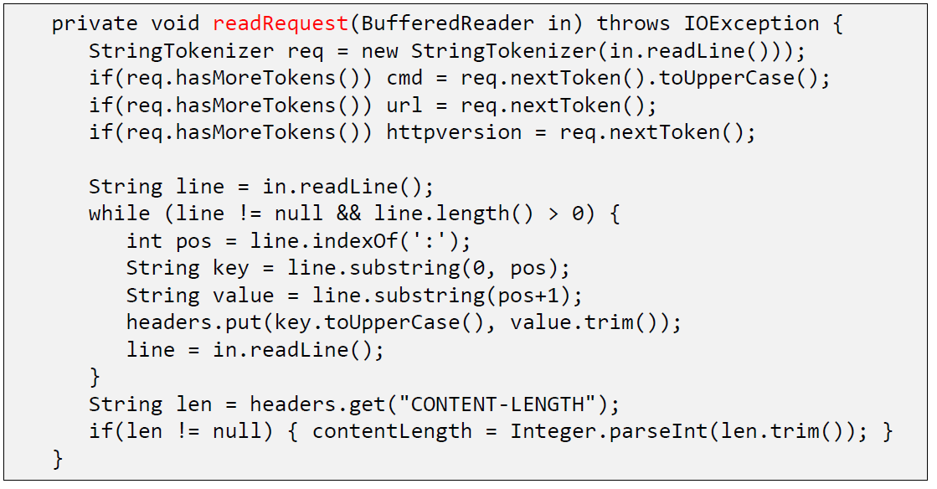

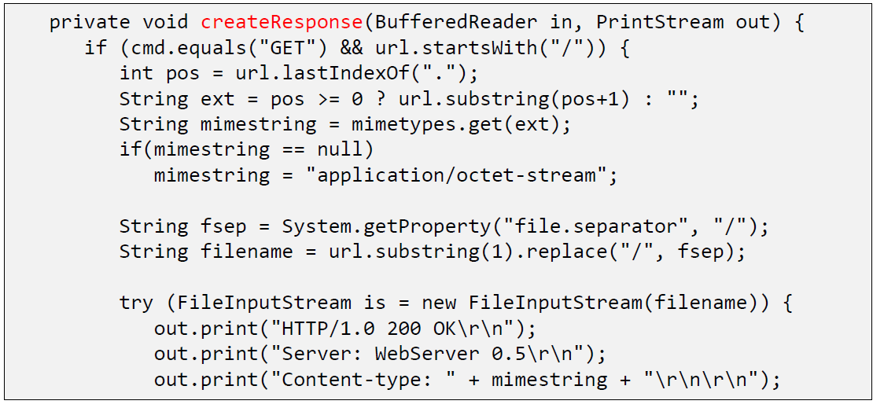

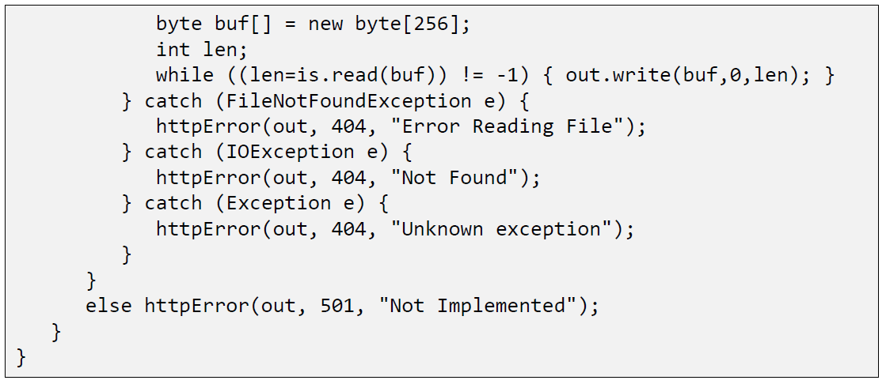

### Java internal Web Server

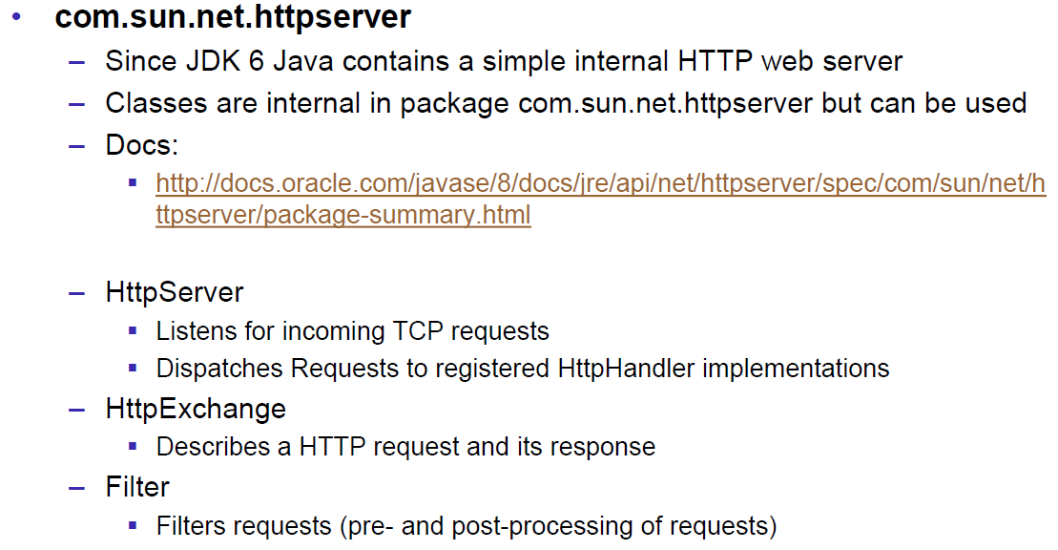

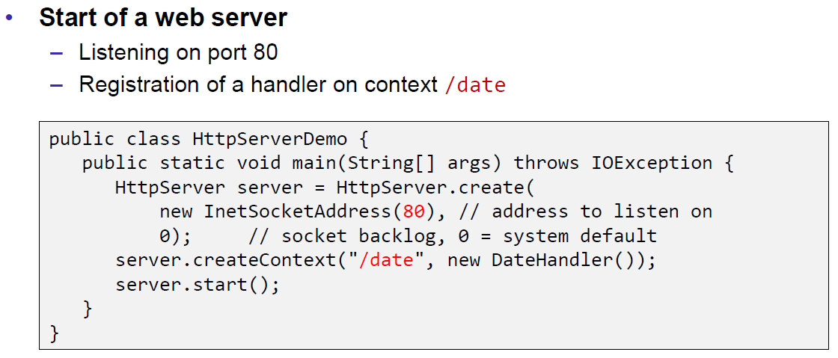

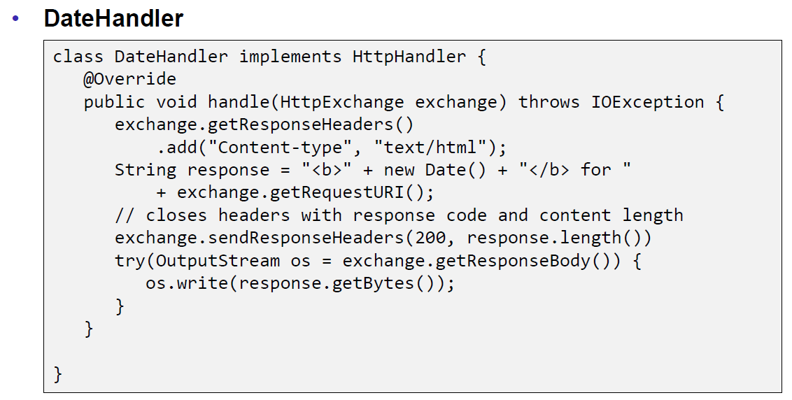

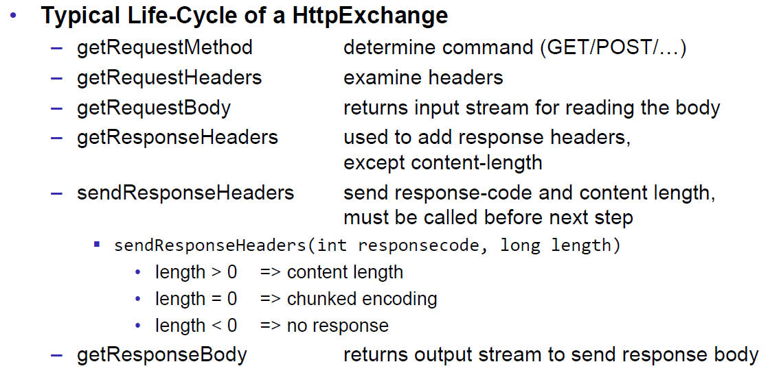

## HTML Forms & URL Encoding

### HTML GET Form

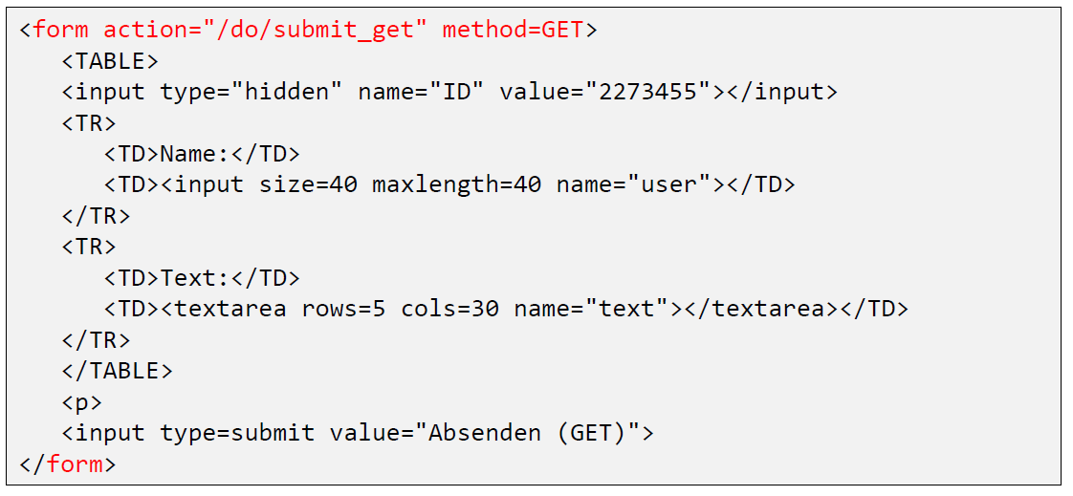

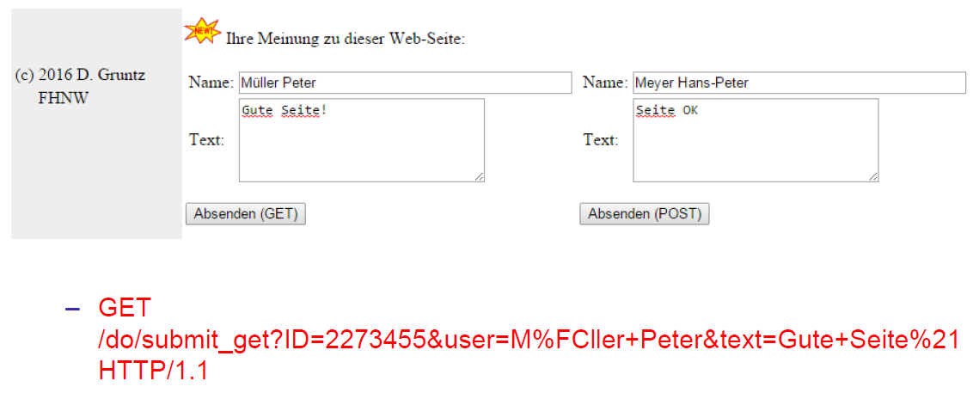

### URL Encoding

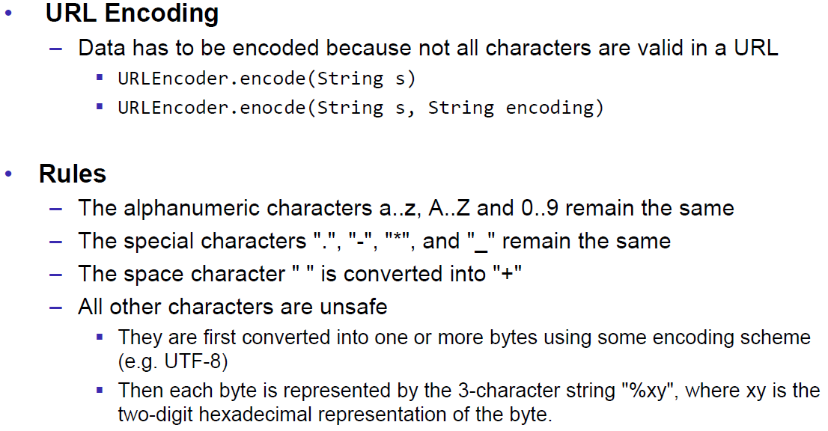

### HTML POST Form

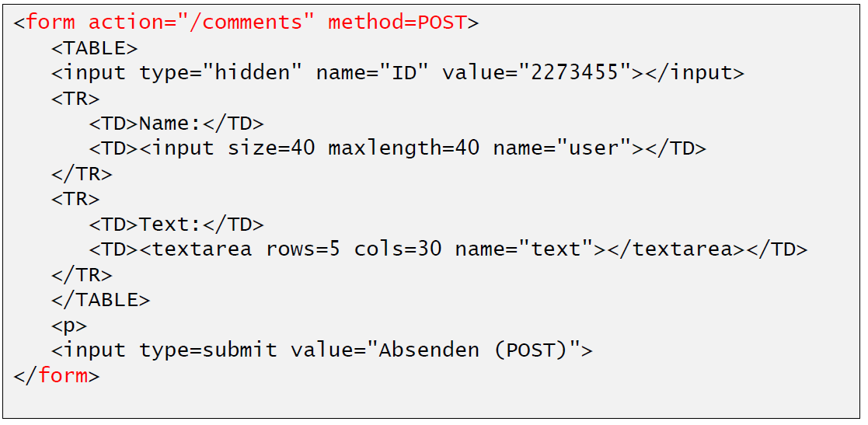

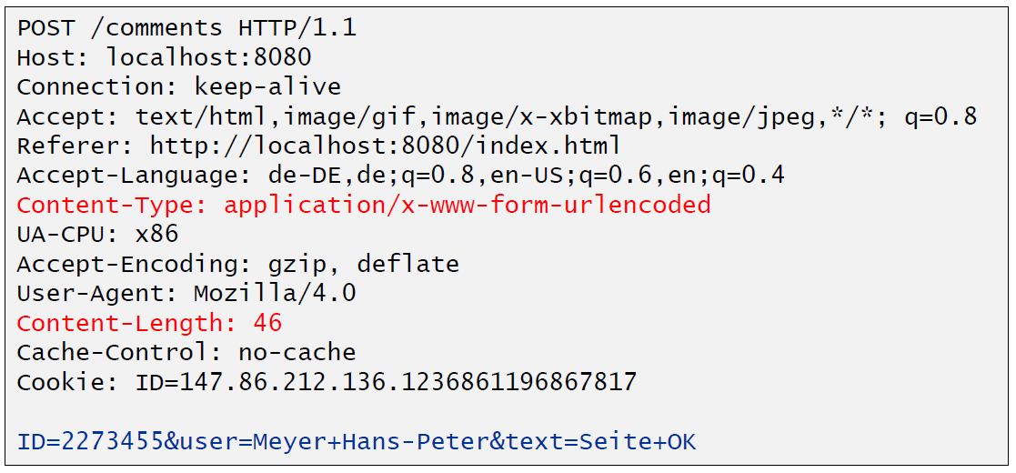

## HTTP Requests from Java

### URL

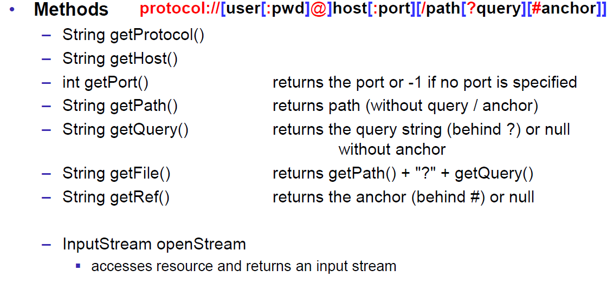

### Sending GET Requests from within Java

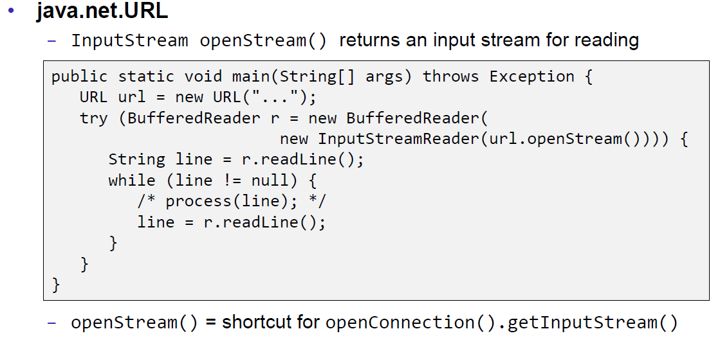

### URLConnection

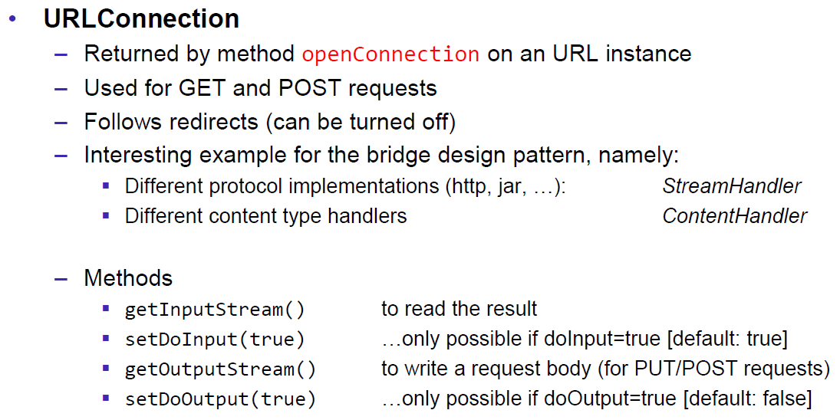

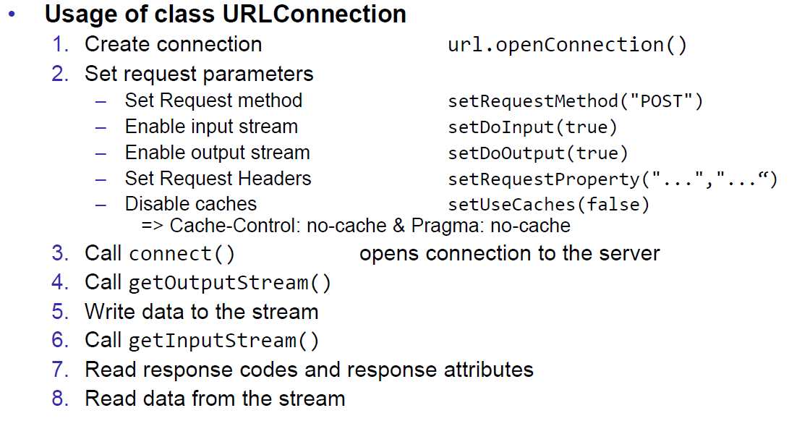

### URLConnection Tips & Tricks

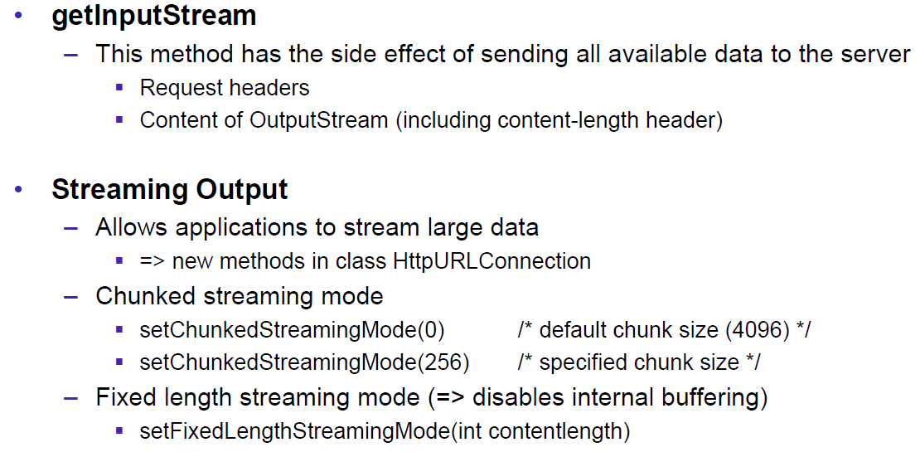

### Sample 1: URLConnection GET

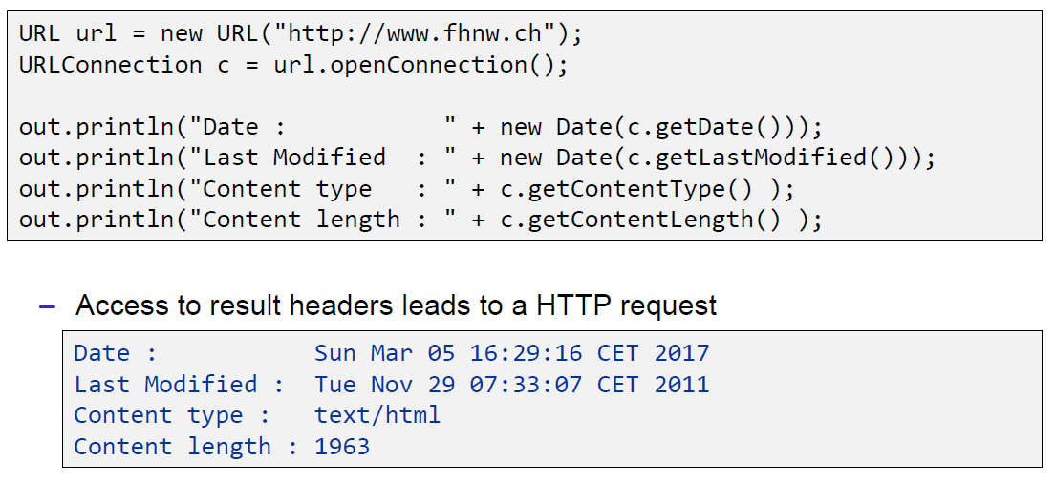

### Sample 2: URLConnection POST

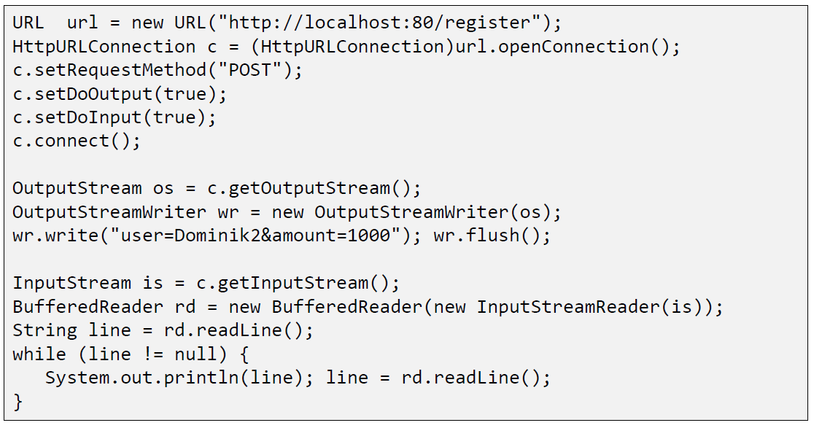

### Sample 3: Currency Converter

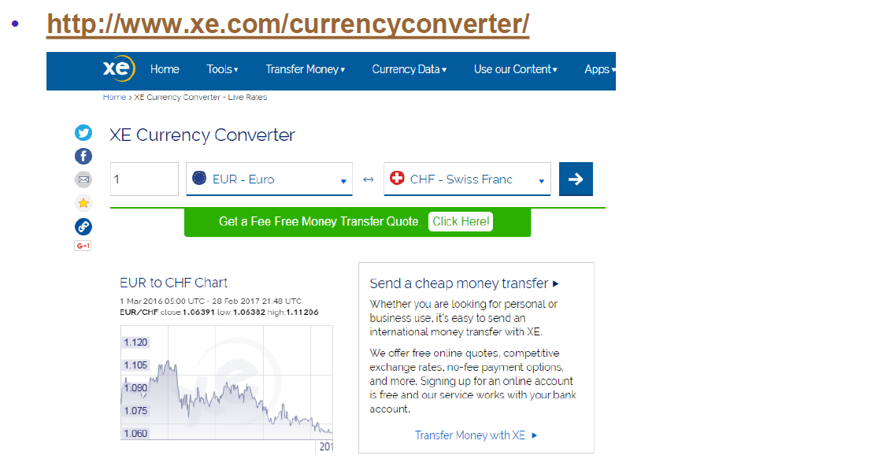

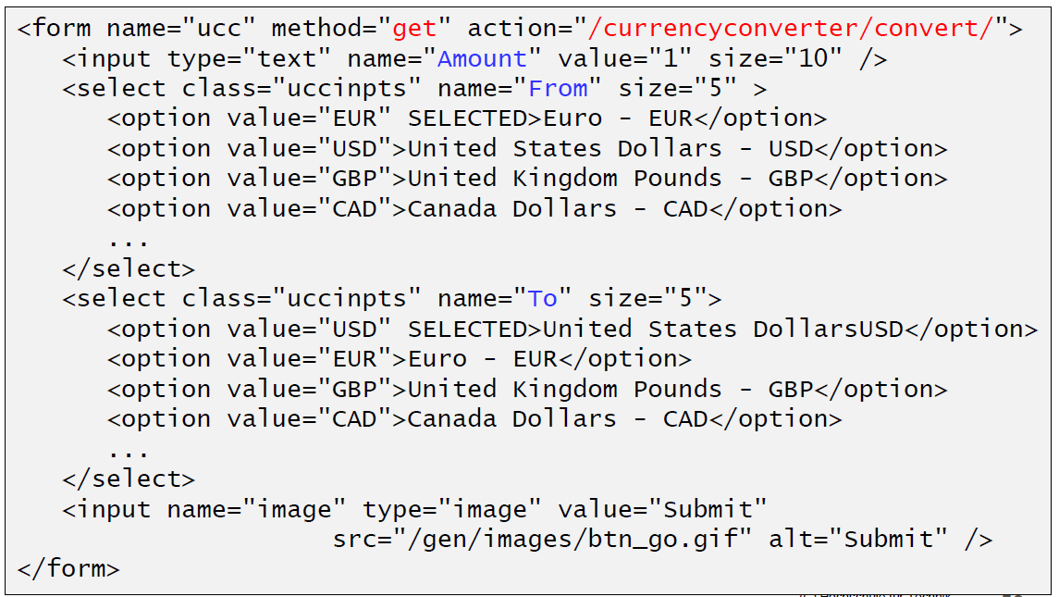

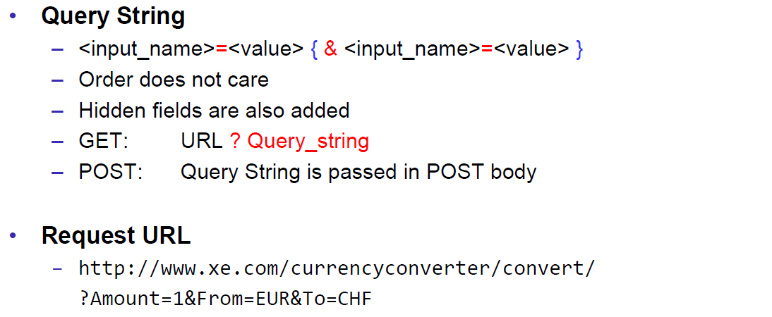

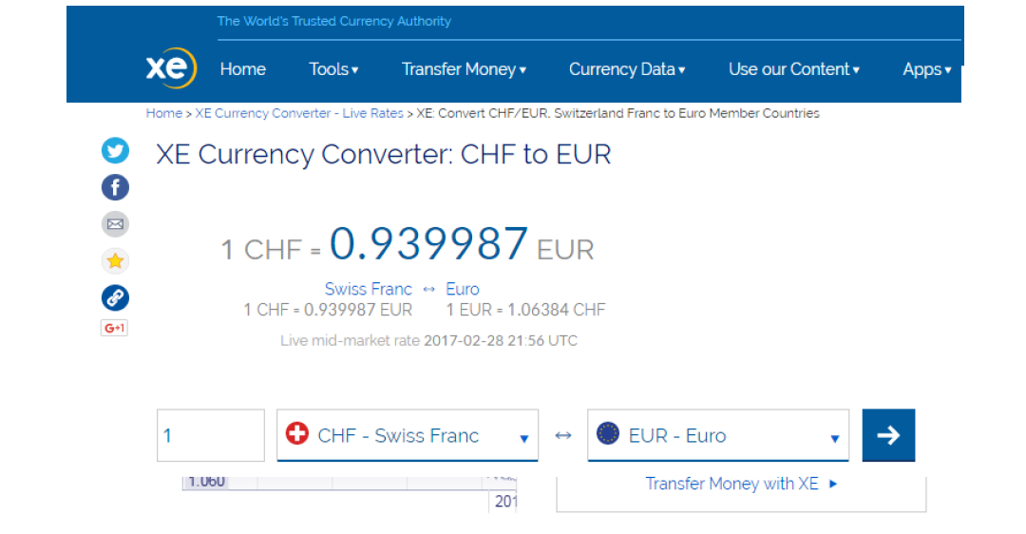

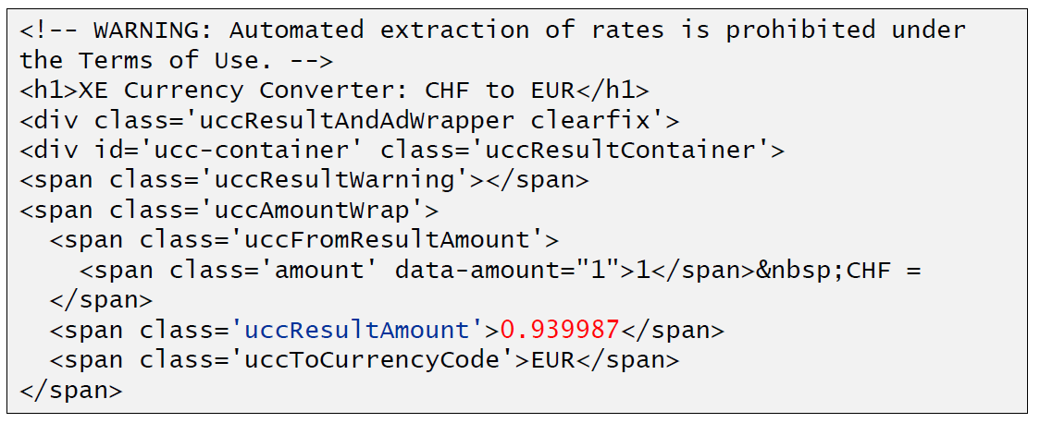

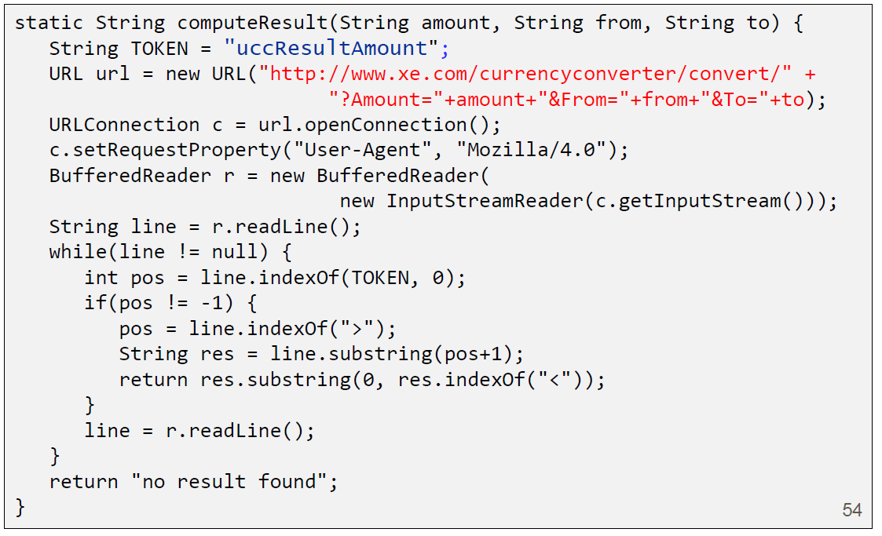

### Other Libraries

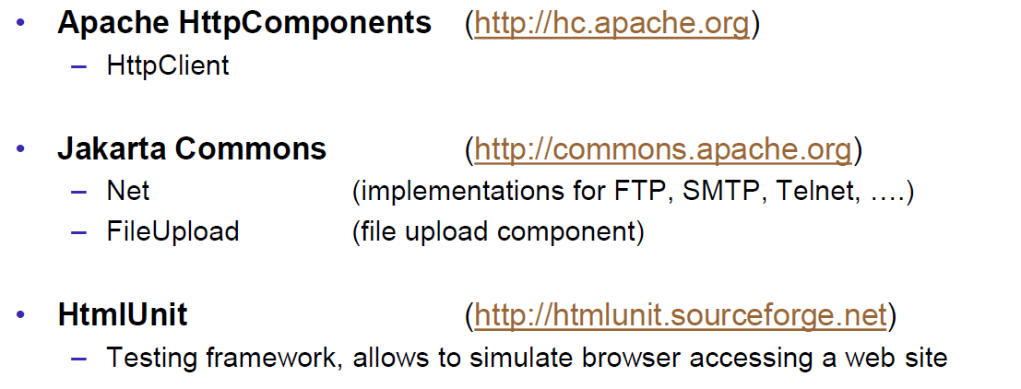

# Woche 4

## Servlets

### Servlet Specification

### Dynamic Content

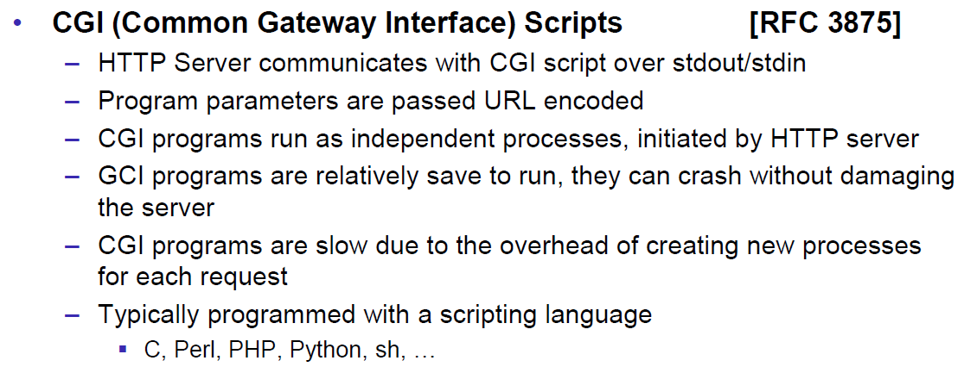

### Servlets

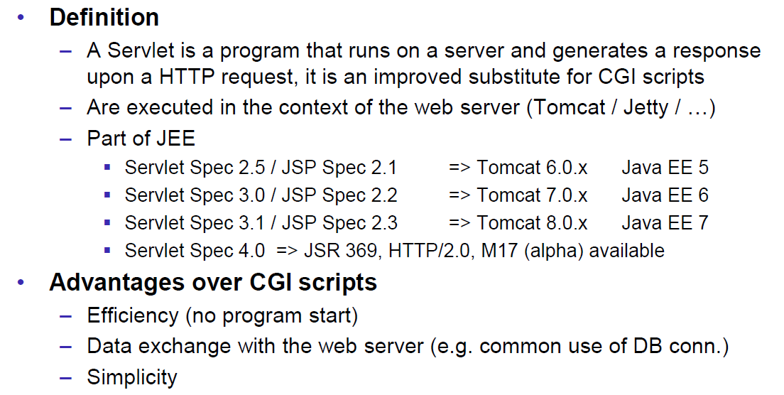

### Servlet Packages

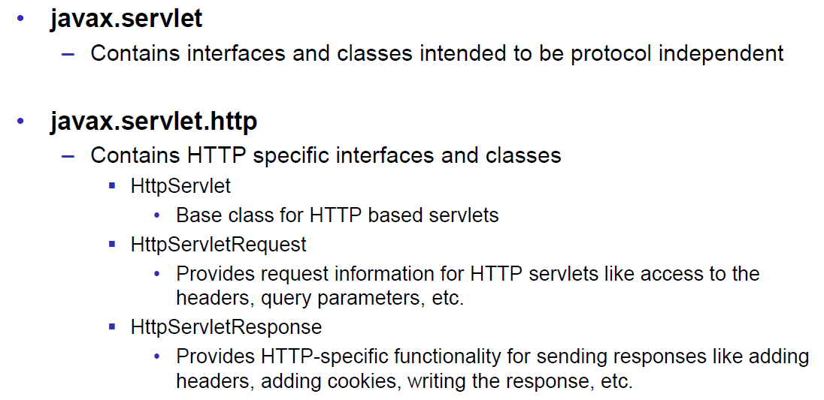

### Servlet Life-Cycle Methods

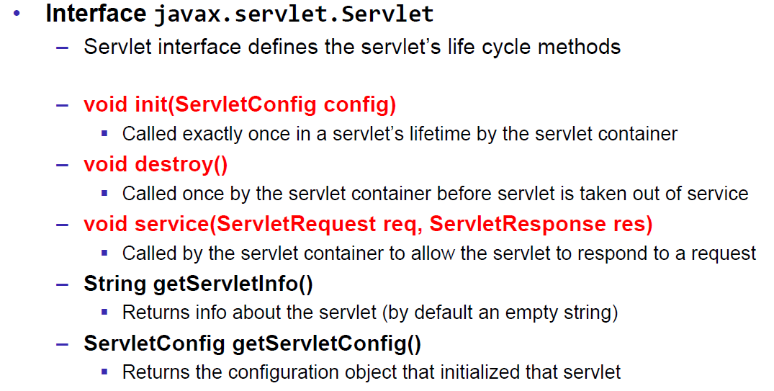

### HttpServlet

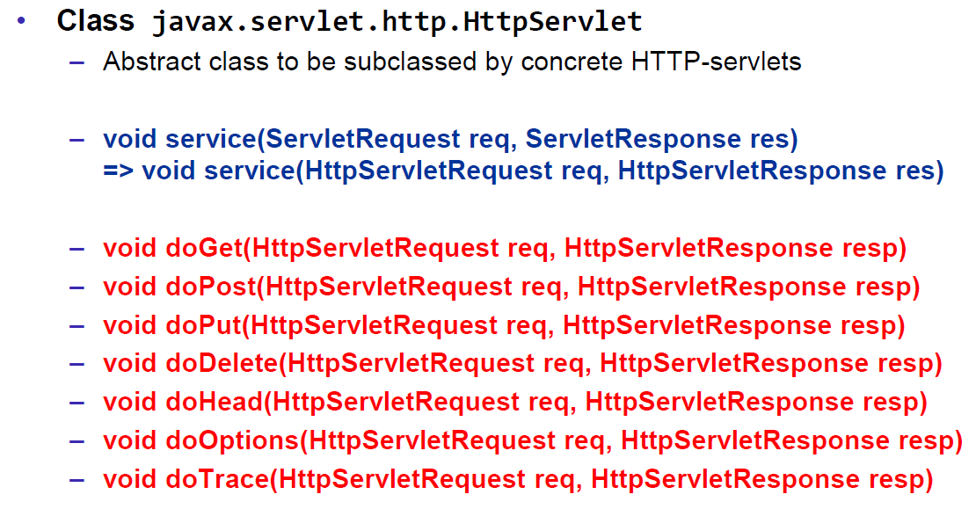

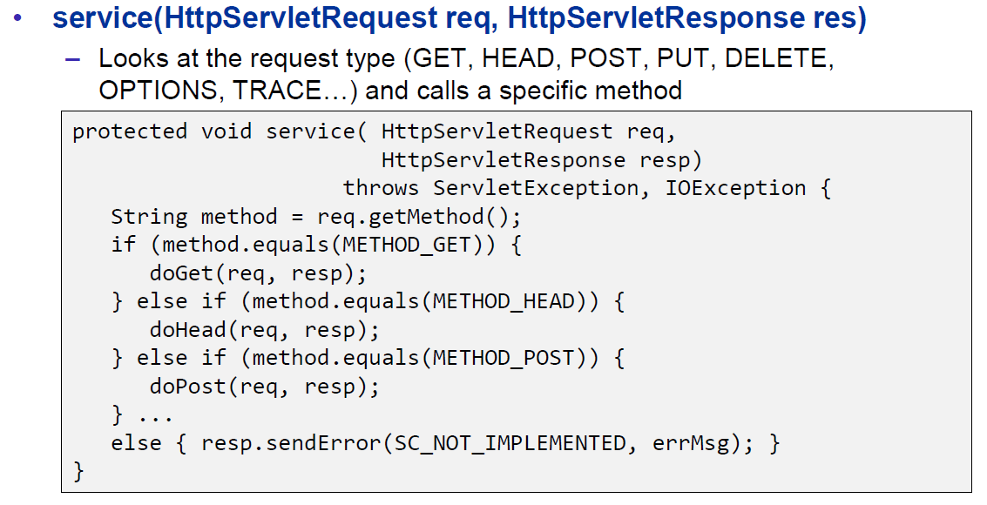

### HttpServletRequest

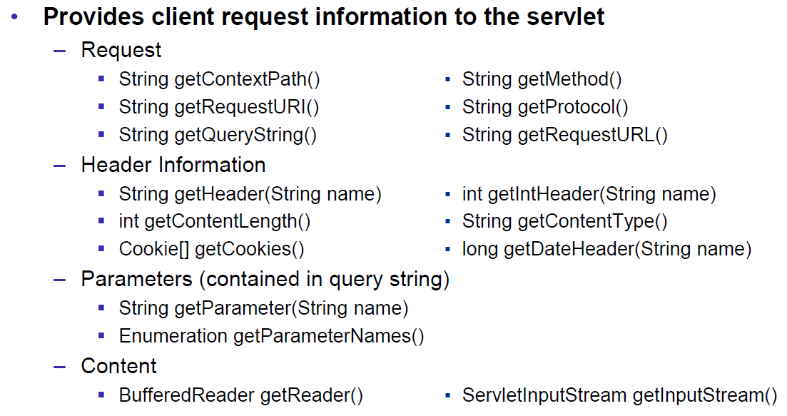

### HttpServletResponse

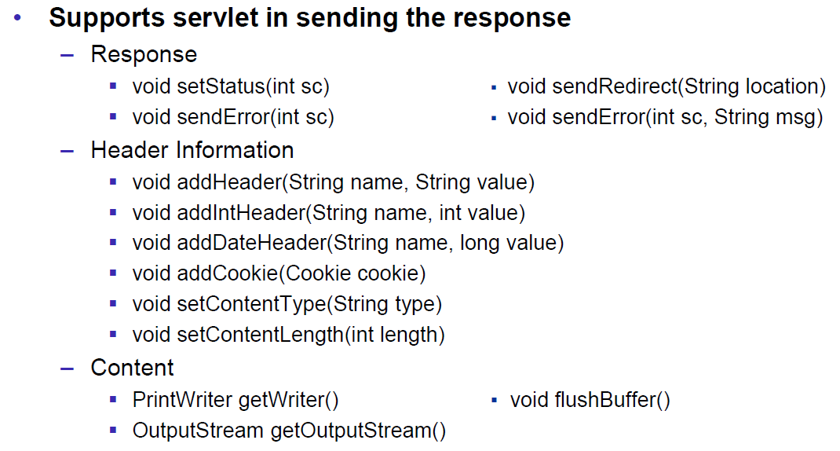

### Servlet Example

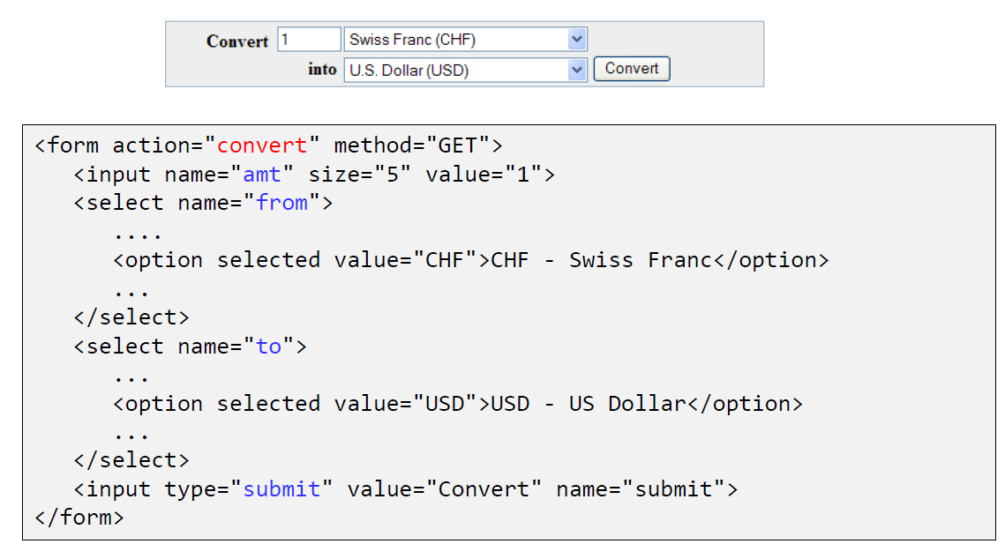

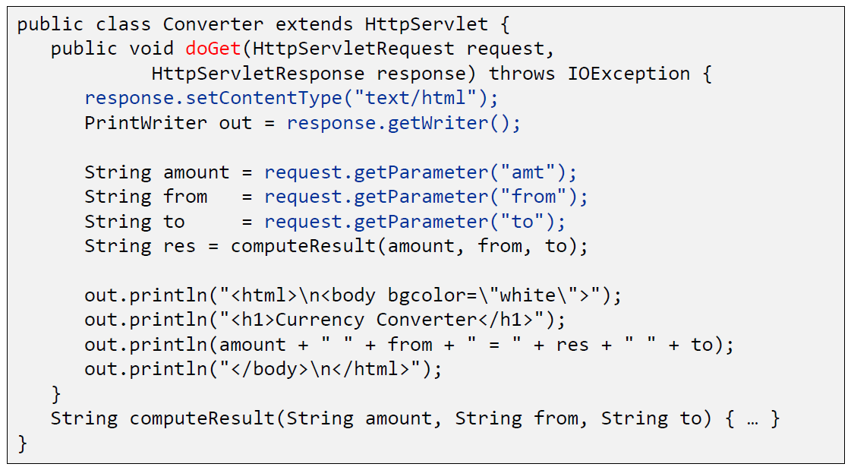

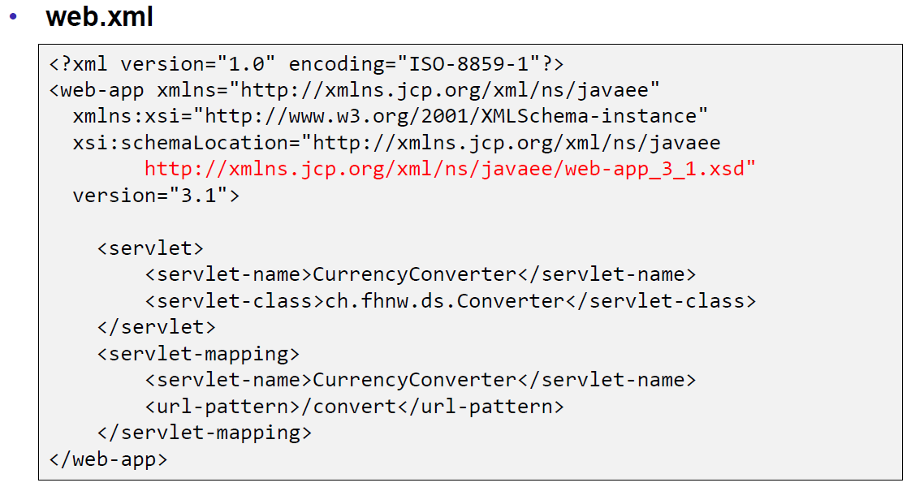

### Webapplication Structure

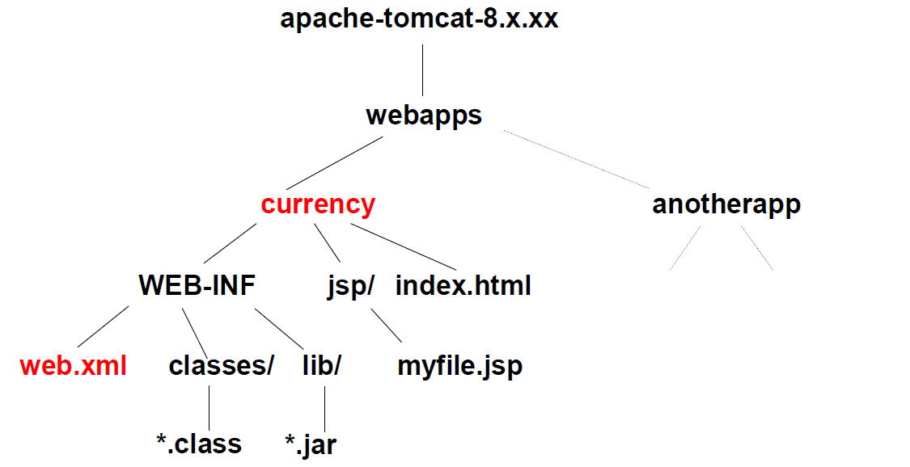

### Annotation WebServlet

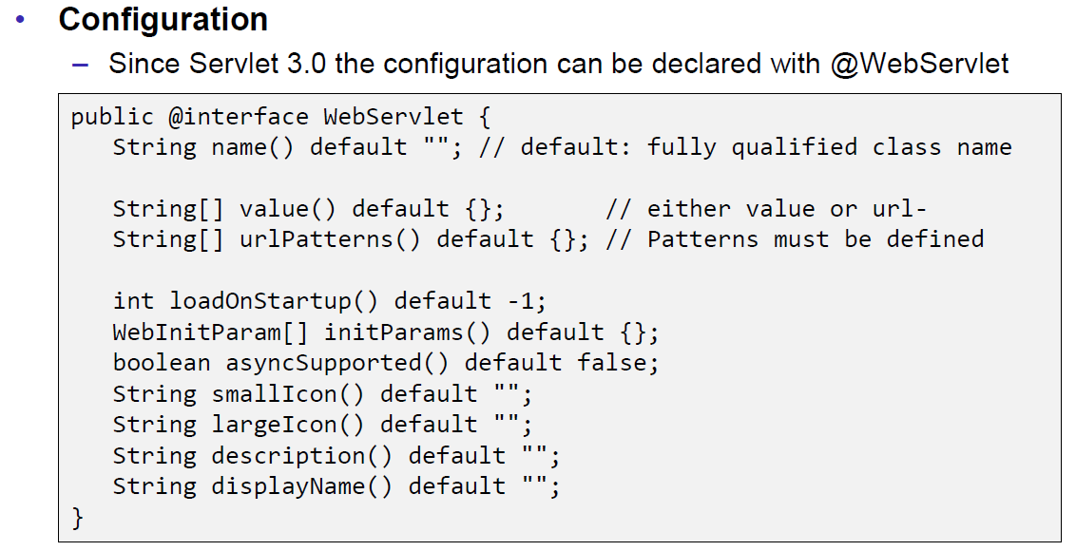

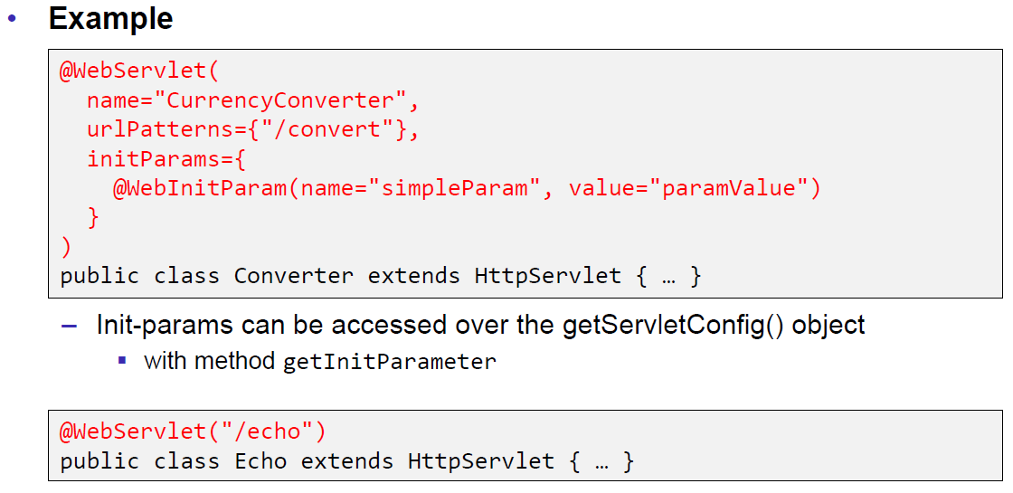

### Webapplication Structure

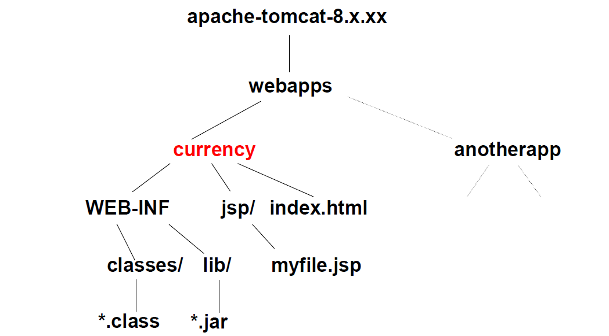

## Tomcat Servlet Server

### Tomcat

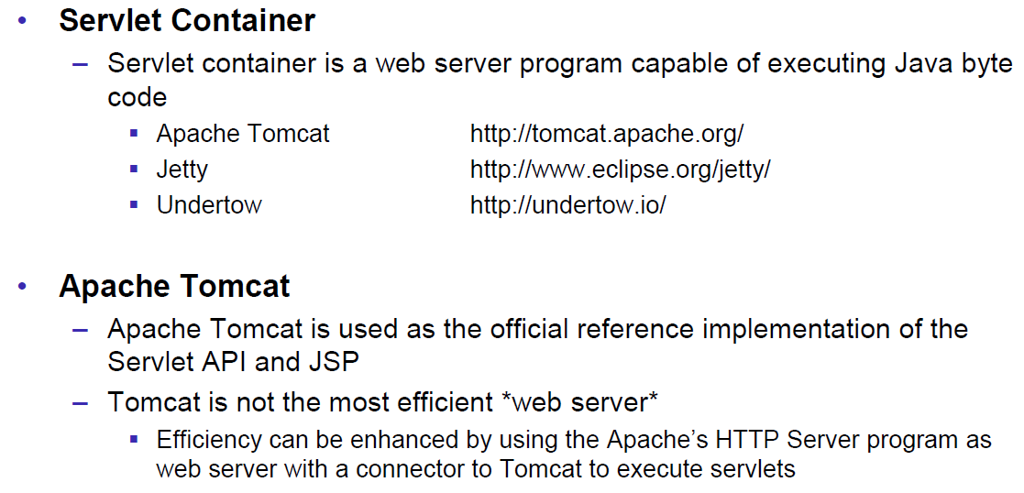

### Tomcat Directory Structure

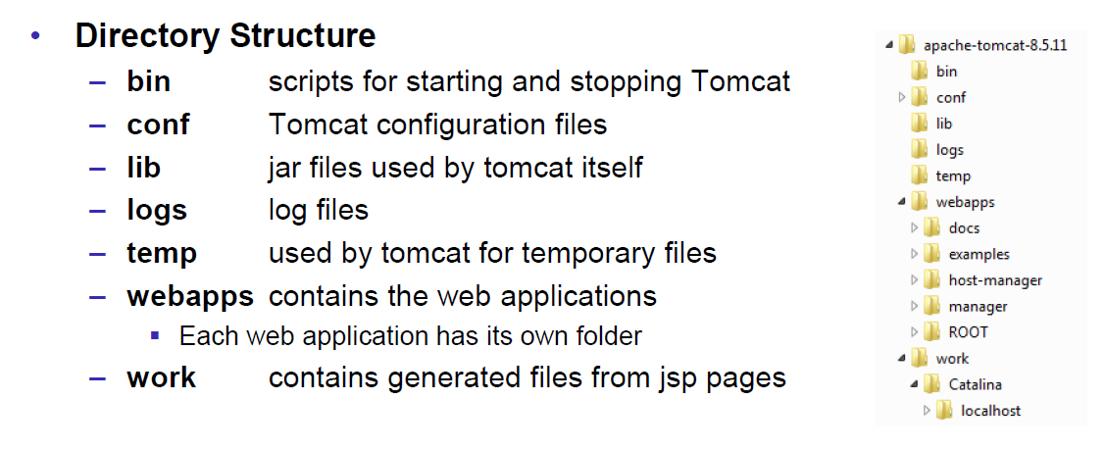

### Tomcat Scripts

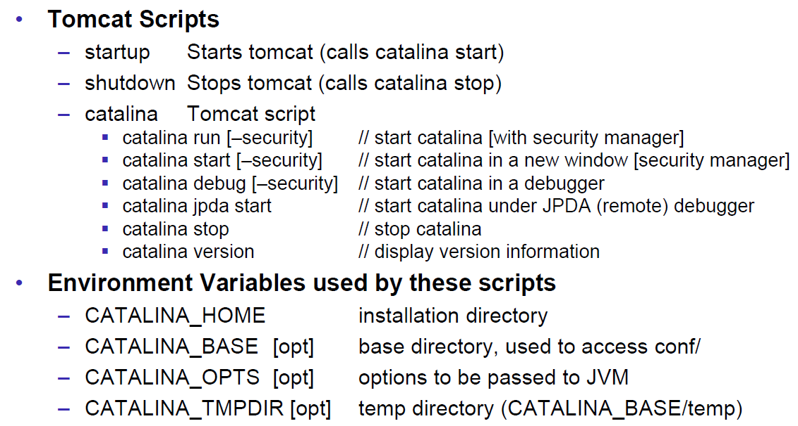

### Tomcat Startup Screen

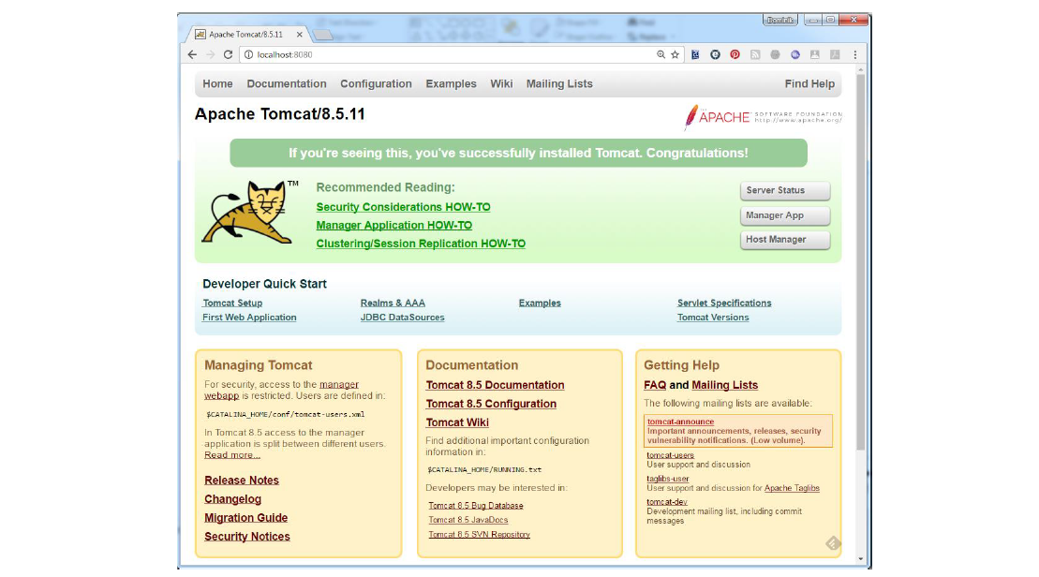

### Tomcat Managers

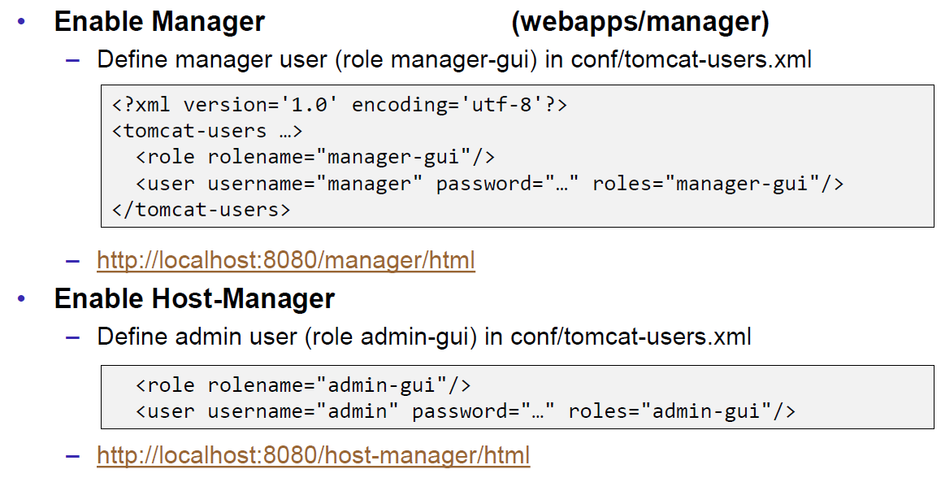

### Debugging

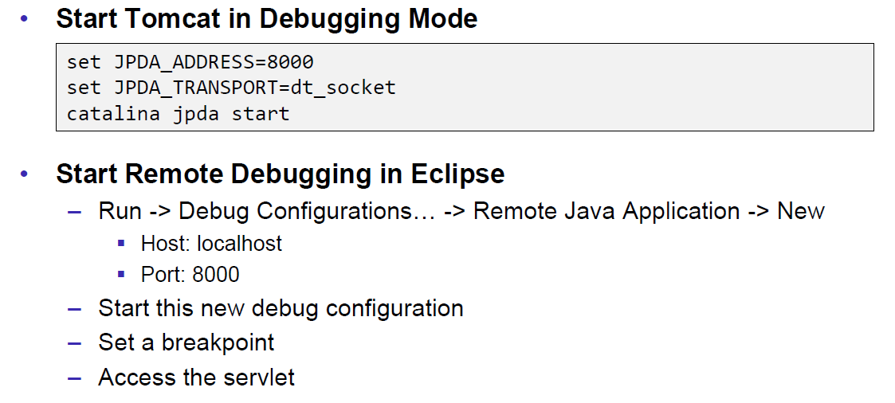

### Tomcat Architecture

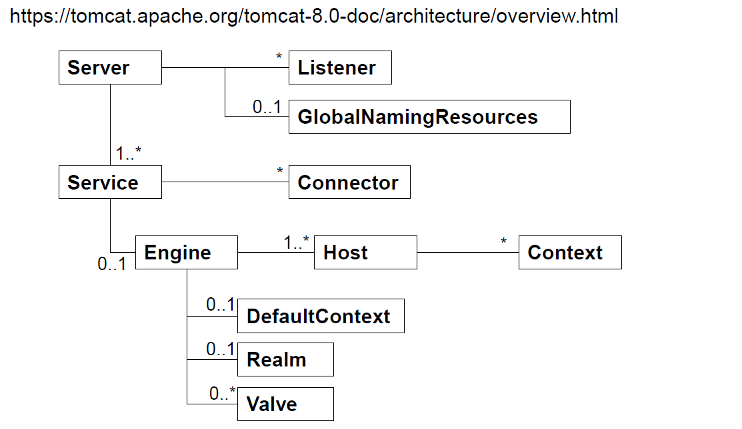

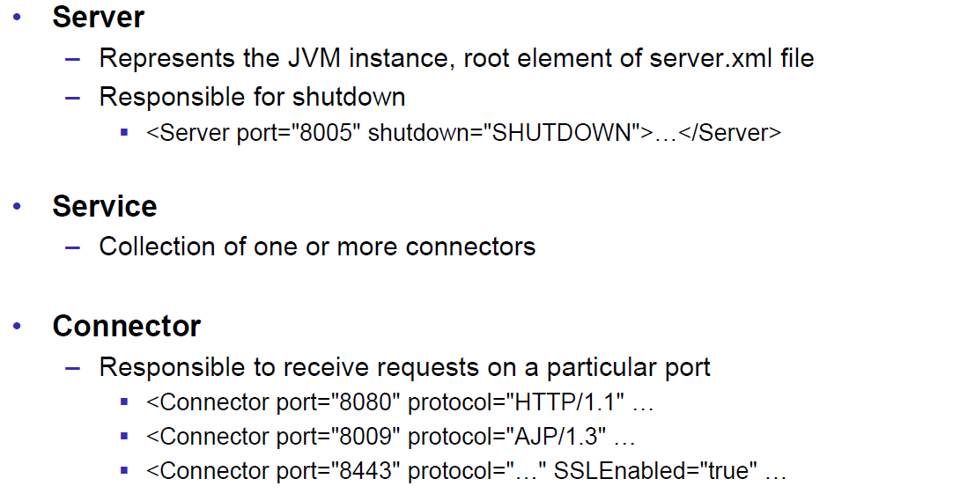

### Configuration of a Host

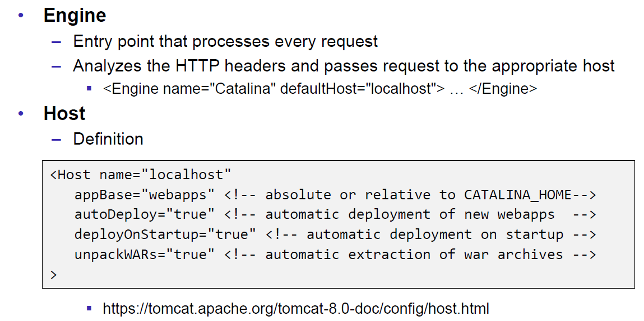

### Configuration of a Context

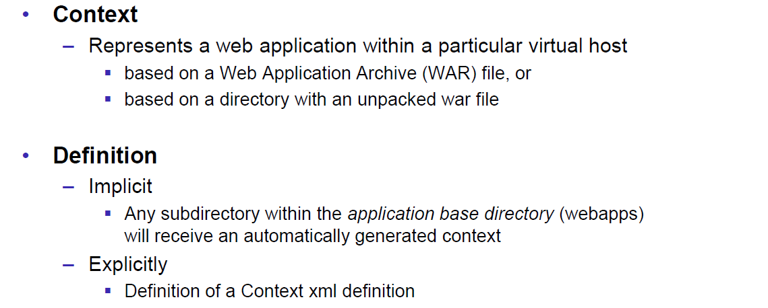

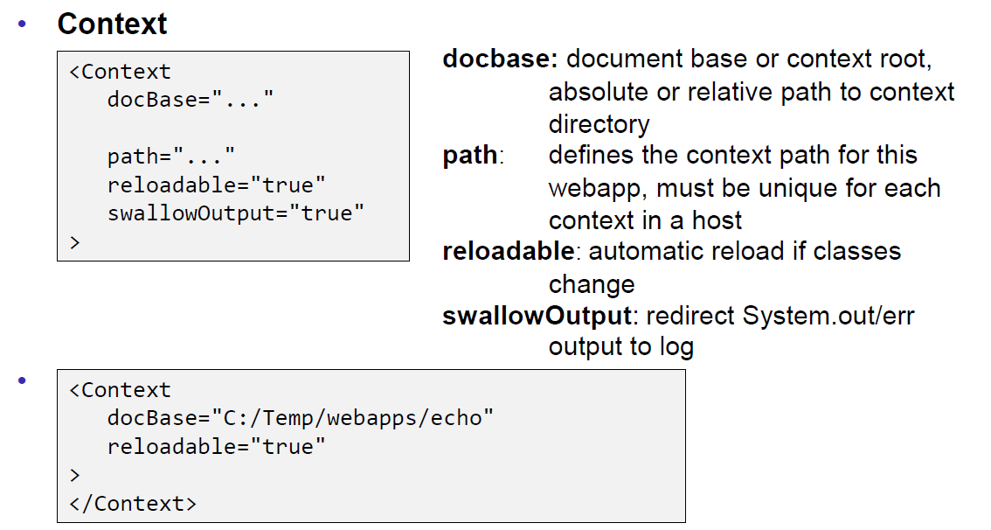

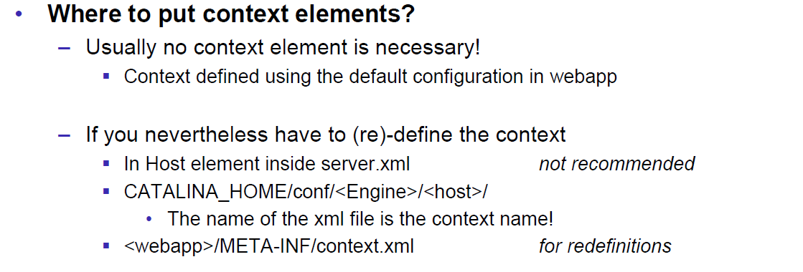

### Deployment while development

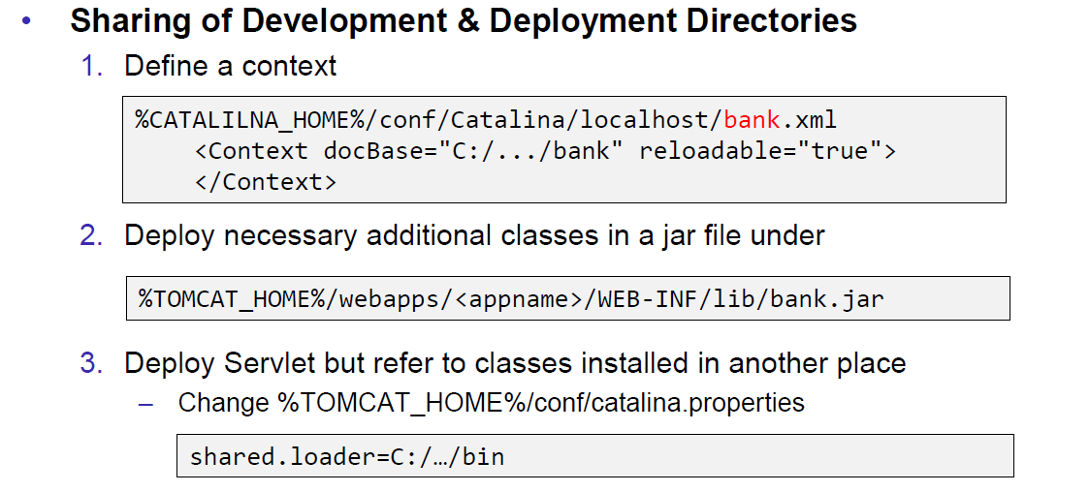

### Eclipse and Servlets (JEE Eclipse Version)

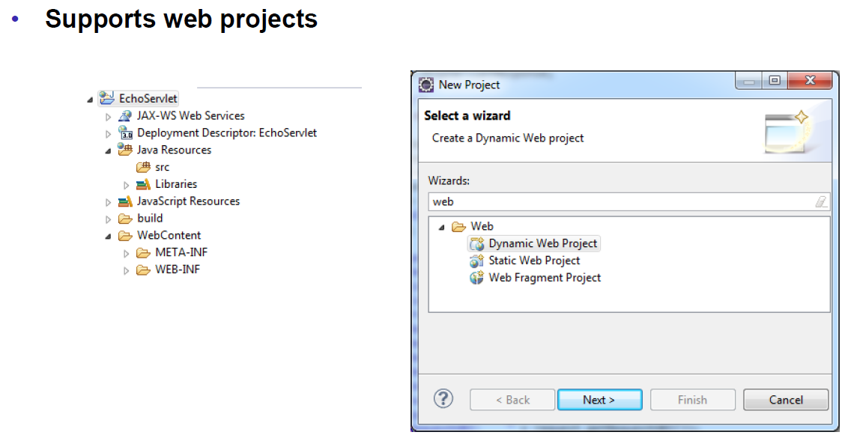

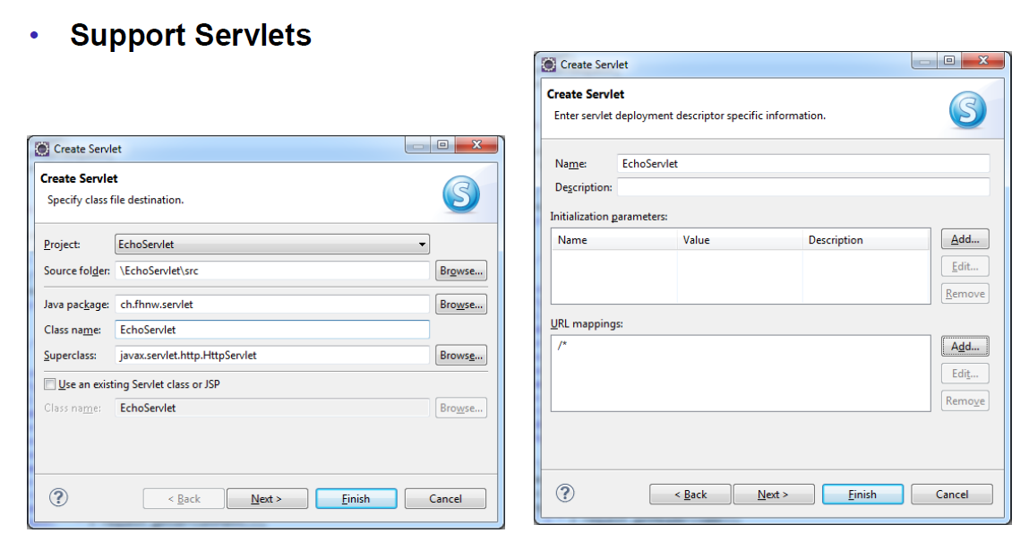

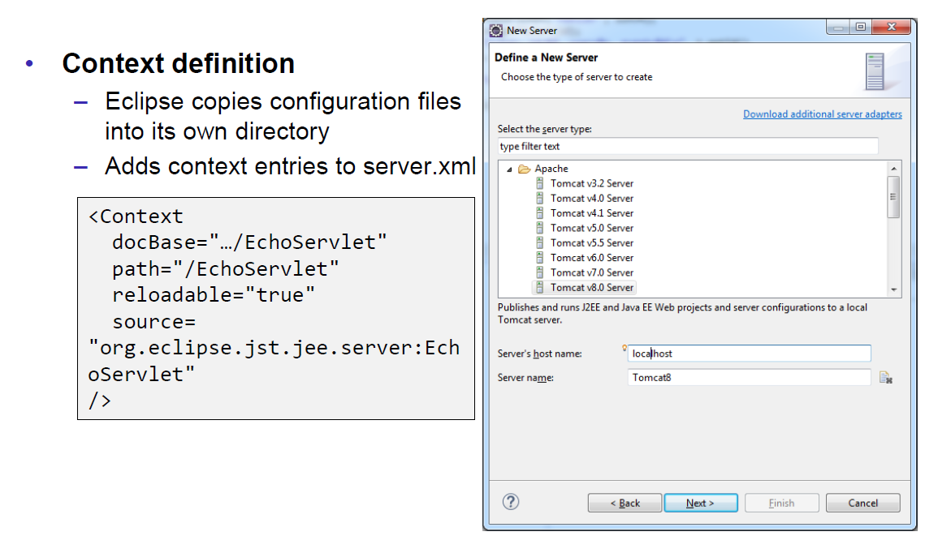

# Woche 5

## Motivation XML-RPX

### Services over HTTP (Currency Converter)

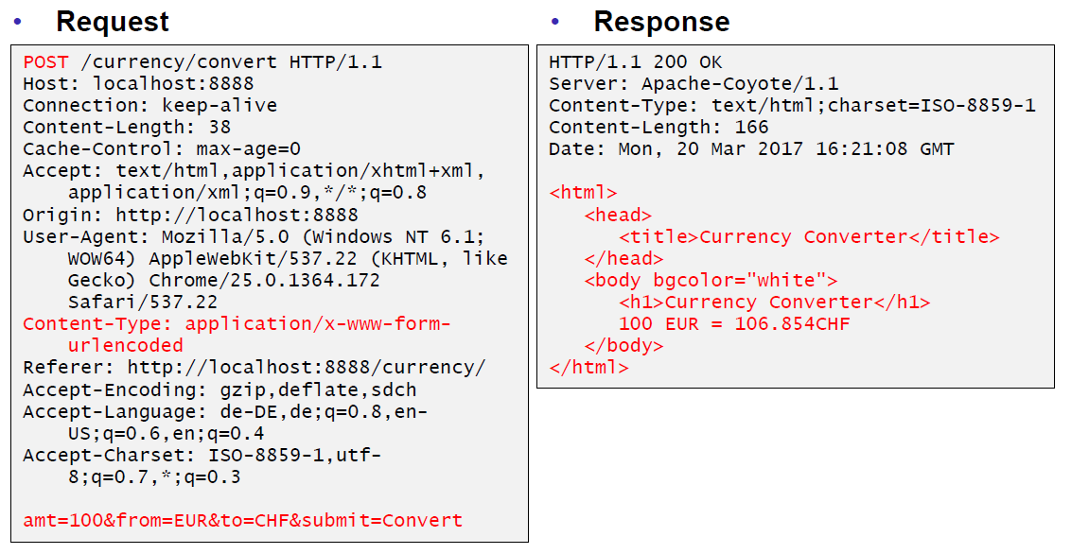

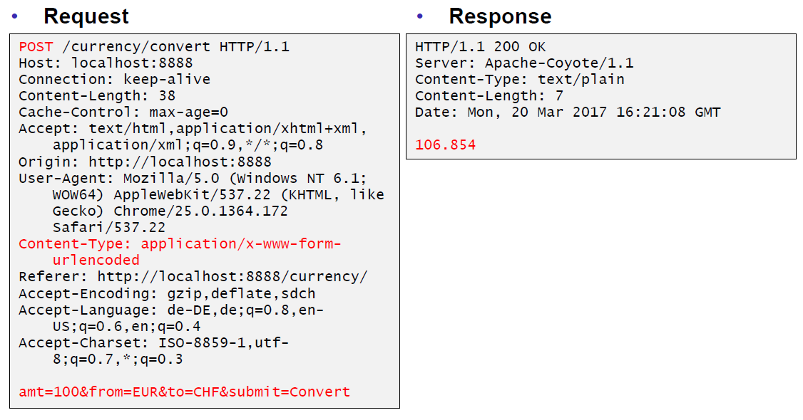

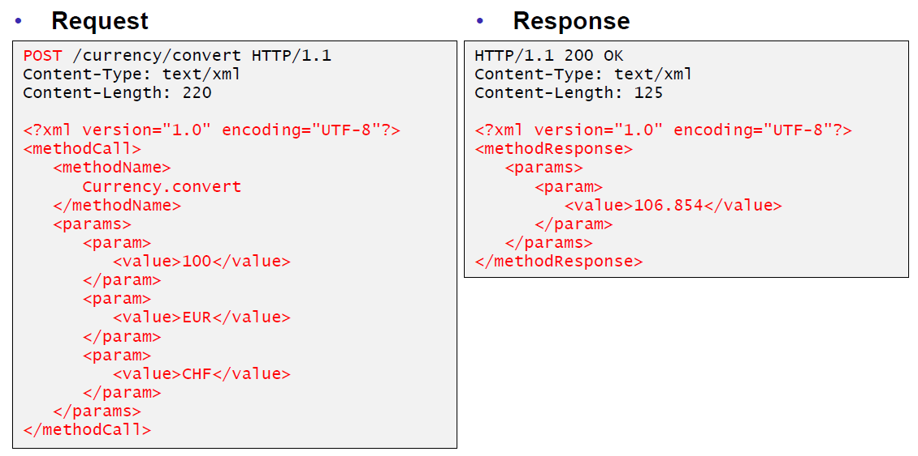

### XML-Remote Procedure Calls

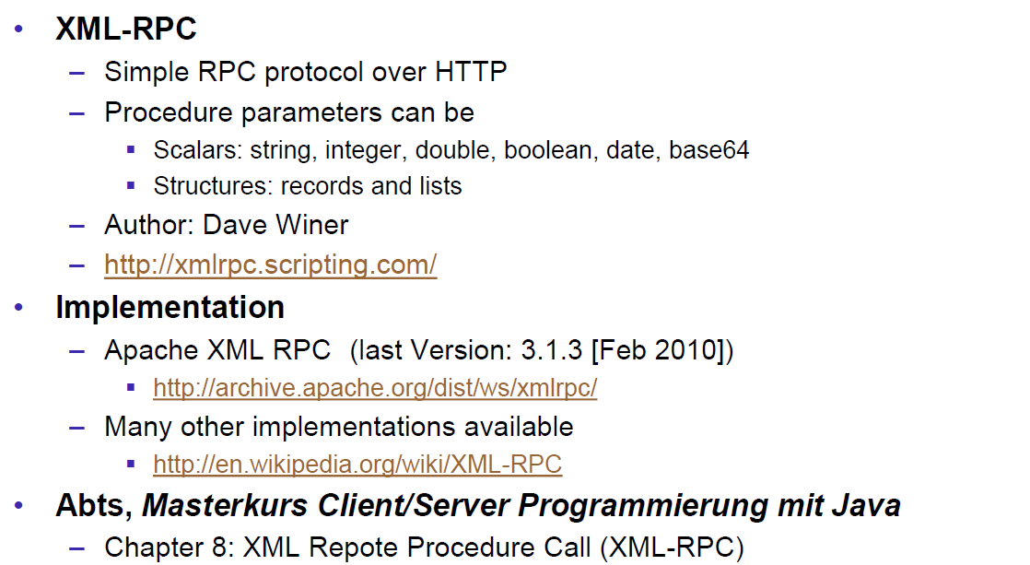

## SOAP und JAX-WS

### SOAP

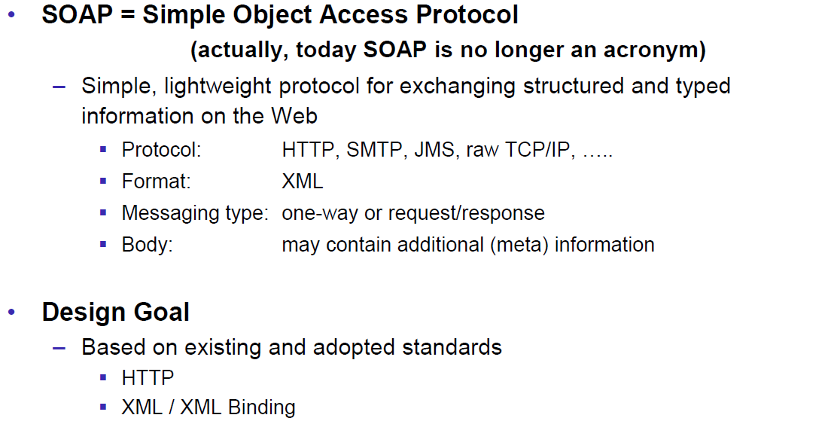

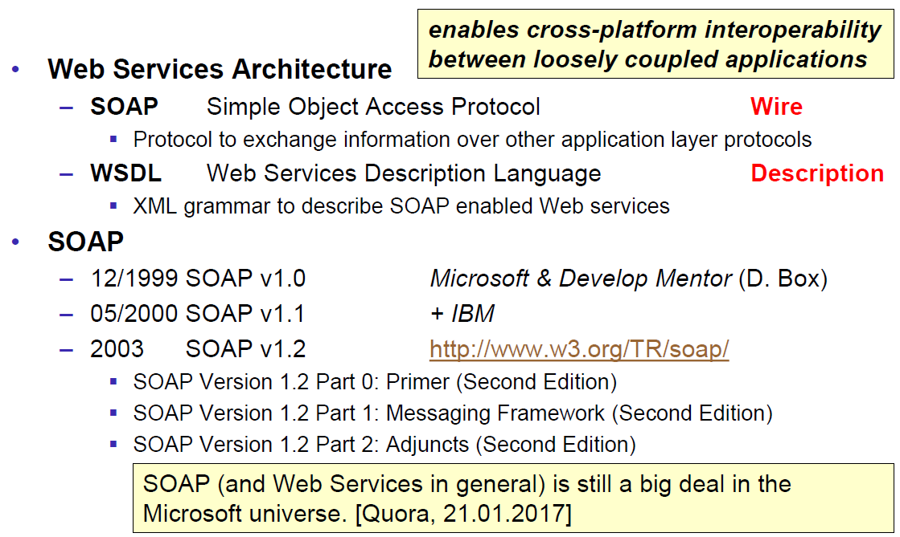

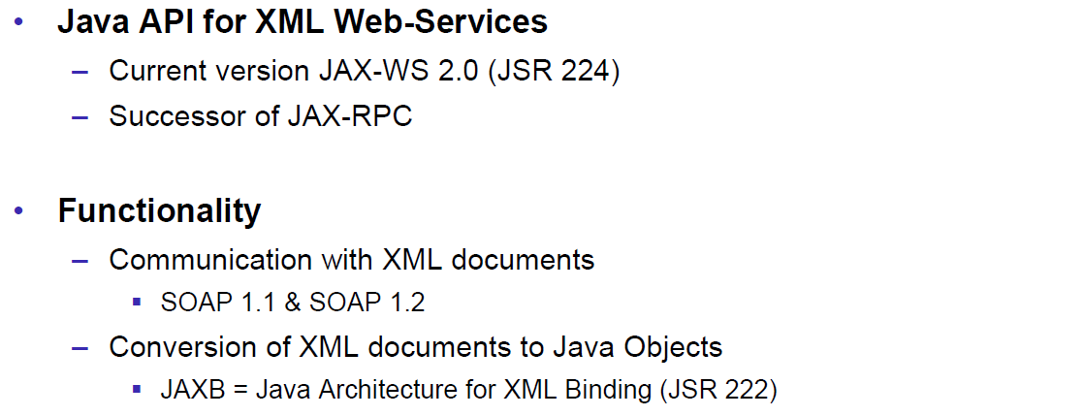

### JAX-WS

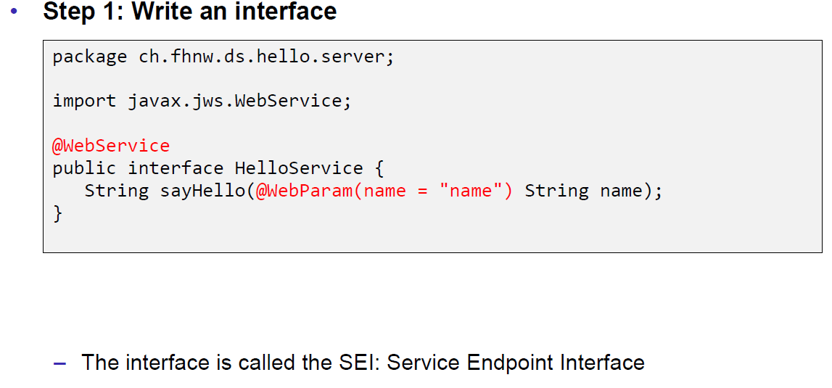

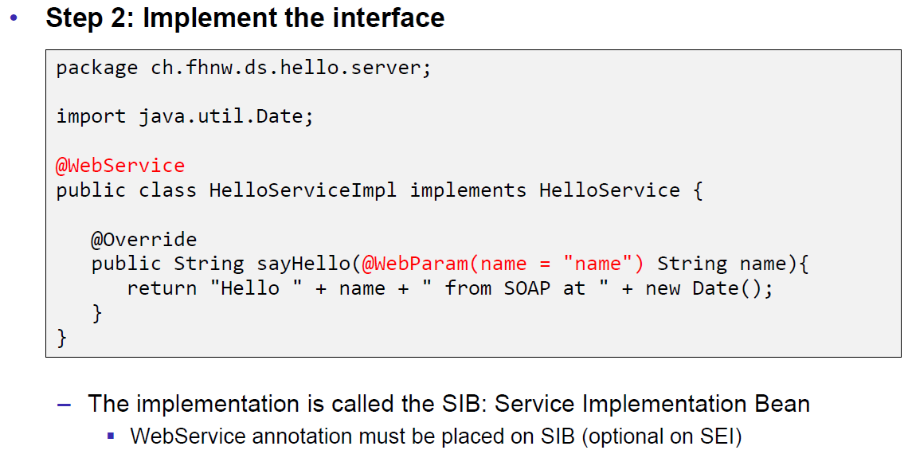

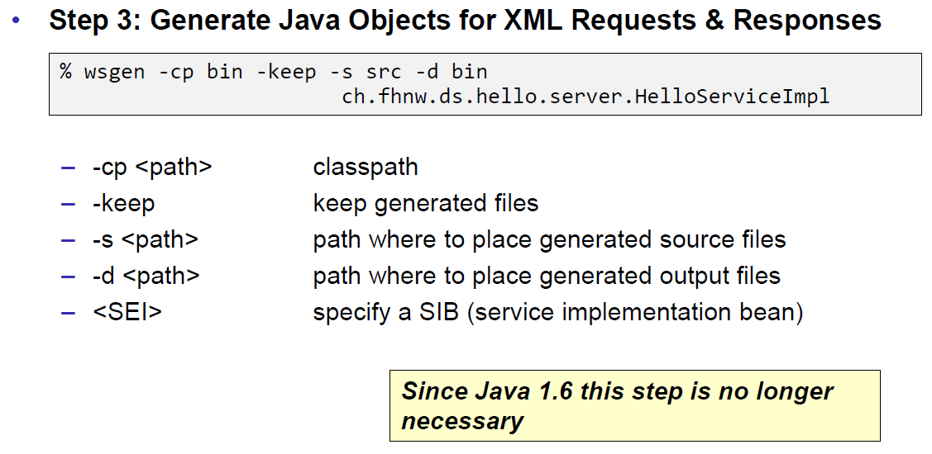

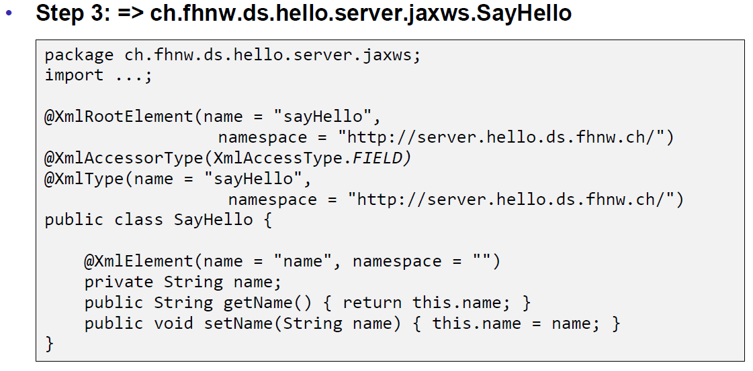

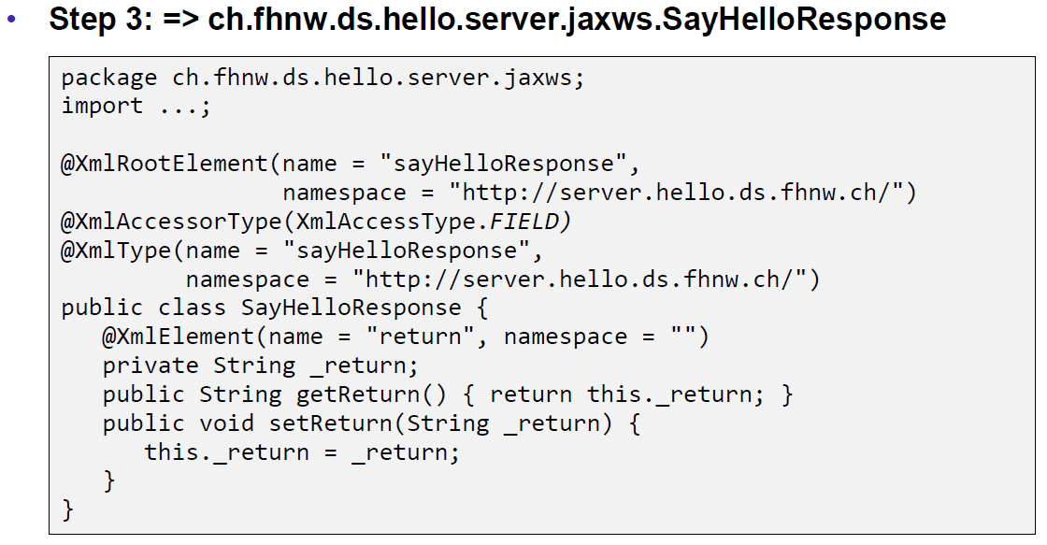

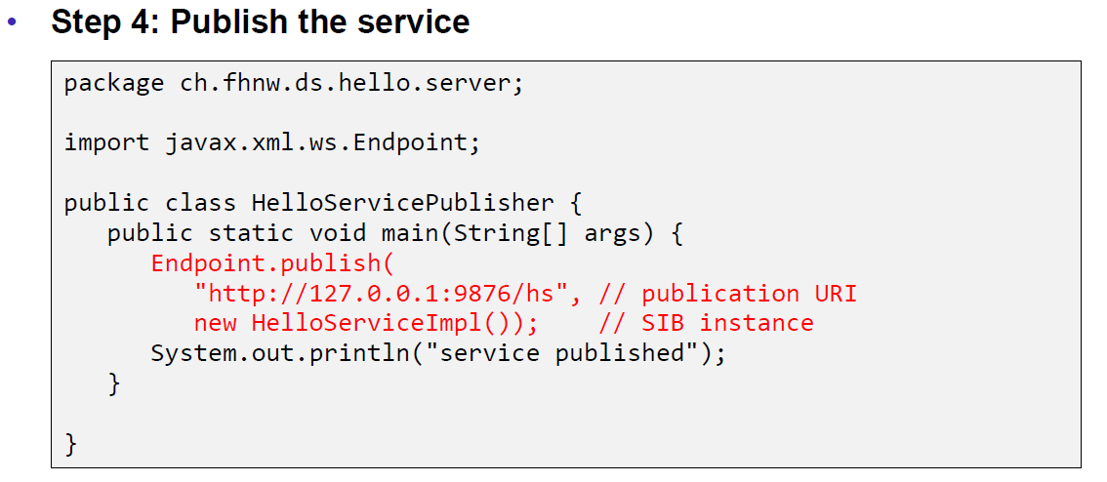

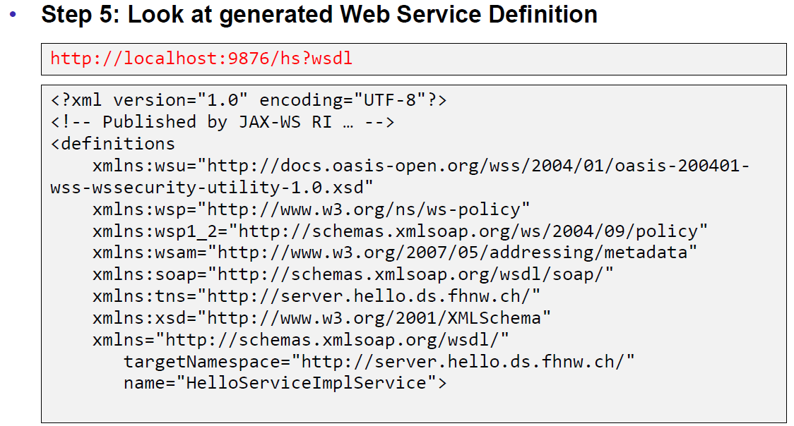

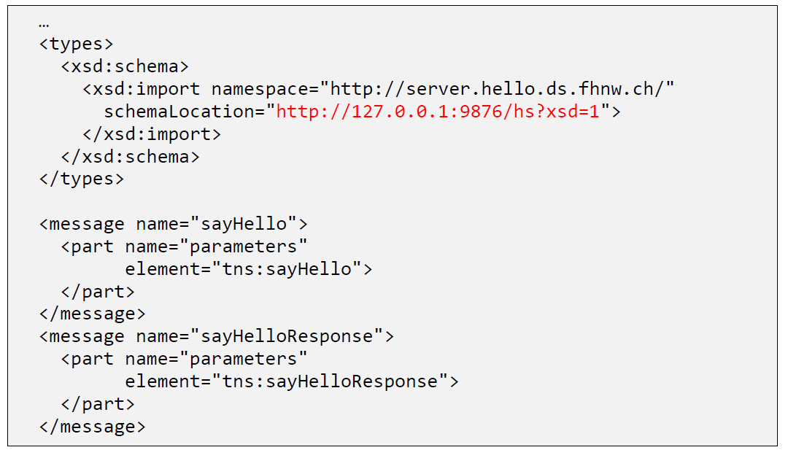

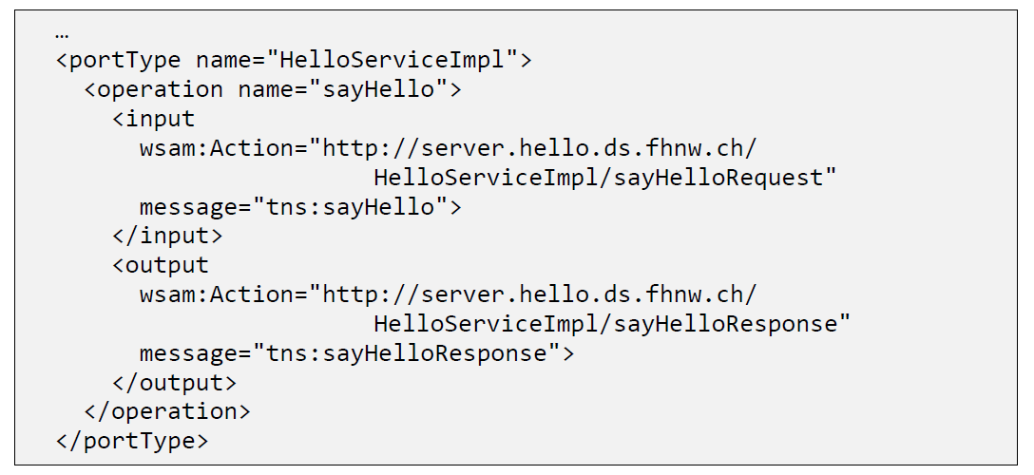

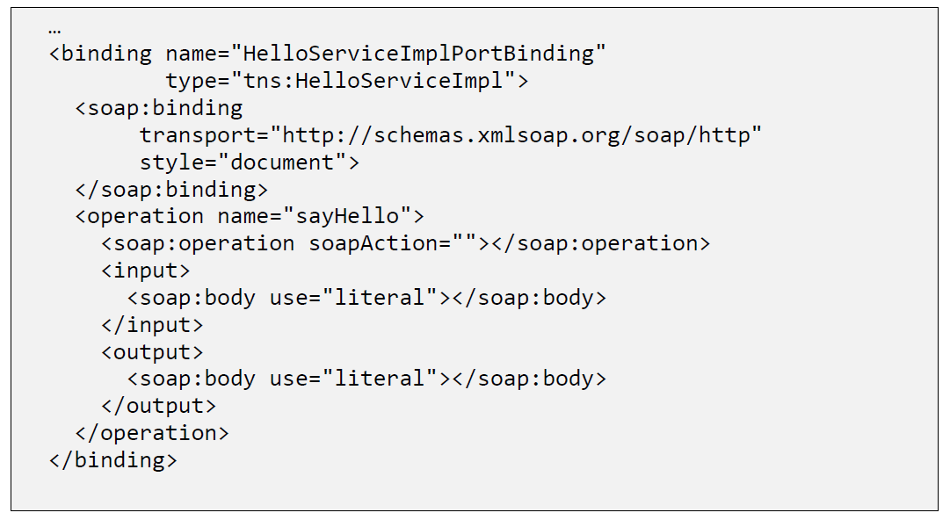

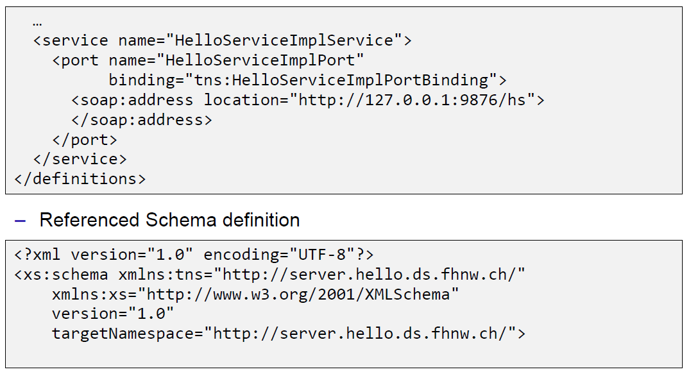

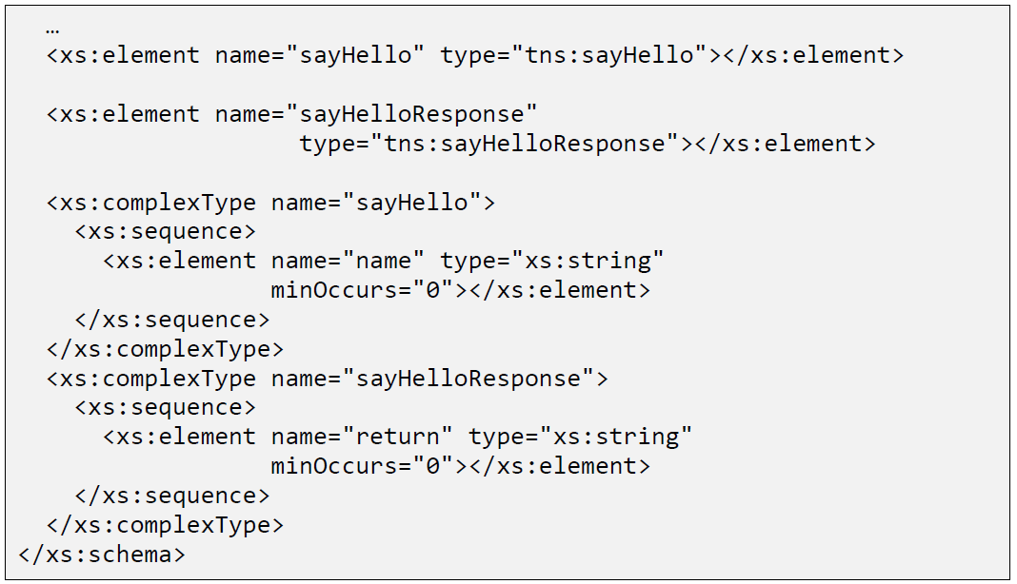

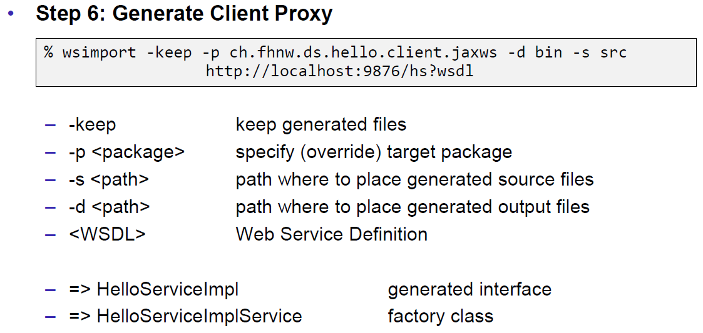

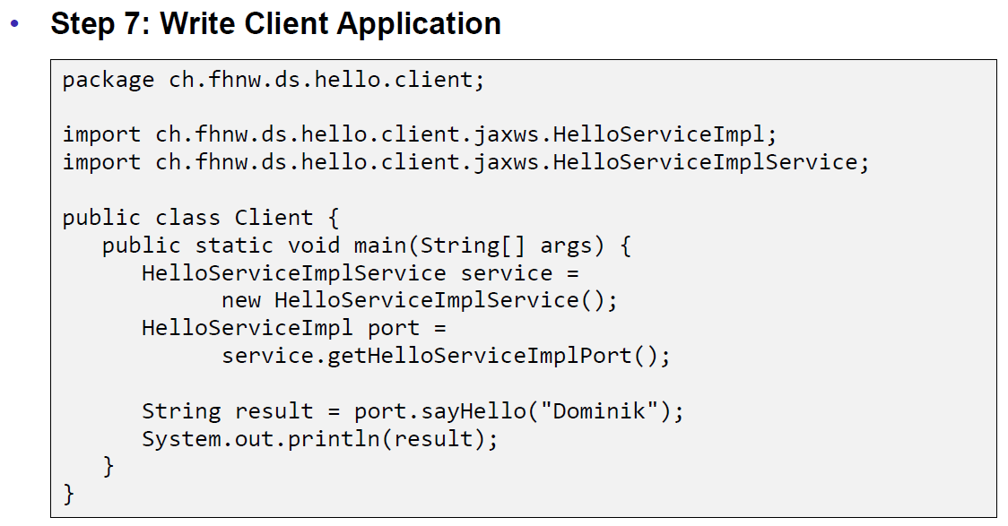

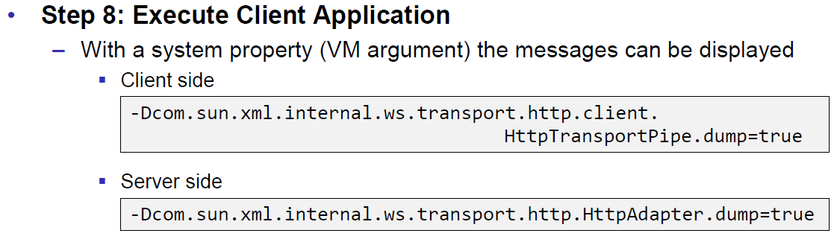

### JAX-WS HTTP Request

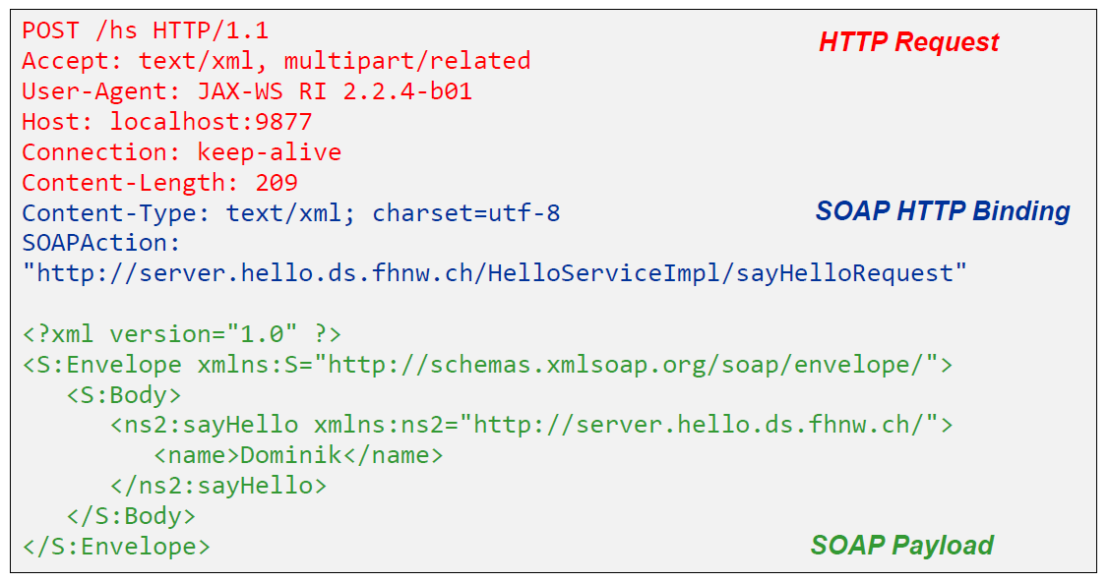

### JAX-WS HTTP Response

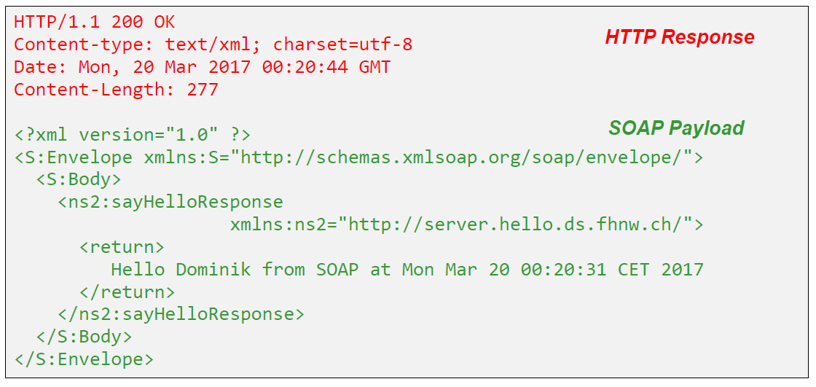

### SOAP Message Structure

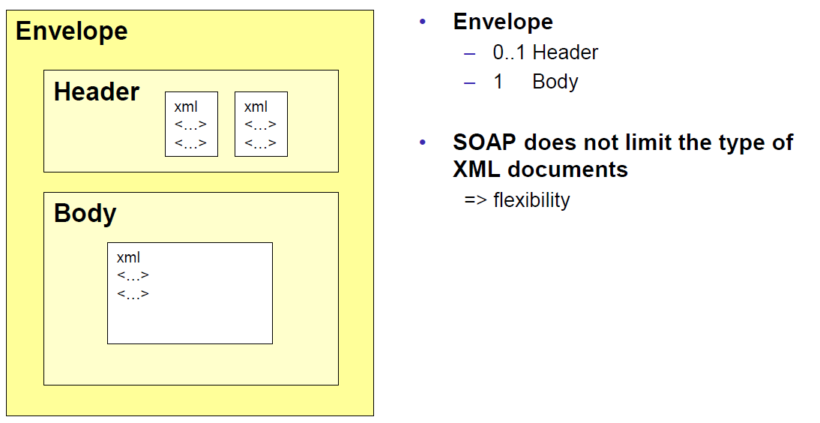

### Tools for SOAP

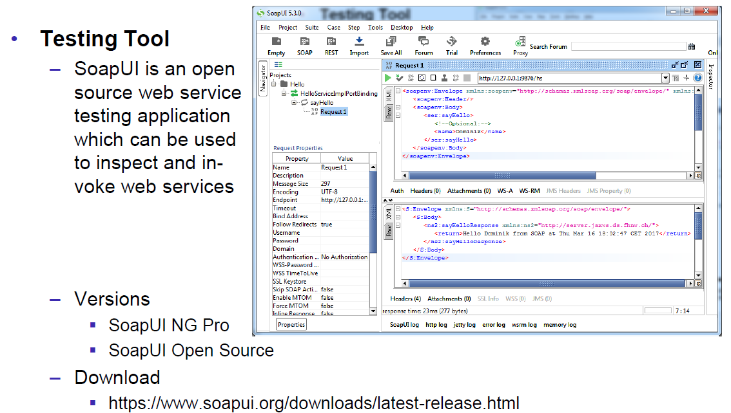

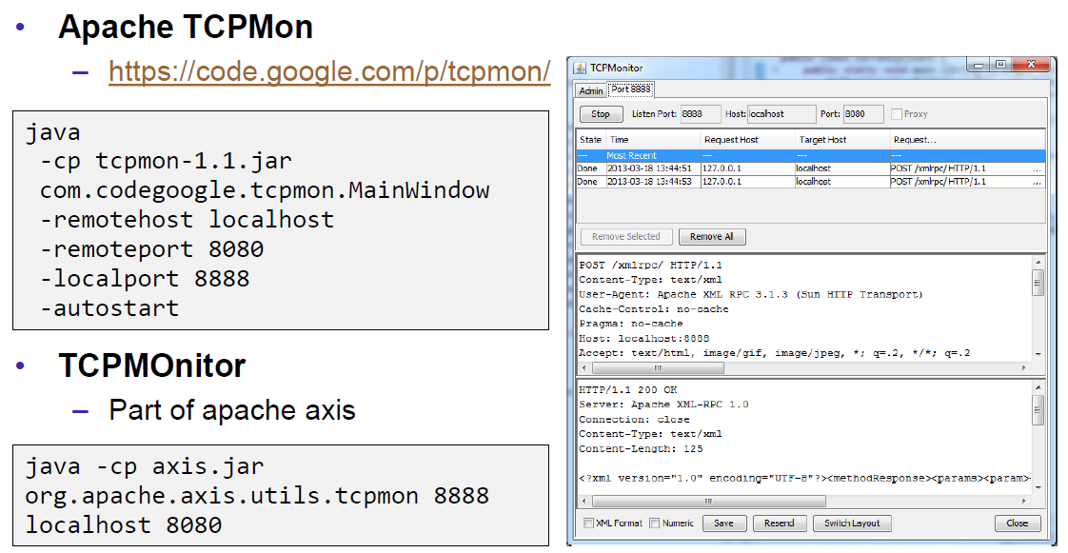

## WSDL

### WSDL

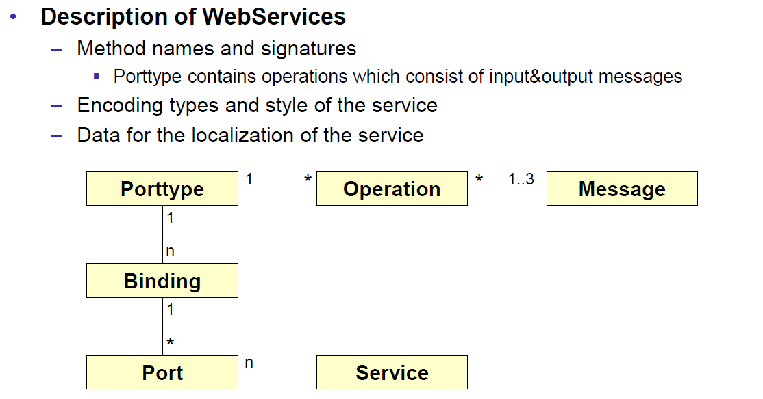

### WSDL Examples

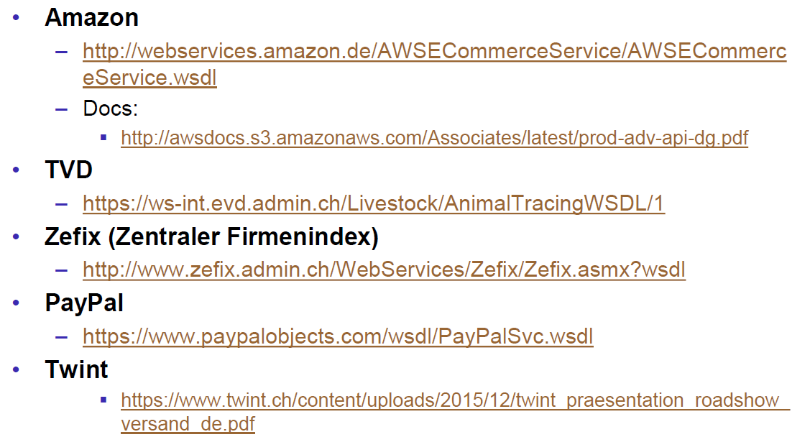

### WSDL Structure

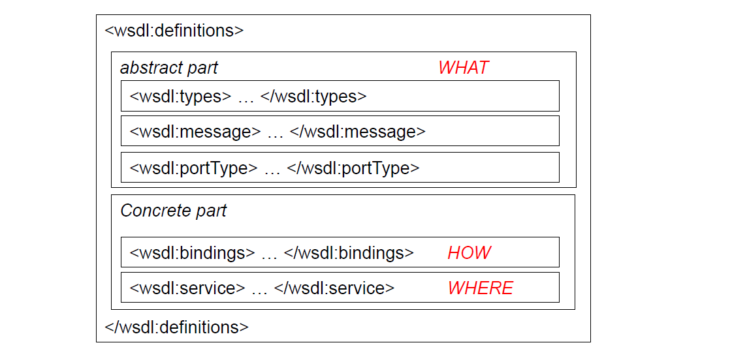

### WSDL Definitions

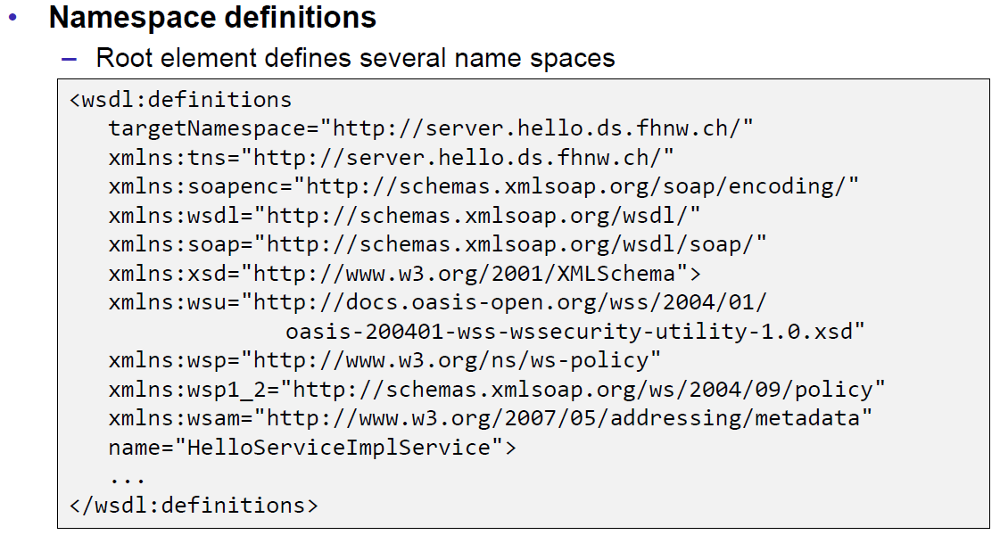

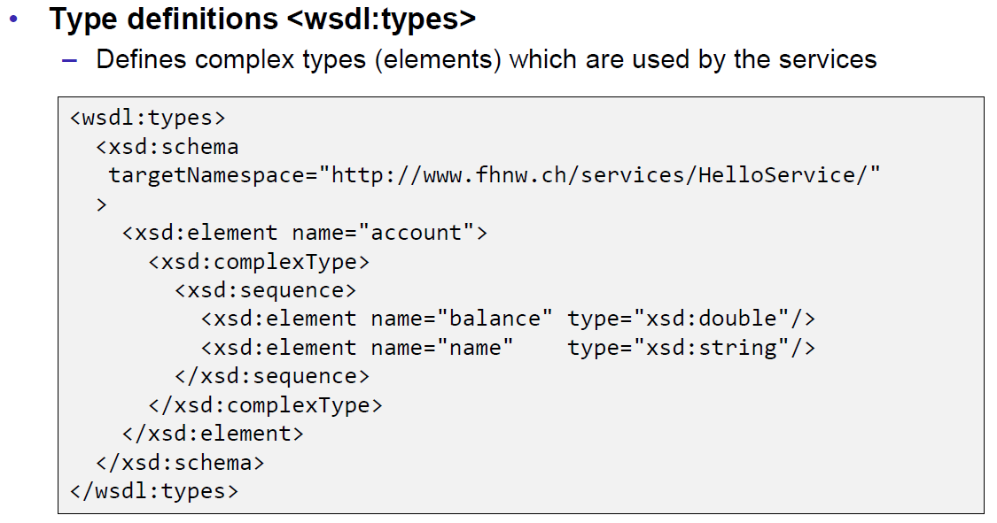

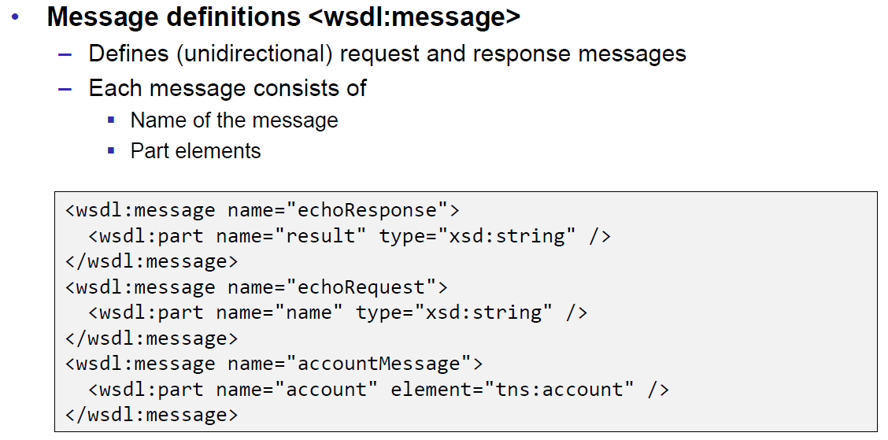

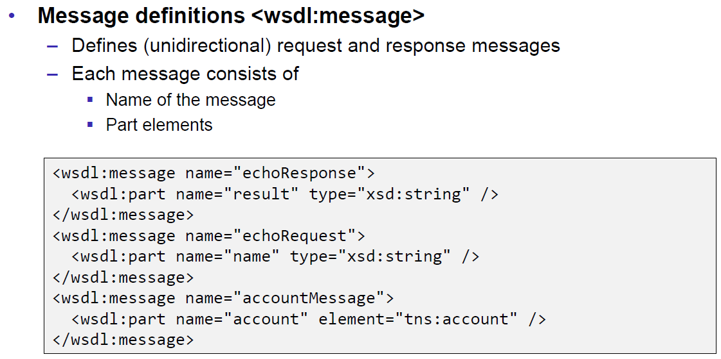

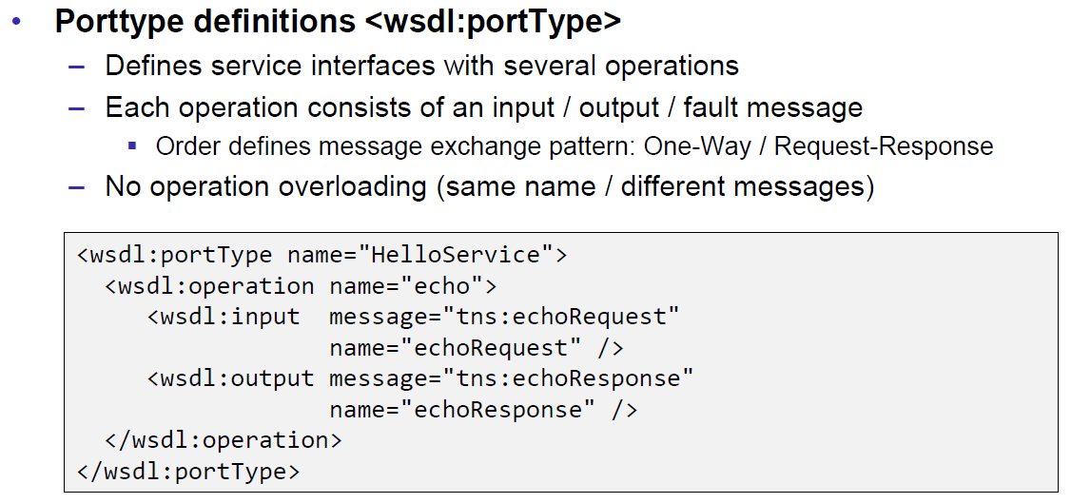

### Message Exchange Patterns (MEP)

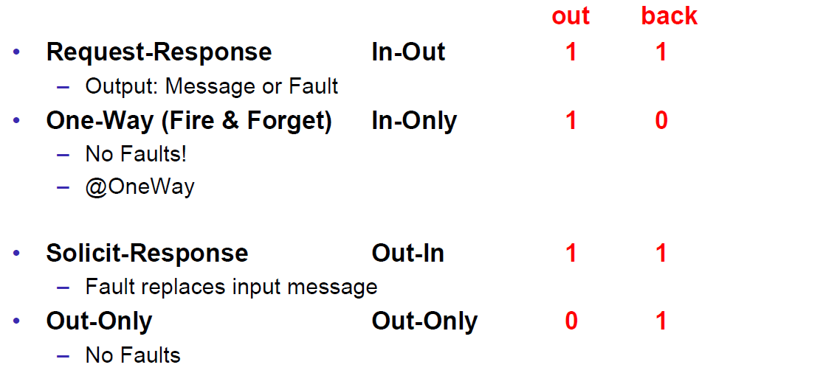

### WSDL Definitions

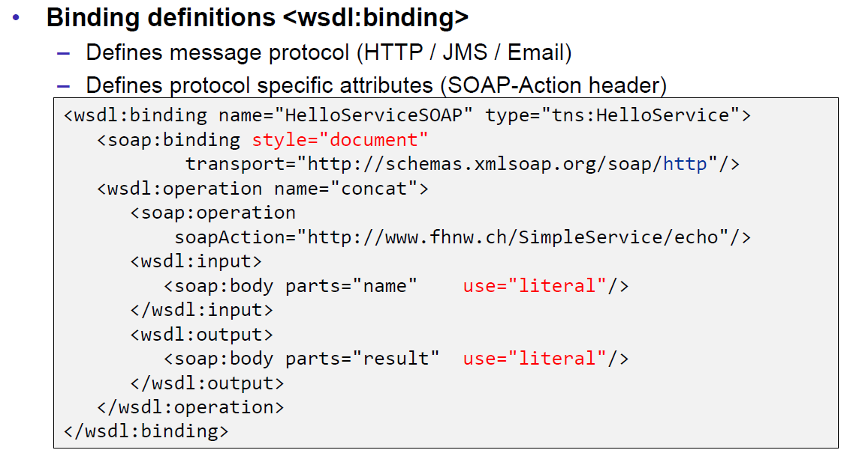

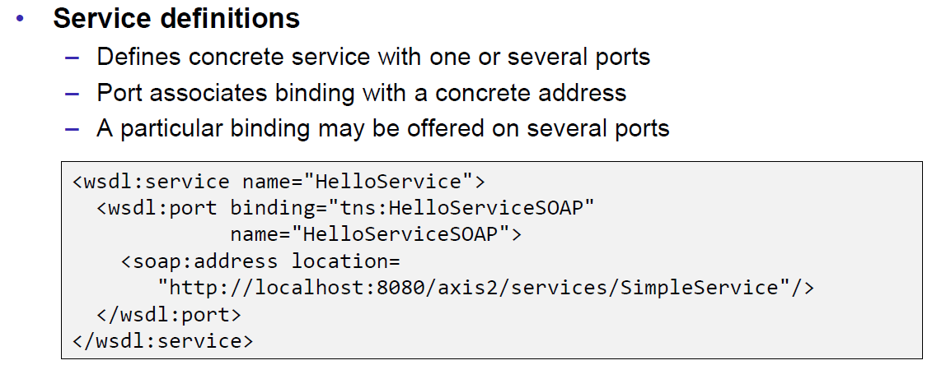

### Web Service Styles

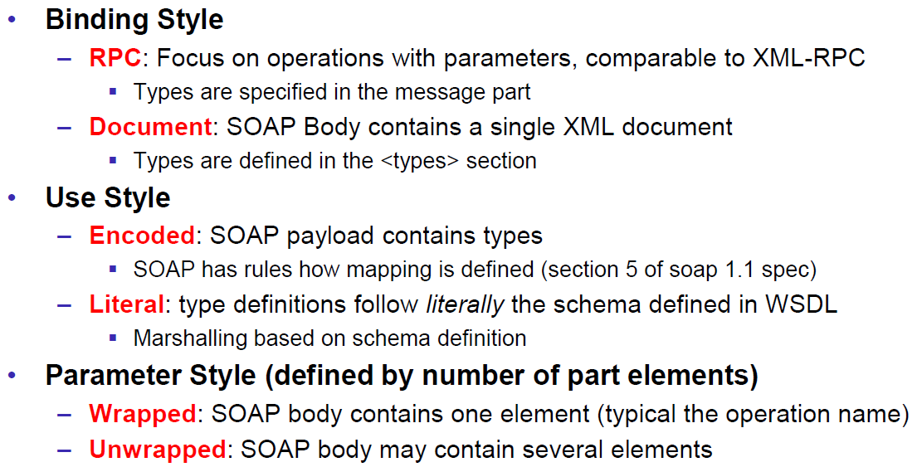

### RPC/Encoded

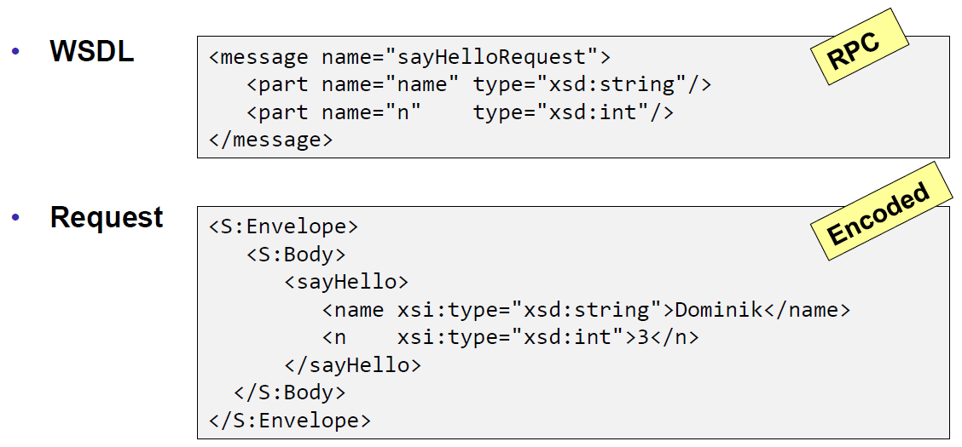

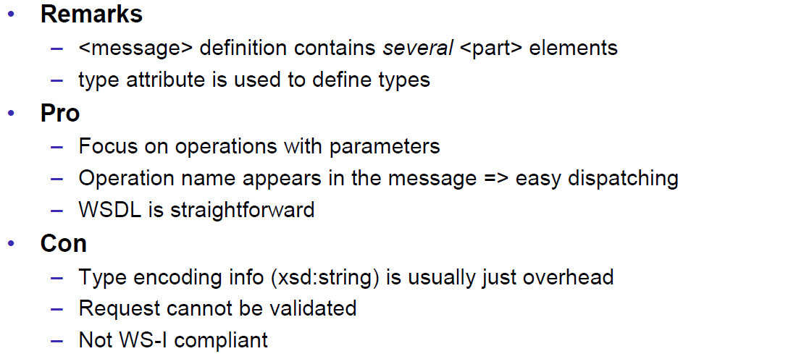

### RPC/Literal

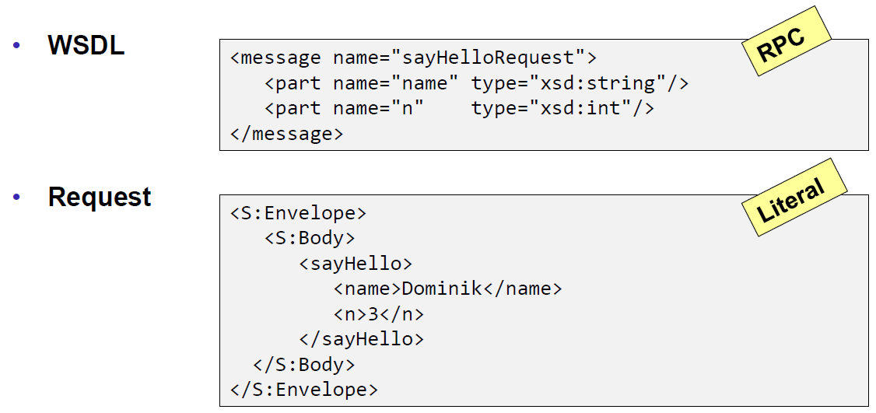

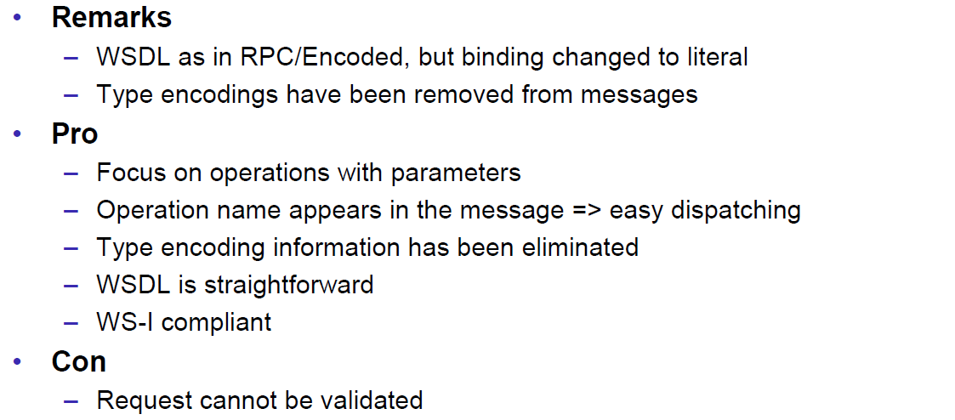

### Document/Literal/Bare

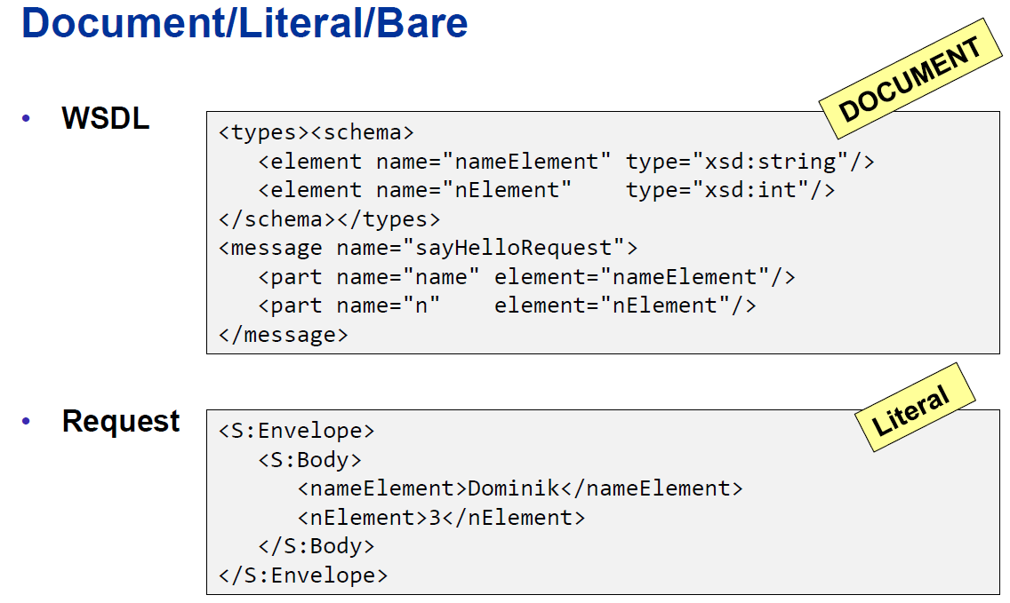

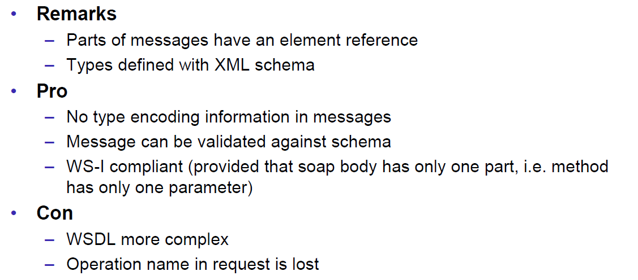

### Document/Literal/Wrapped

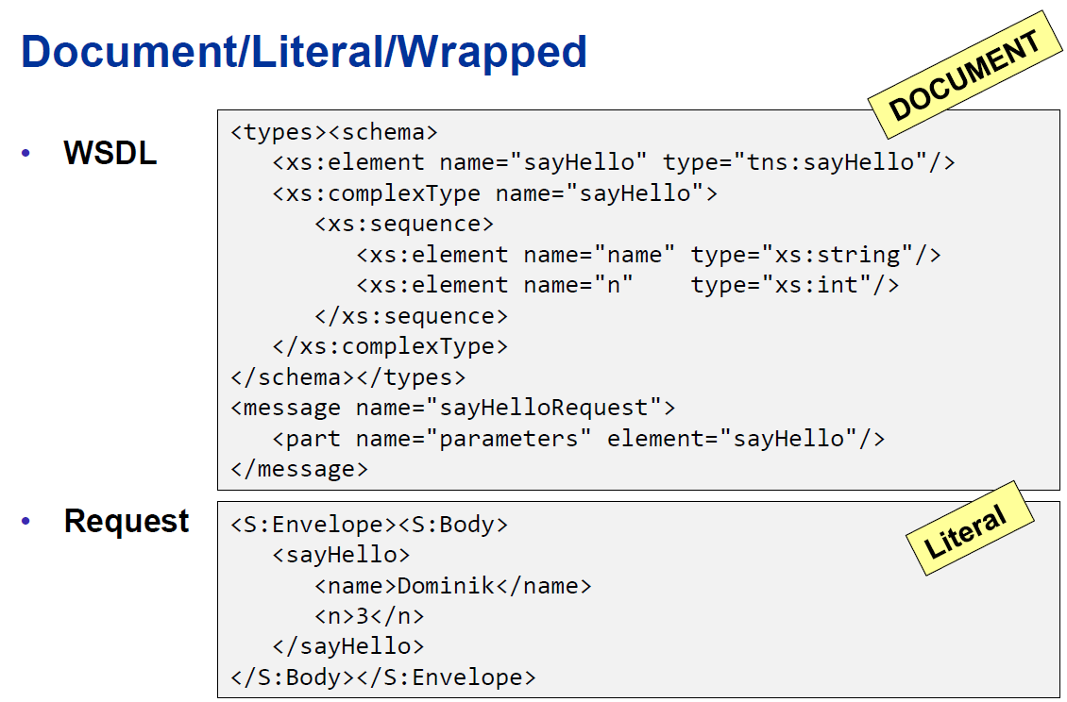

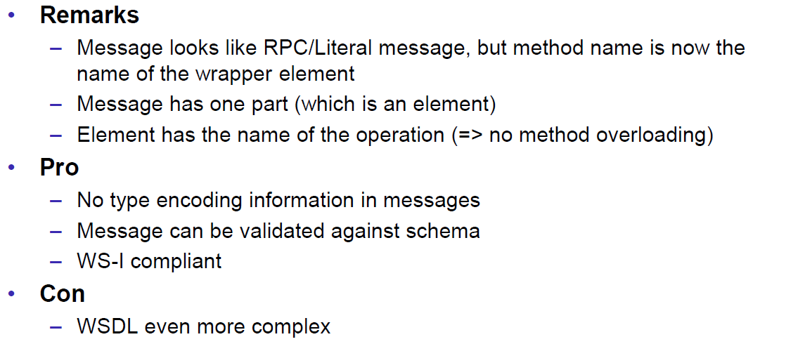

### Web Service Styles

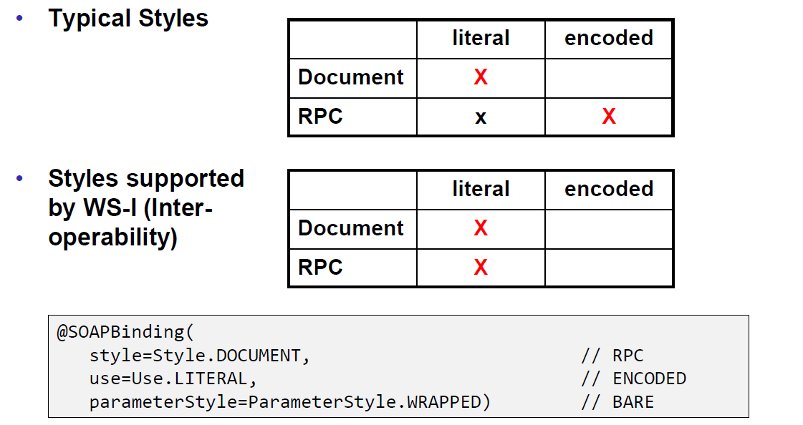

### Further References

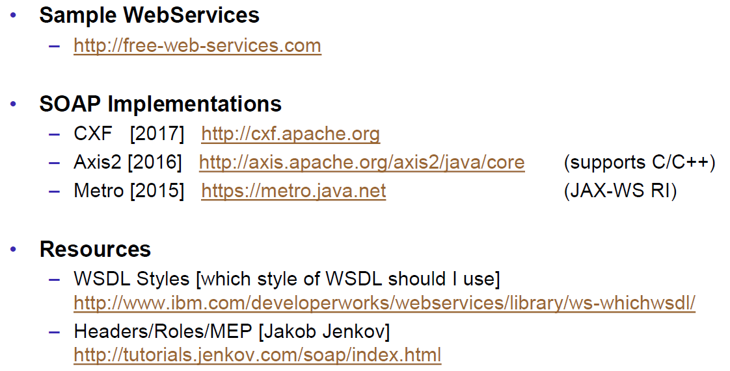

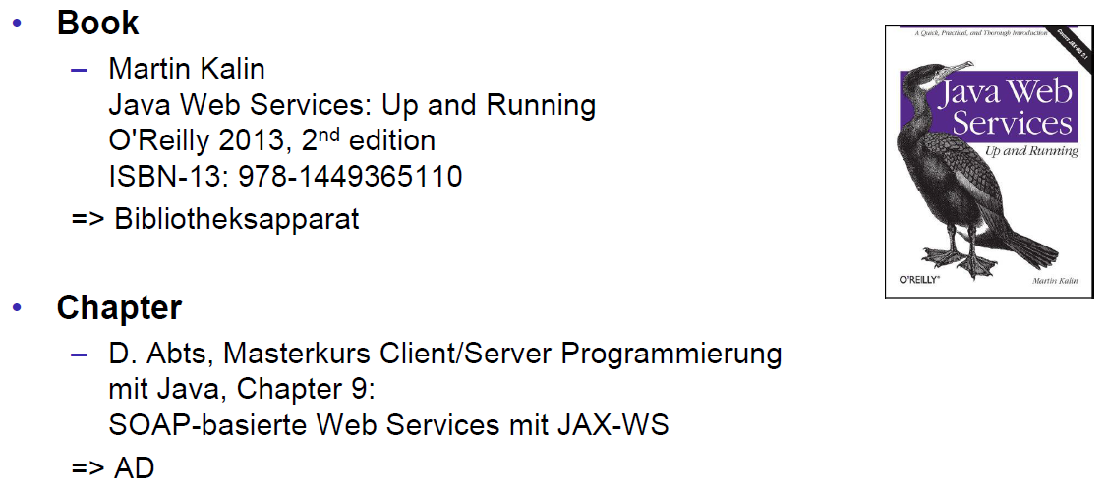

# Woche 6

## REST Concepts

### Representational State Transfer (REST)

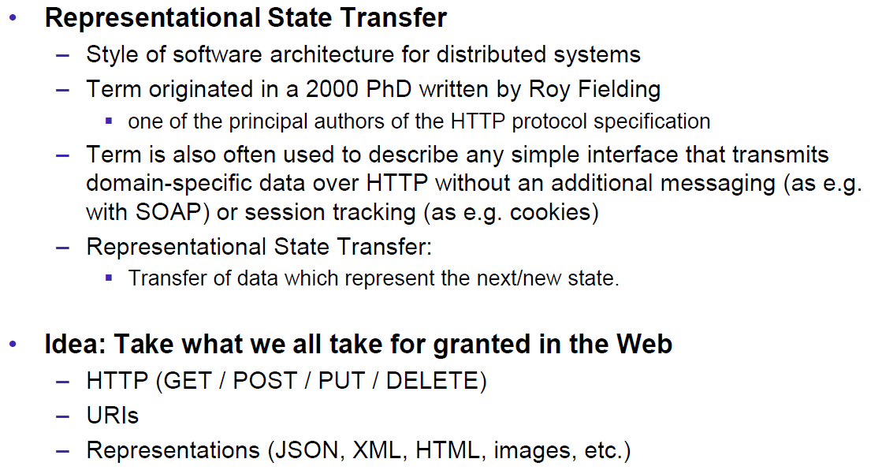

### REST Principles

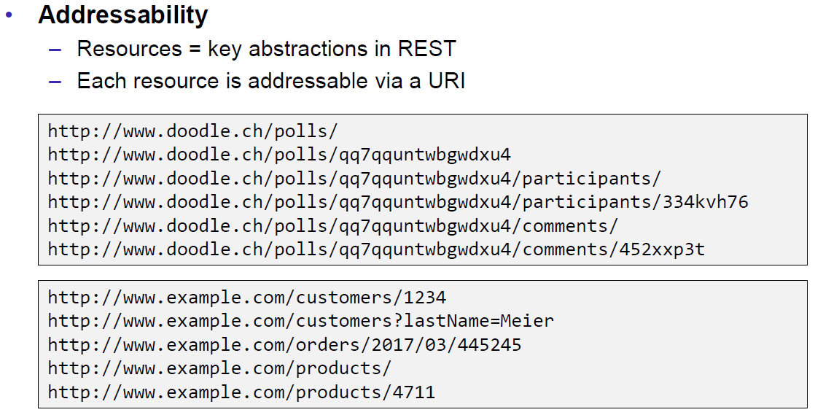

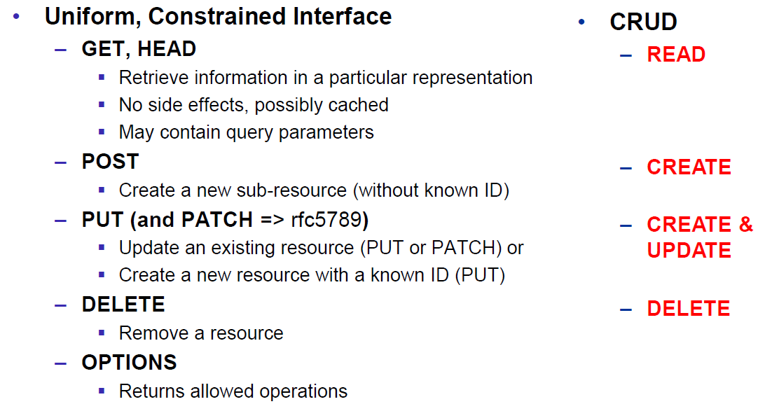

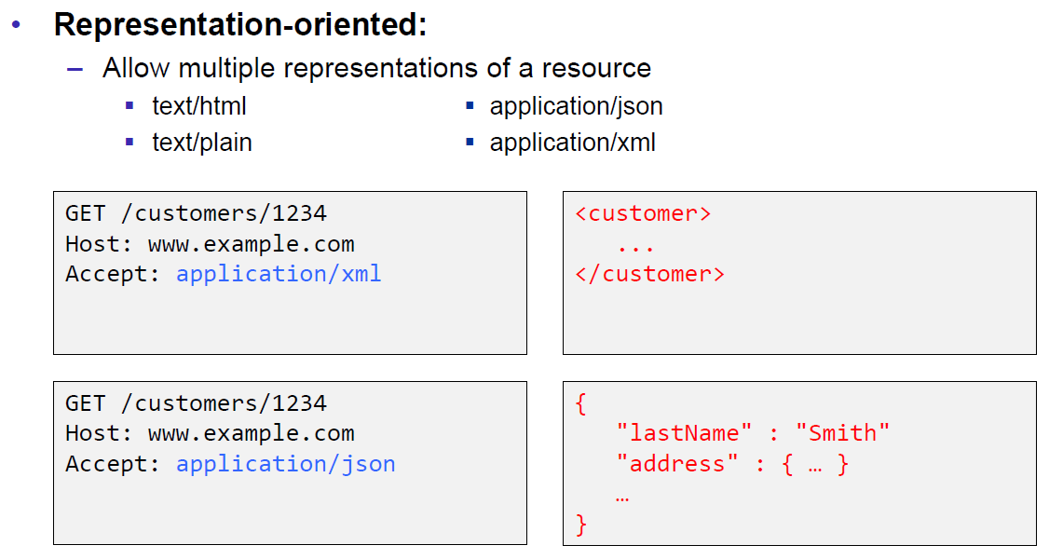

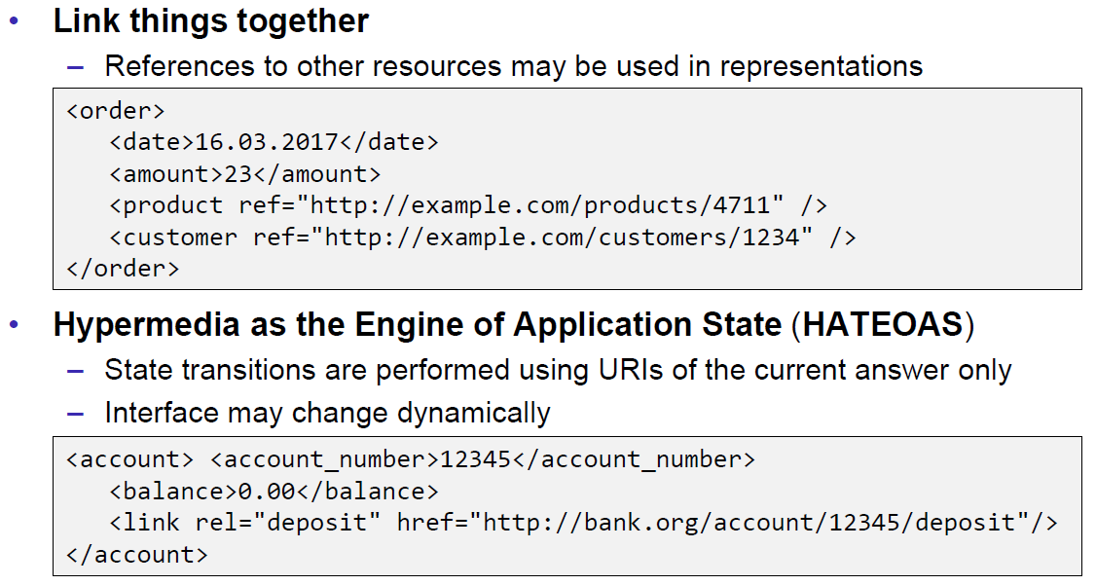

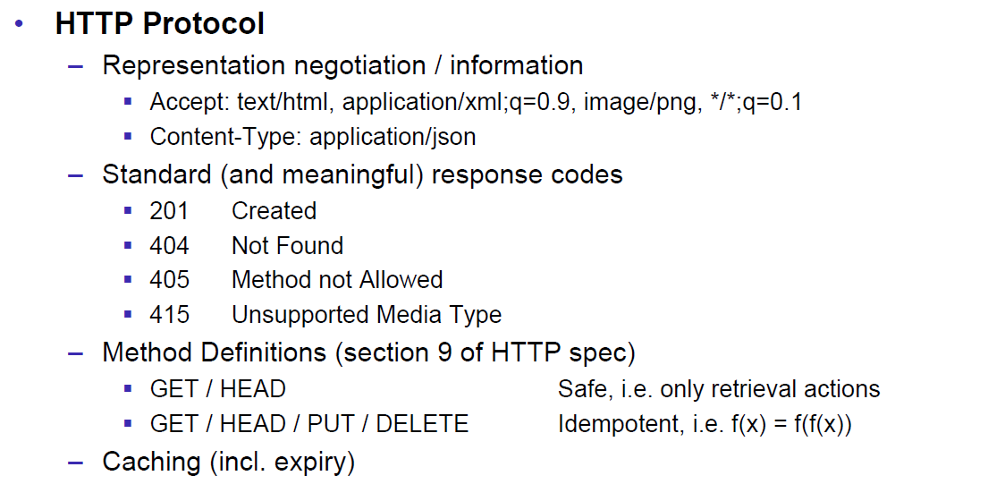

### REST Short Primer

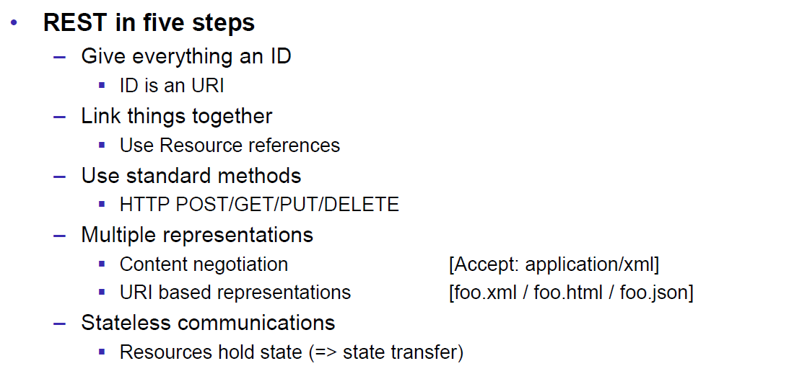

### SOAP versus REST

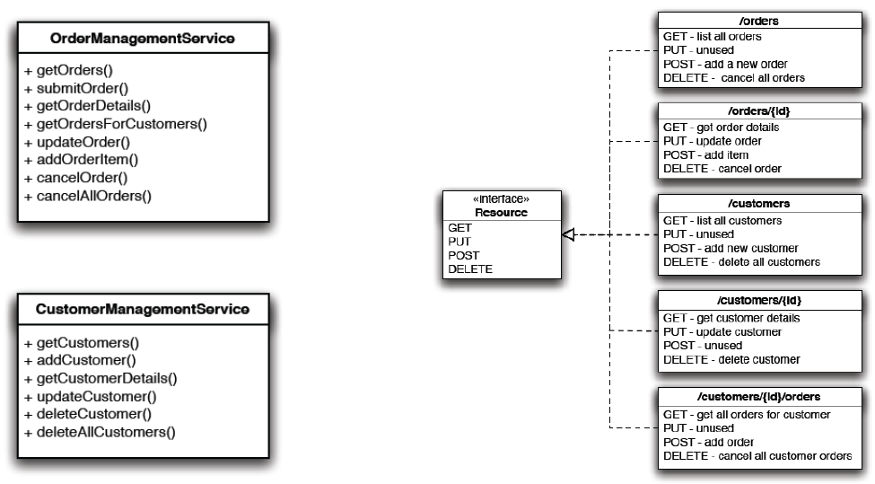

### REST Common Patterns

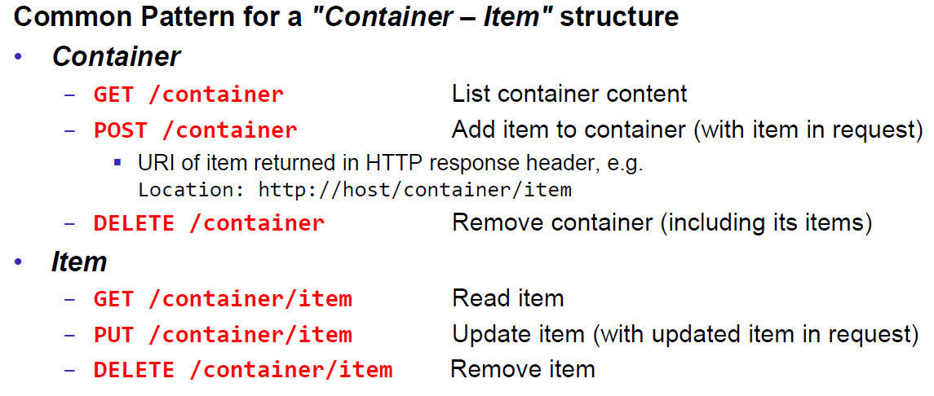

### Example Doodle

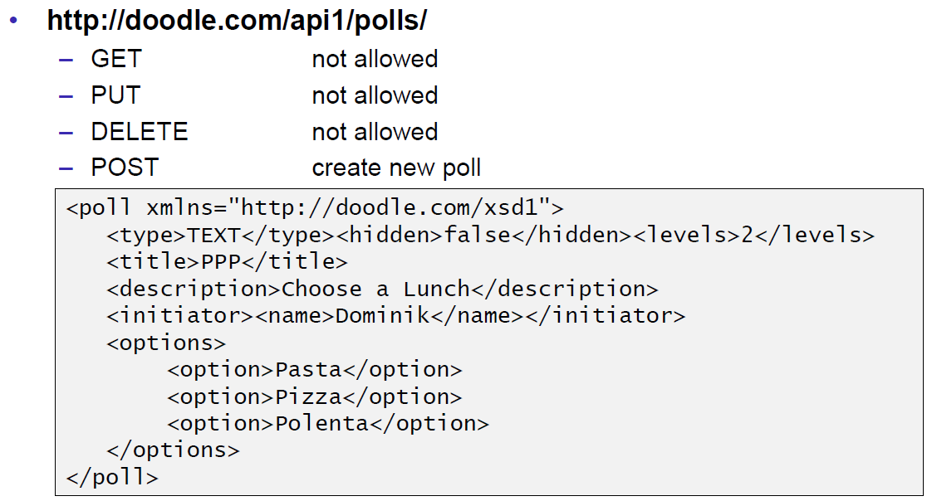

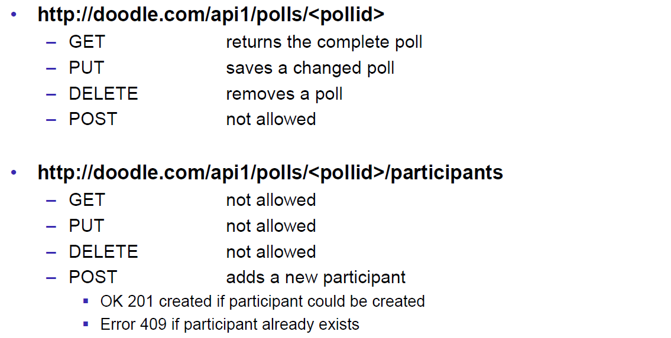

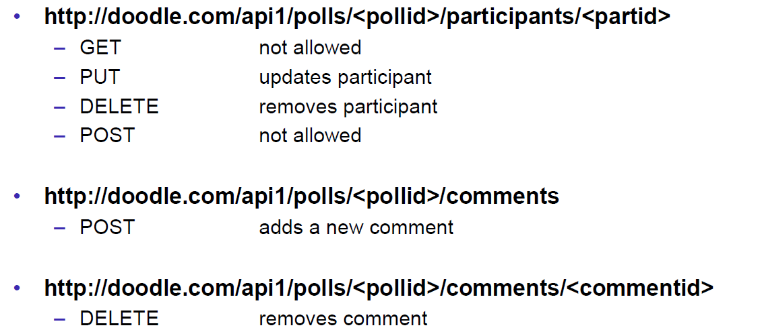

### REST versus SOAP

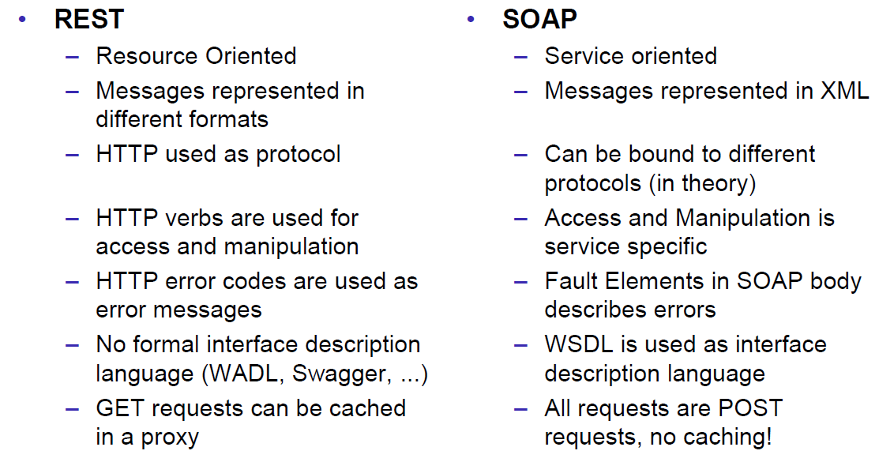

### Client Side

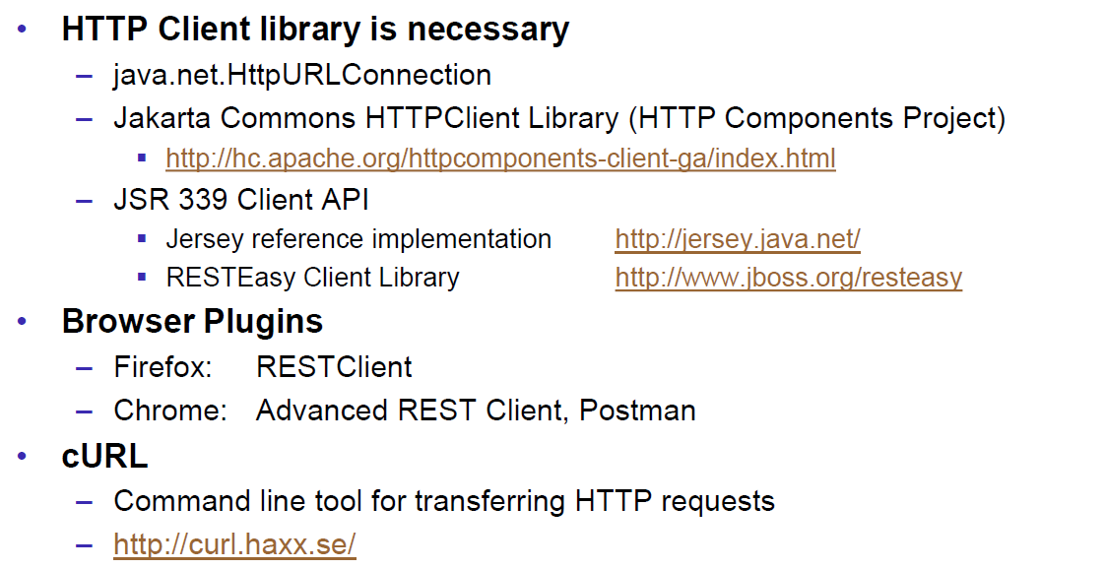

### Web Client Plugins

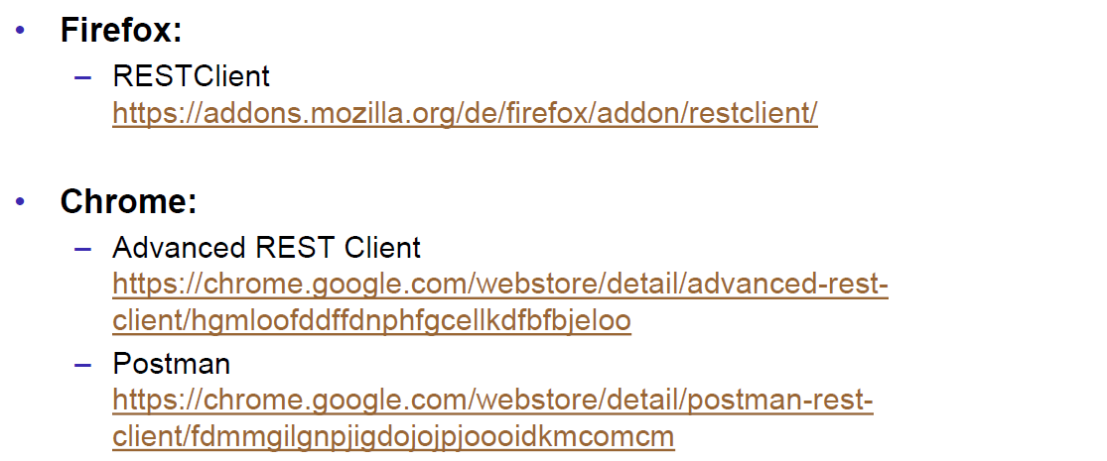

### Client Side via curl

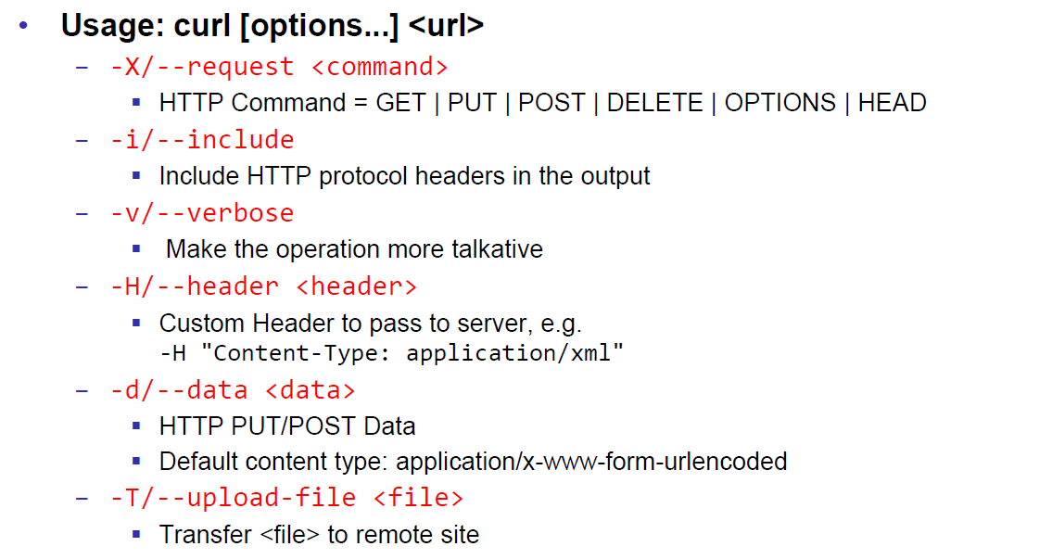

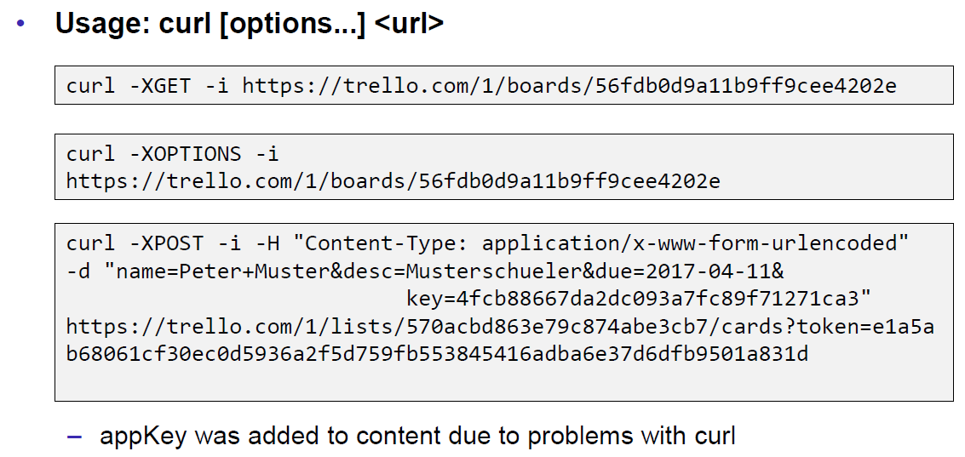

## REST Server Implementations

### Server Side

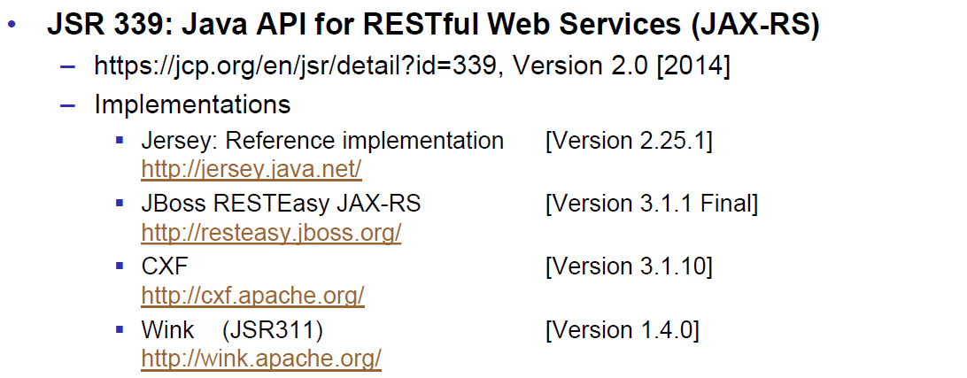

### JAX-RS Services

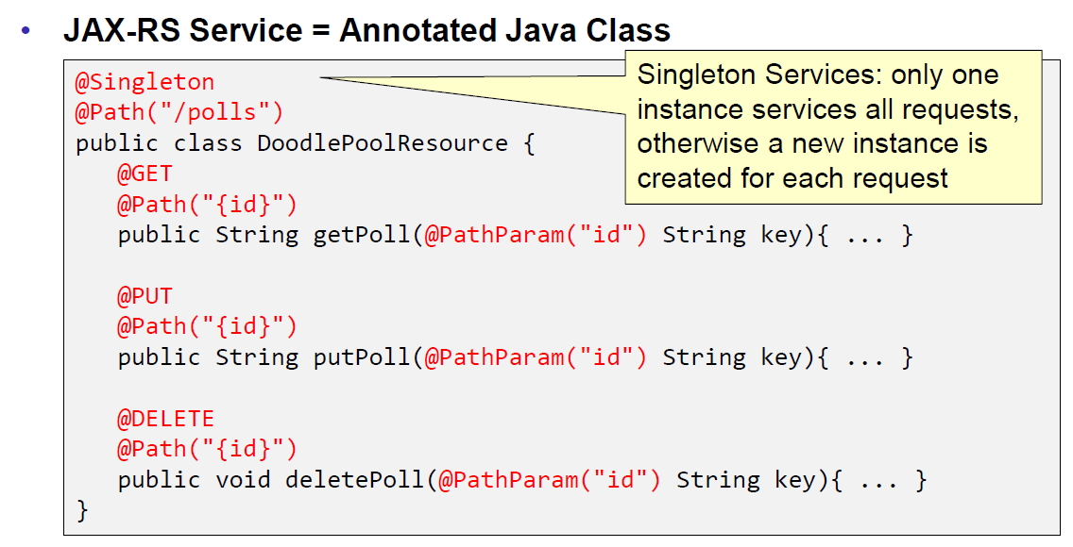

### JAX-RS HTTP Methods

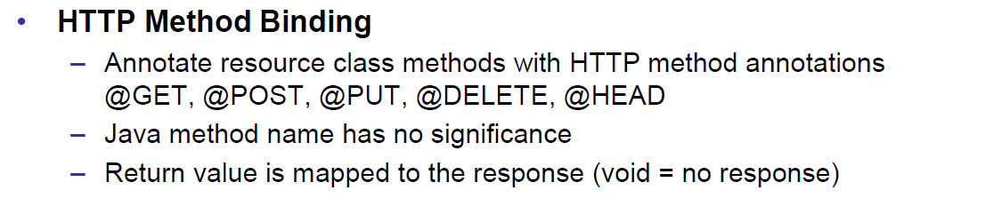

### JAX-RS Injection

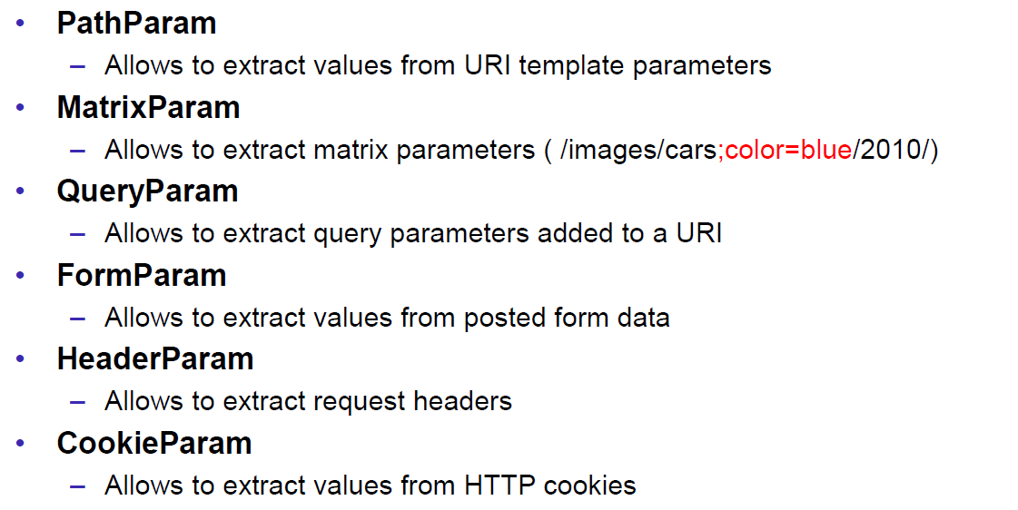

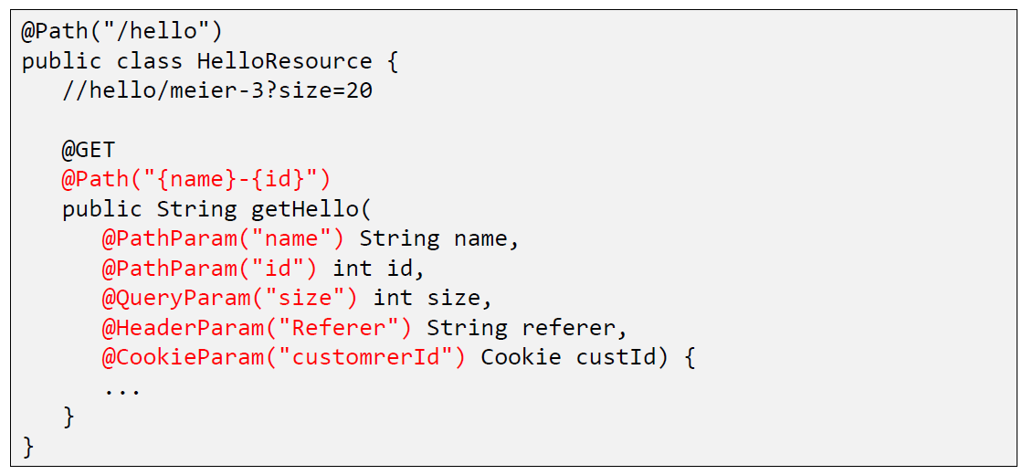

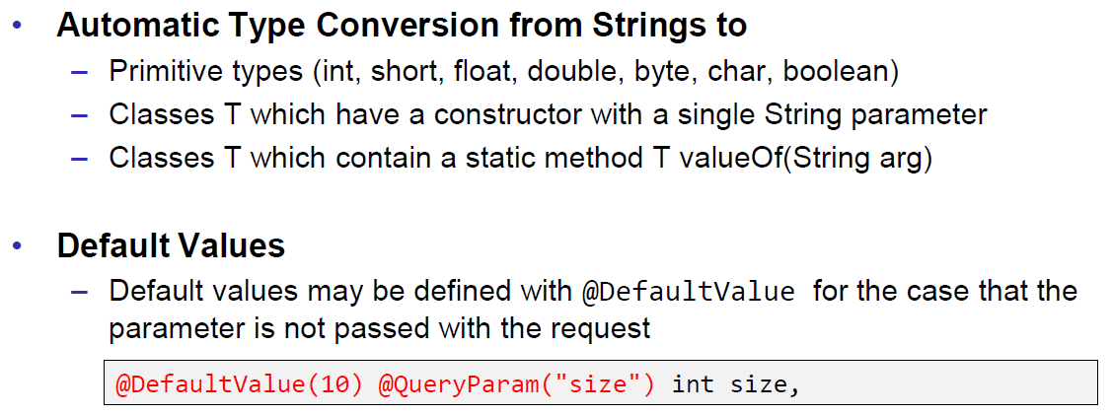

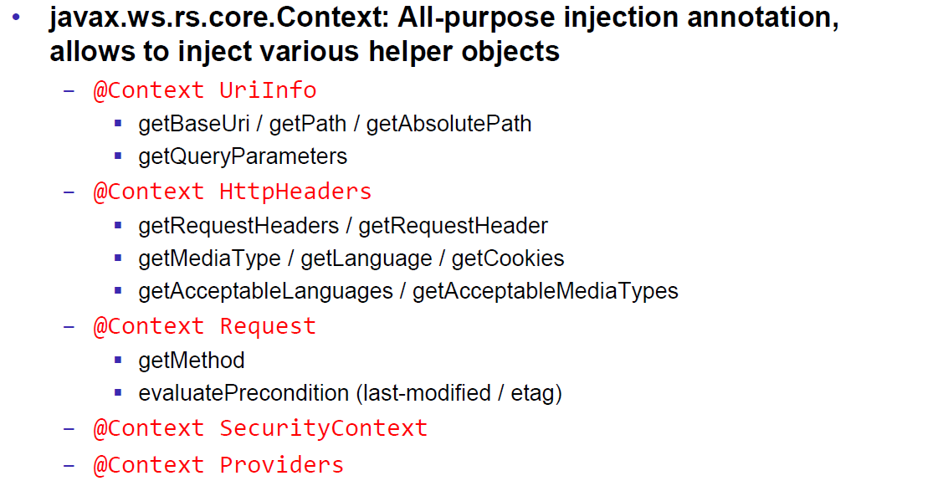

### JAX-RS Content Negotoation

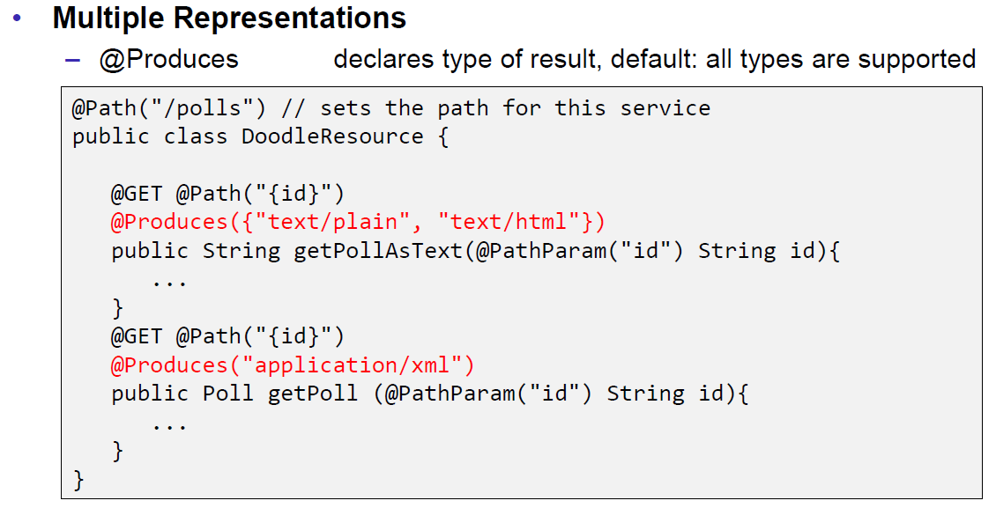

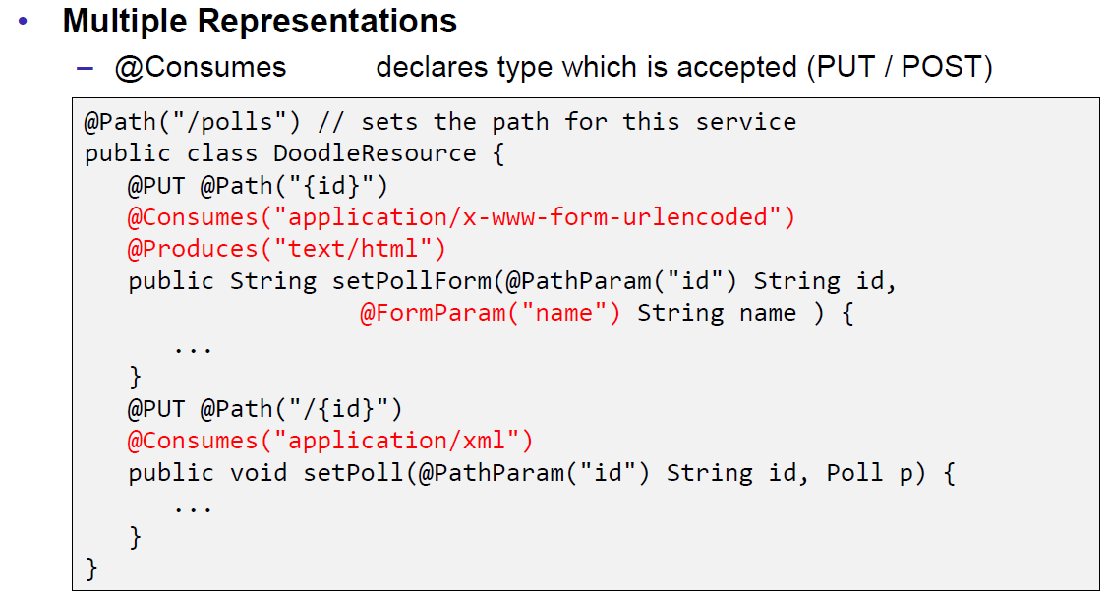

### JAX-RS Content Handlers

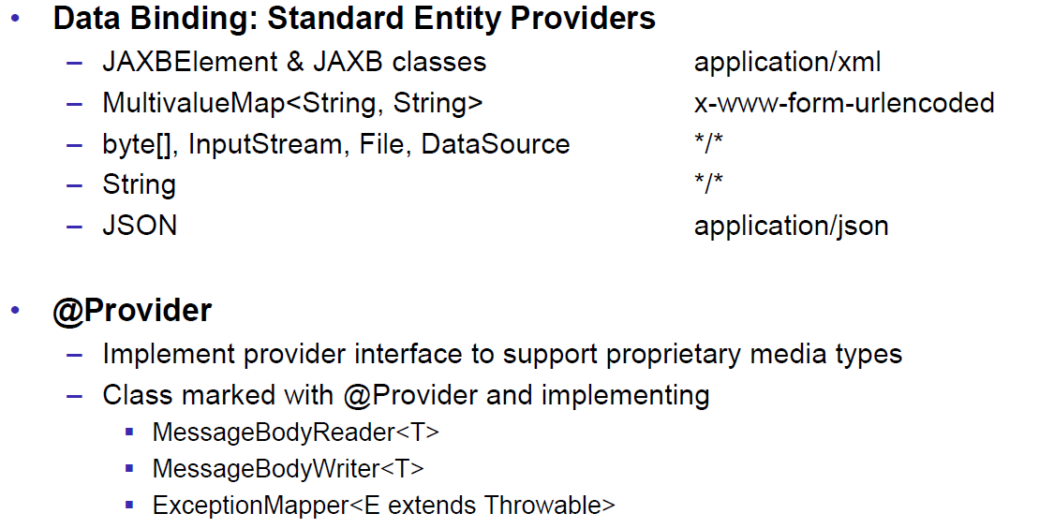

### JAX-RS Responses

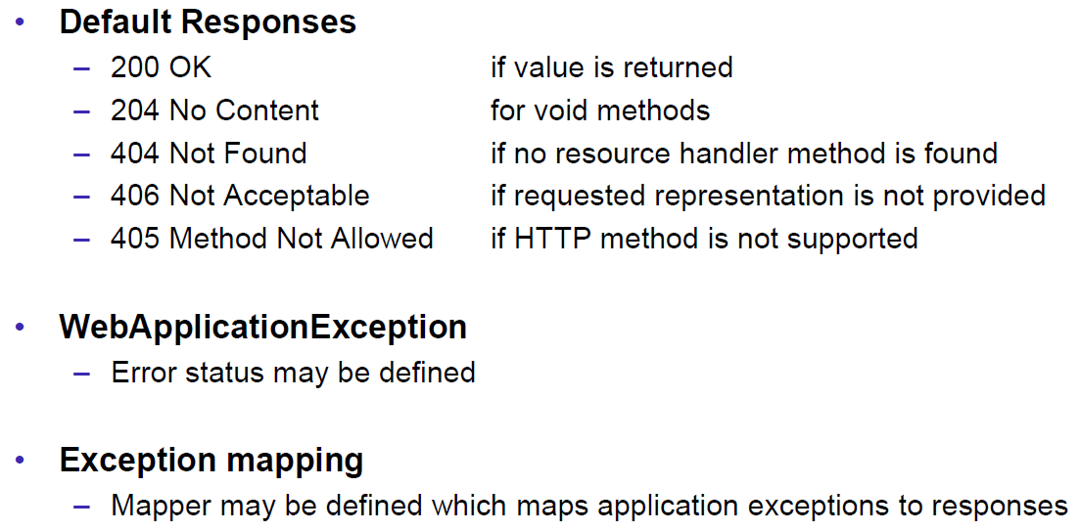

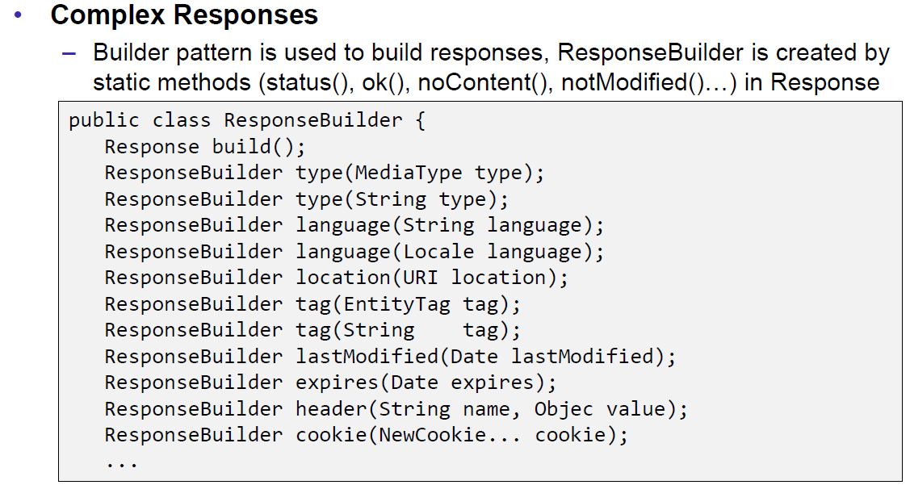

### JAX-RS Conditional GET

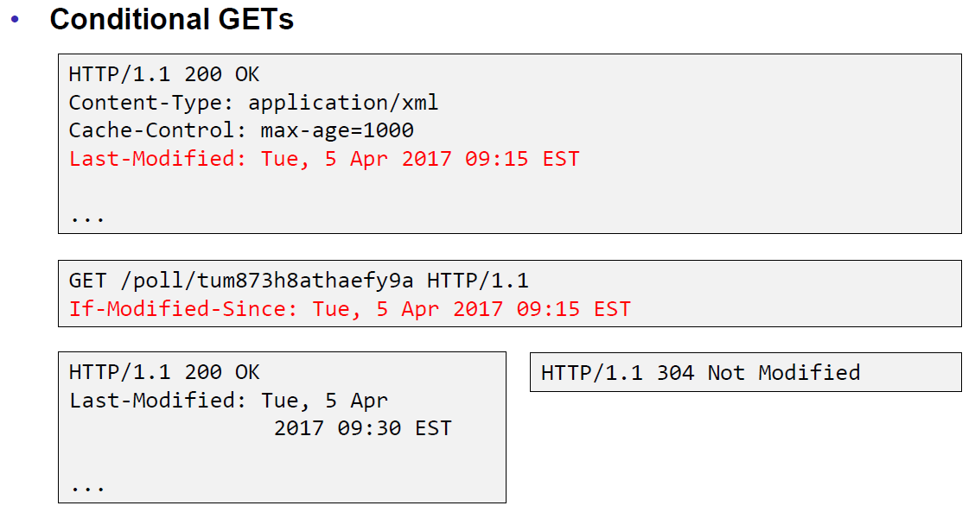

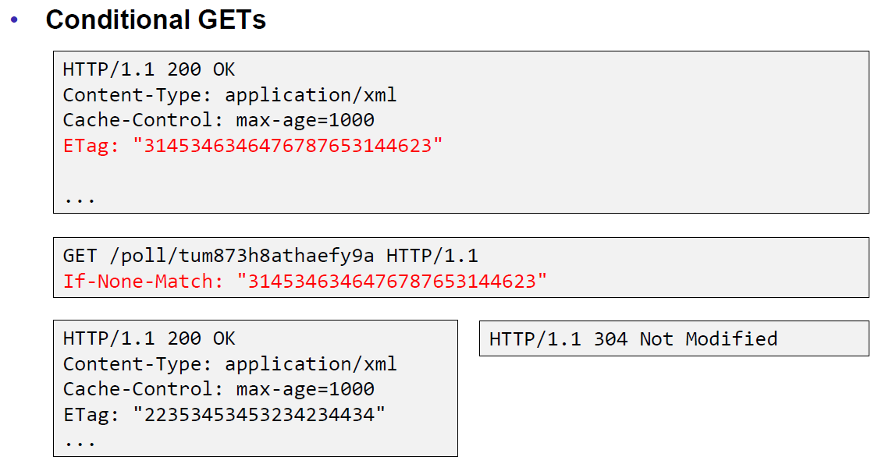

### JAX-RS Cache Control

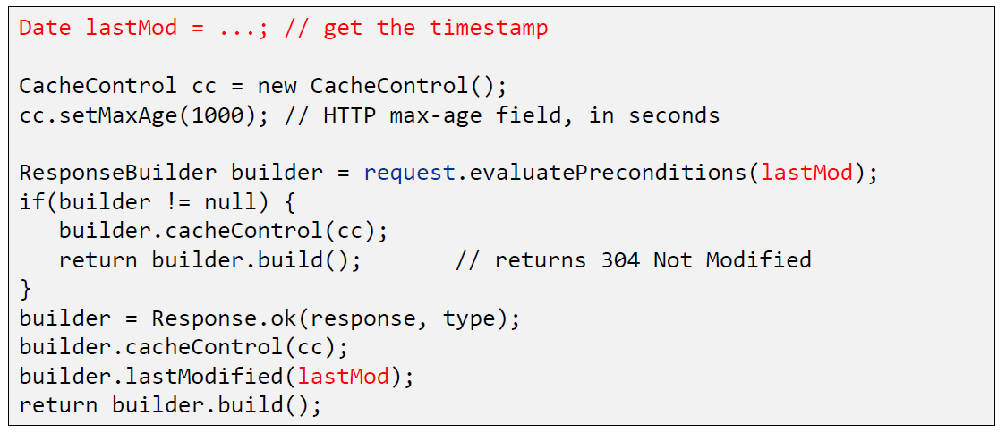

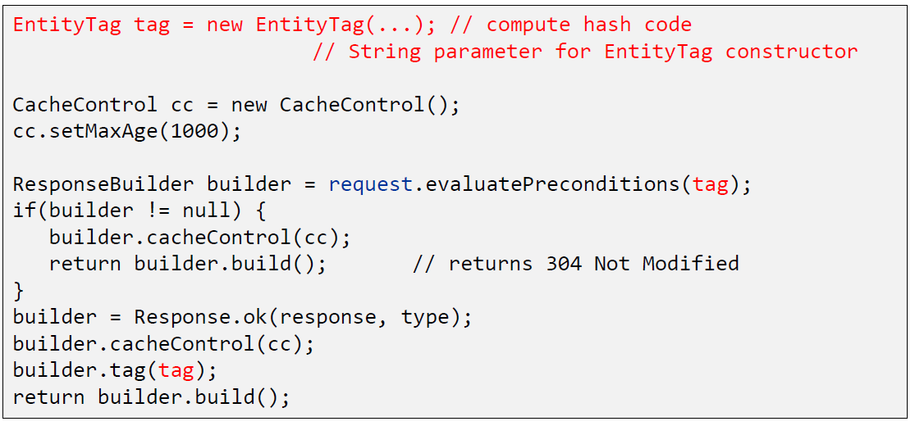

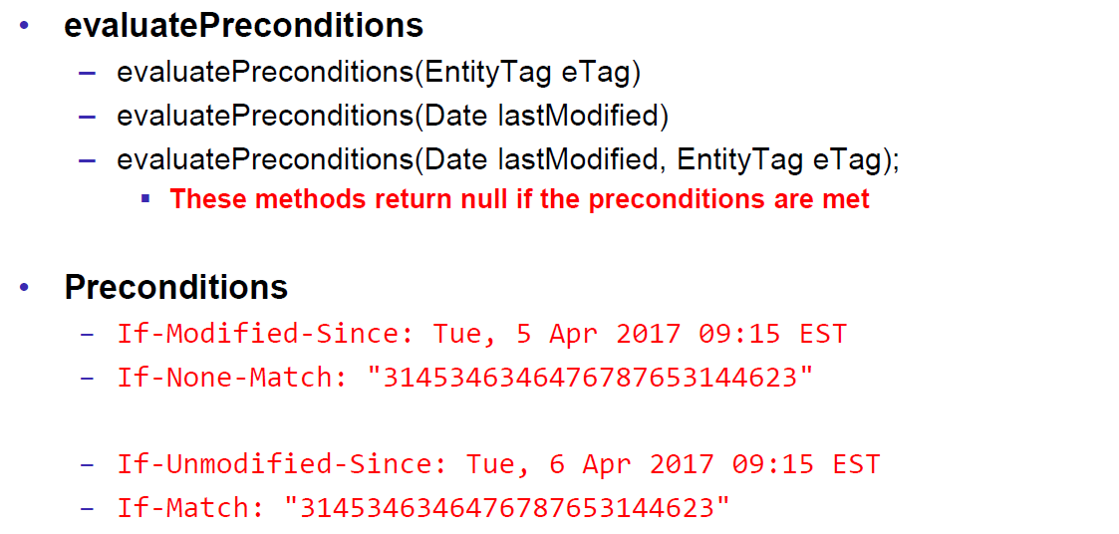

### JAX-RS Optimistic Locking

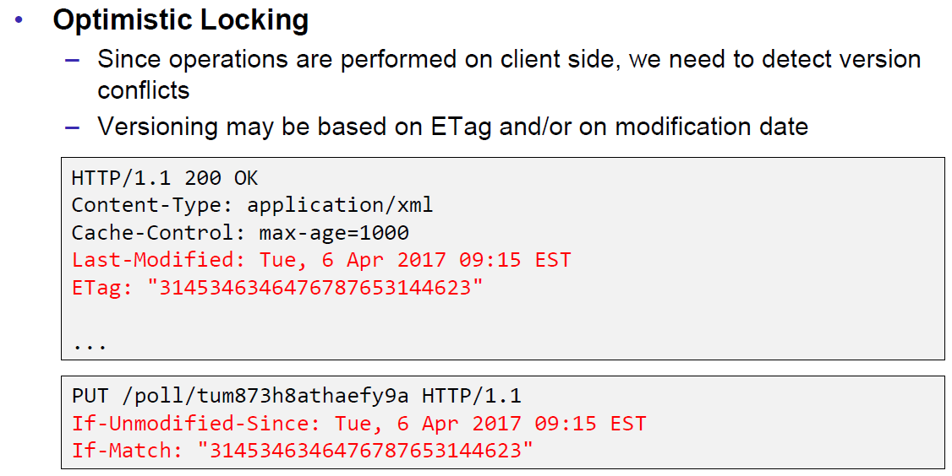

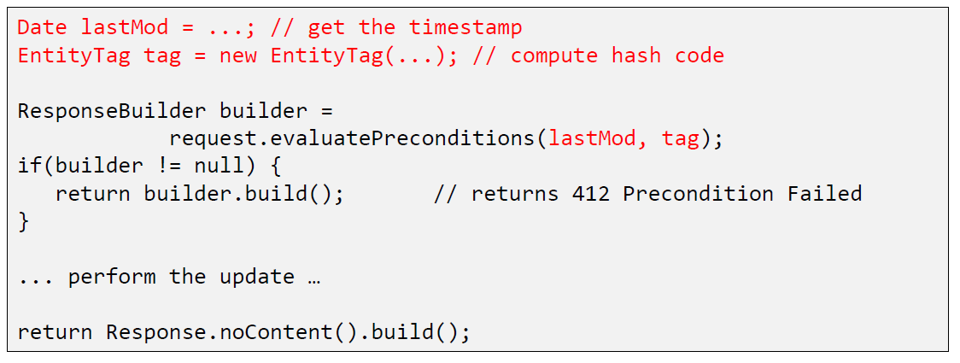

### JAX-RS Deployment

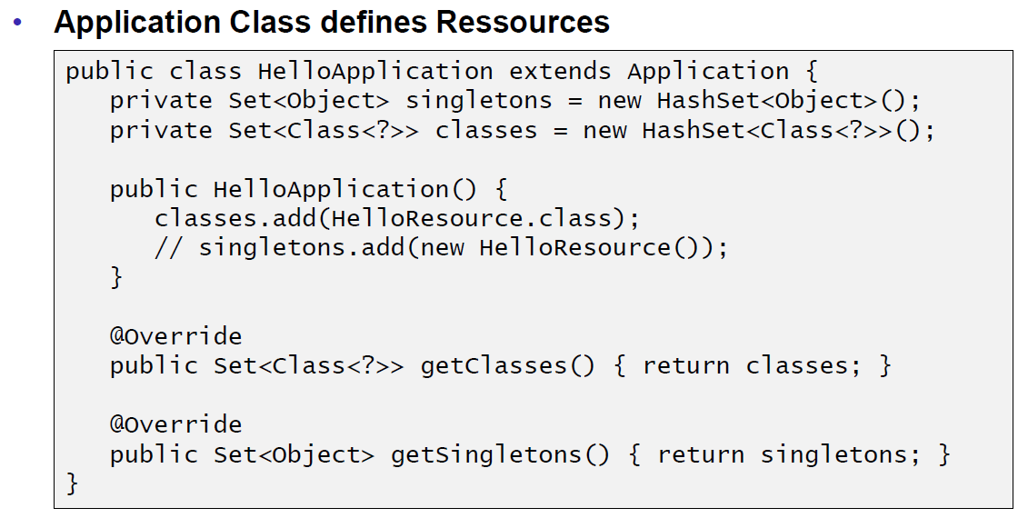

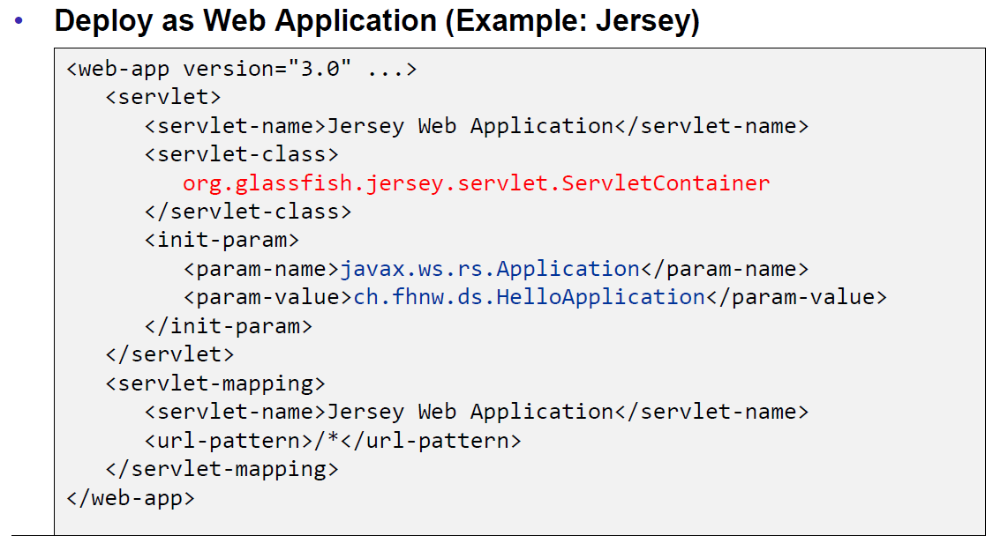

### Deploy Stand Alone via Jersey

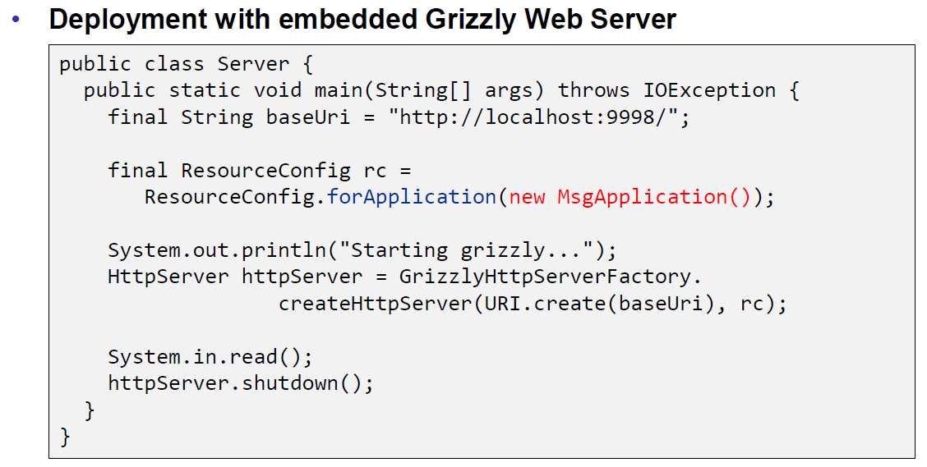

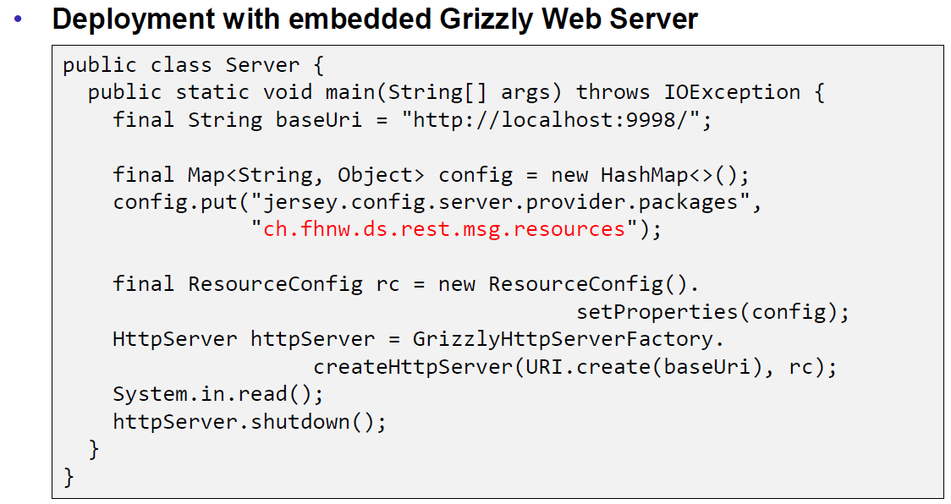

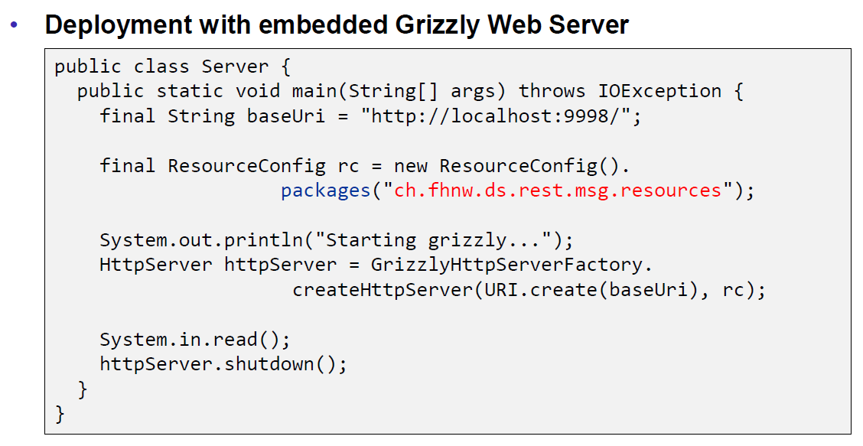

## REST Clients

### JAX-RS Client API

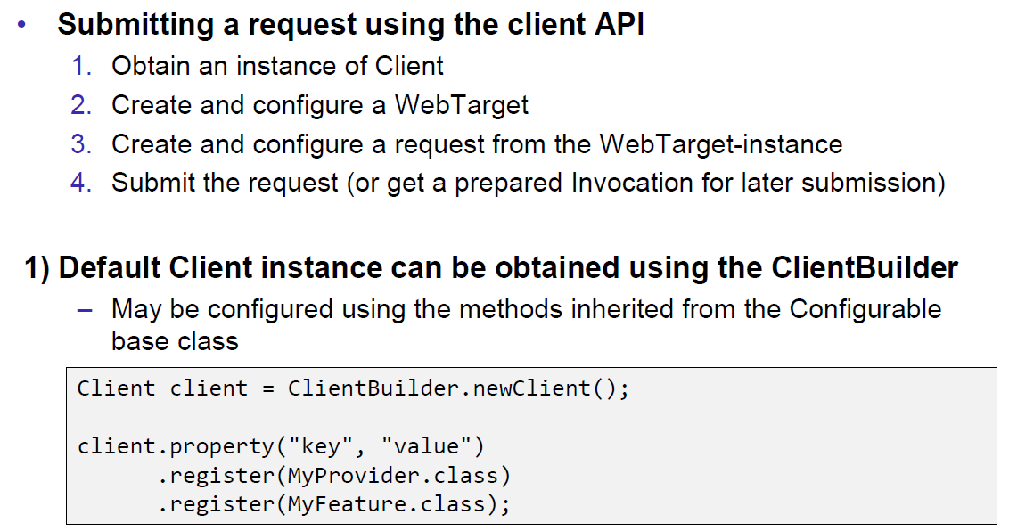

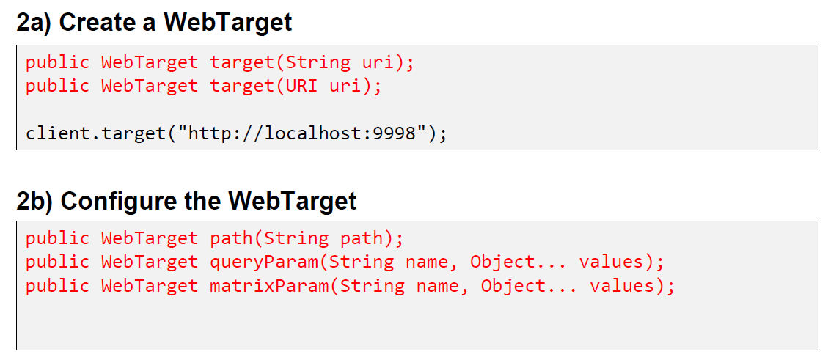

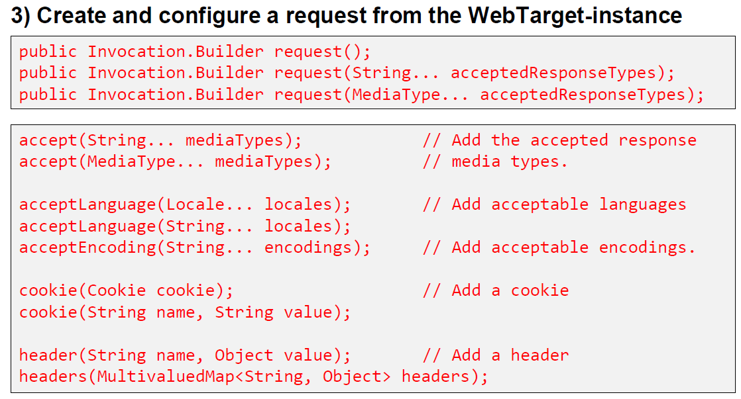

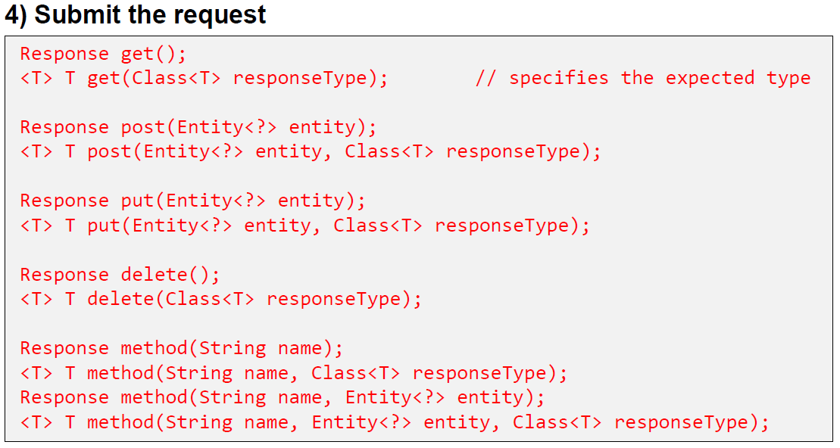

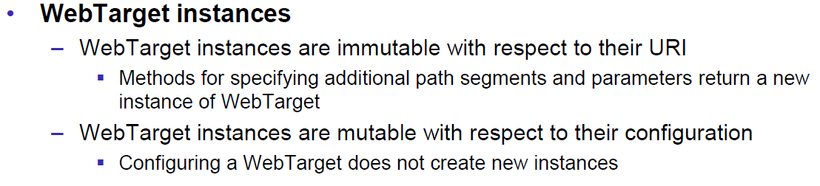

### Resources

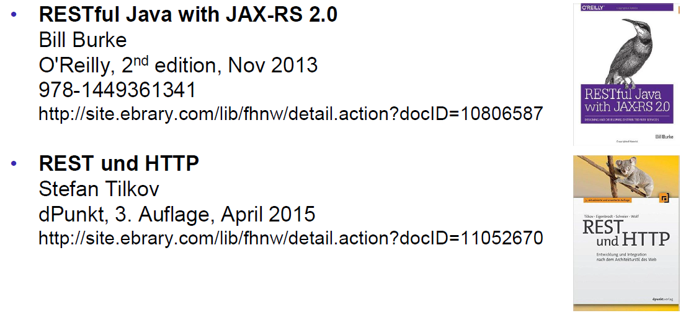

# Woche 7